
2701 N. 16th Street, Suite 110, Phoenix, Arizona 85006 ● www.azleadership.org ● 602.279.5263

Taxpayers’ Bill Of Rights:

Bad News For Arizona’s Working Families

Policy Analysis Brief
By Dave Wells, Ph.D.
(Political Economy and Public Policy)
Arizona State University (for affiliation purposes only)
Originally developed February 2003—revised March 2005.

Arizona has faced continual budget shortfalls over the last few fiscal years and lawmakers are seeking ways to balance the budget this year and also address long-term problems. One solution that has been proposed is that the growth of state spending be limited to population growth plus inflation. Unfortunately, while limiting spending provides a framework for budgeting, it would come at great cost to the state’s future, ultimately undermining quality of life indicators, economic growth and our ability to improve wage levels.

If what is termed a taxpayer bill or rights or TABOR had been implemented in 1980, the current TABOR limit would be $5.4 billion applied to the General Fund, far below the $8.1 to $8.3 billion that will be spent this year. Over time, TABOR would

- Dramatically curtail the ability of the state to adequately fund employee salaries exacerbating existing problems with employee turnover and leading to poorer government service.

- Reduce investment in K-12 and university education, undermining achievement goals set by the No Child Left Behind Act and AIMS as well as the basis of a strong workforce to ensure economic growth.

- Establish a historical precedent that Ronald Reagan never pursued and only Colorado, a state struggling economically, is exploring. Colorado, though a wealthier state than Arizona, shows significant declines in qualify of life measures.

- Damage the ability of the state to recover from economic slowdowns worsening the above problems.

Problem 1: Addressing a Problem we don’t have. Expenditure growth is not a problem, but TABOR’s formula would create one.
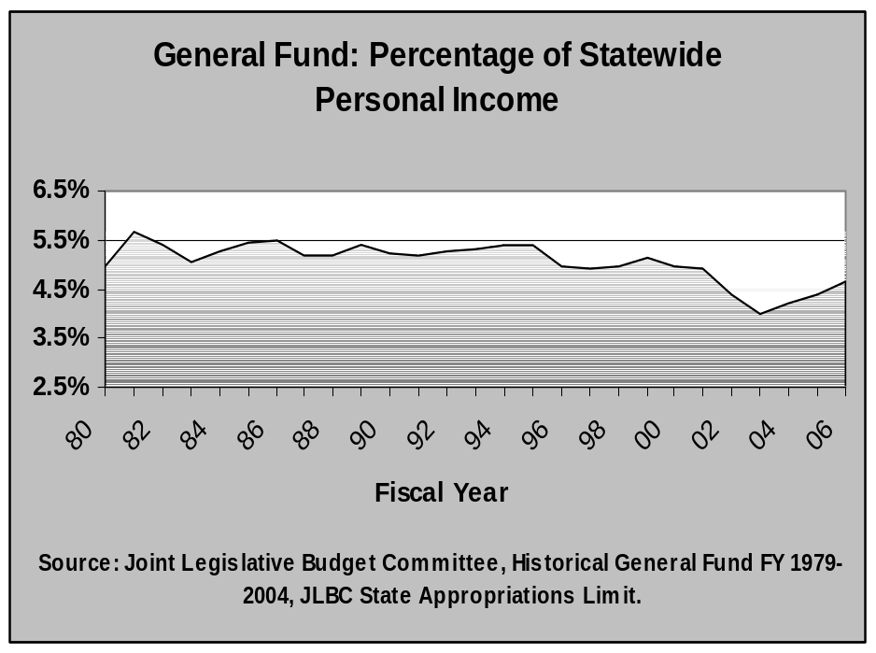
Presently state spending is limited by a ceiling measured by population growth plus inflation plus economic growth. The statutory benchmark used is total state personal income.
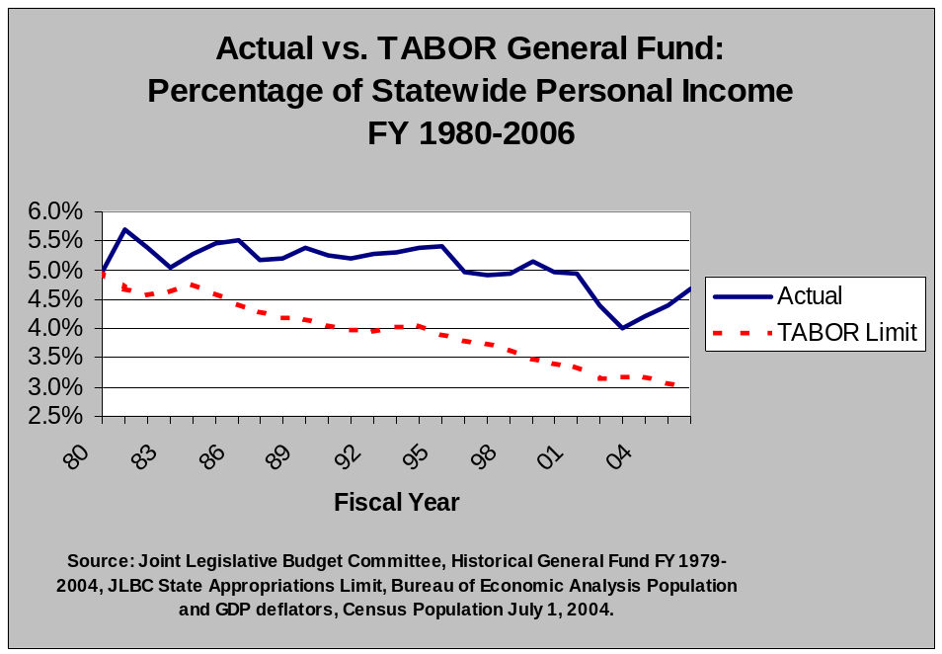
State spending may not exceed 7% of state personal income. State legislators have kept state spending well below this level, and this is not the cause of our current budget problem.
By limiting growth in state expenditures to population growth plus inflation. By necessity, assuming economic growth, state expenditures would FALL relative to the size of the economy. To fiscal conservatives this makes ideological sense, but practically speaking would create significant problems. Some of the key problems are identified below. In the bottom chart, the TABOR formula limit is contrasted with actual general fund expenditures, which includes payments to the budget stabilization fund. Had TABOR been in effect since 1980, in the current budget cycle the TABOR limit would be $ 5.4 billion. Given that the current debate is between expending $8.1 versus $8.3 billion, legislators who support TABOR should ask themselves what third of government services they intend to see TABOR eventually eliminate.

Problem 2: Employee Pay Raises that Just Match Inflation in Good Times Won’t Make For Productive Government.
Governing Magazine noted in its most recent analysis of state finances that Arizona state government “has had trouble retaining employees. More than 11 percent of Arizona’s workforce left voluntarily in fiscal 2003, the second-highest rate in the country.”
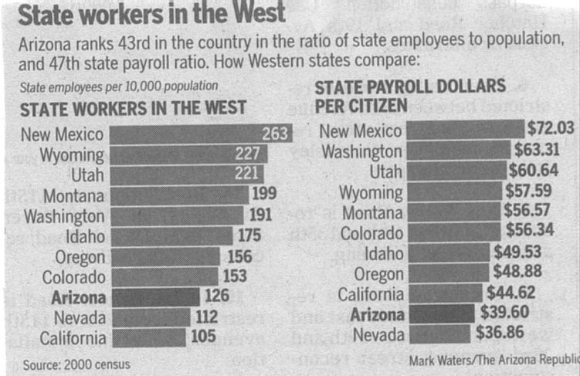
State employees are underpaid leading to costs of turnover and poor morale, which undermines governmental effectiveness. Leading examples that have appeared in recent years: corrections officers paid $25,000 a year with a 25% annual turnover rate. CPS caseworkers with a masters degree starting at only $26,000 and have nearly the same turnover rate. There have been some modest improvements in the above cases, but, overall, Arizona state analyses show wages to be 17 percent below similar jobs in the private sector.
Addressing issues like this requires that salaries be adjusted to market levels—but that means salaries need to rise FASTER than inflation. When you recognize that during a low revenue year state employees receive a real pay cut (no adjustment for inflation) and even in the current legislative budget’s proposed 2.5 percent raise, employees face a real pay cut since there’s not cost of living adjustment due to higher pension contributions, already low state employee pay continues to sink relative to the private sector wages or other states. Ultimately we lose our most productive employees. Employees are any institution’s greatest asset. Citizens have a right to expect good government service. Limiting growth of state spending to inflation and population growth is not a path to better government service.

Problem 3: Education Is Our Future, But We’d Likely See Worse Educational Performance.
While the 2000 census showed that Arizona was becoming increasingly Hispanic, the largest growth in the Hispanic population is among young people. Drop out rates among Hispanics are alarmingly high and the state’s drop out rate is the worst in the country. School districts must make significant investments in teachers, small class sizes, and support services to help students build a foundation for success. We know that those without a high school degree will face significant economic challenges and are far more likely to be a future financial burden on the state. In fact, most of the people in our state prisons failed to graduate from high school.

If population grows faster among children as is currently the case, then funding for K-12 would need to grow faster than overall population. This would exacerbate the challenge of adequately funding education. Most of our school districts are already hemorrhaging from recent years when they have only received the two percent inflation adjustment mandated by proposition 301 for their basic operations, even though their actual costs have gone up faster due to higher pension contributions, health insurance premium hikes, and experienced-based salary steps that generally match inflation. TABOR would make such funding standard practice.
Investing in our future is important. As economies become more prosperous and efficient, they invest a greater share of GDP in education and health care. This is true not only in the United States, but among all leading economies from Europe to Japan. In layman’s terms, this means that expenditures for education and health care grow faster than population growth plus inflation. In fact, they grow faster than population growth plus inflation plus economic growth. Since state government plays a key role in these areas, it would be dangerous to limit the ability of state government to meet educational and health care needs. Companies are going to be less likely to bring high paying jobs here if our educational system under performs.
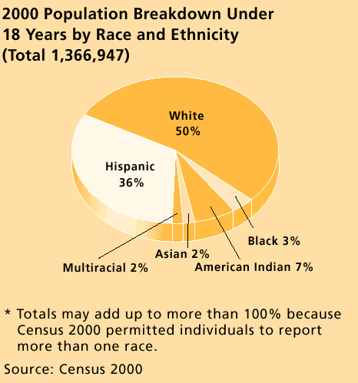

Problem 4: It’s not a path that Ronald Reagan took or most cities would advise.
While many conservatives applaud the notion of smaller government, in fact, during the Reagan Revolution, the federal government grew faster than population growth plus inflation. We simply do not have sufficient historical evidence that imposing such a stern limit would have positive outcomes. Colorado, which passed TABOR in the 1990’s, faced with an economic downturn, has made draconian cuts to higher education and continues to have poor rates of growth (see below).
After all, if this is good policy for the state, shouldn’t it also be good policy for cities? Which city has limited its expenditure growth to population growth plus inflation? Population growth typically requires building infrastructure. Infrastructure may well last for a long time, but the building costs on top of operations will normally outpace population growth plus inflation. Arizona is a growing state. We need the spending flexibility to manage growth effectively.

Problem 5: During economic expansions, the state wouldn’t be able to compensate for a failure to fund needs during recessions.
If you look at state spending you see that it is far more variable than inflation plus population growth. Even though on average the state has only modestly exceeded inflation and population growth in the last decade, recessions see significant drops. Stern spending limits would prevent state government from addressing this imbalance once revenues improve.
During shortfalls many state agencies are asked to take significant cuts. When revenues rise, state governments often need to play catch up. Building maintenance has been delayed. Staff vacancies need to be filled, and needed public services that were temporarily cut need to be restored. While, if funded, the budget stabilization fund would partially act to stabilize state spending, it’s unlikely to eliminate this business cycle effect completely. When revenues fall, the state would find itself challenged to maintain sufficient levels of services and then pre-empted by spending limits from making up for lost ground when revenues recovered.
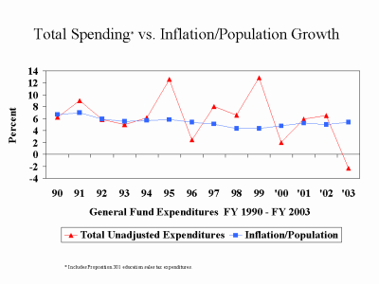
Colorado, which has implemented this restriction with the limit first reached in 1997 has faced annual budget deficits since 2001 leading to significant reductions in public investment. Colorado has sliced higher education funding per resident student by one-third since 2002. The reason is simple; in trying to maintain K-12 and Medicaid, both of which exceed TABOR’s cost limits, the state has been forced to find other places to cut. Colorado’s economy matched the growth of Nevada and Arizona from 1993-2001, but since 2001 Colorado is the only state in the Mountain West to have lost jobs! (Idaho, Montana, Wyoming, Utah, Colorado, Nevada, New Mexico, and Arizona)

Problem 6: Colorado has a Taxpayer’s Bill of Rights (TABOR)—but Arizona is a state with a much higher demand for critical state services.
- Colorado is a much wealthier state with nearly a 20% higher median household income (not due to TABOR).
- Arizona’s taxes and expenditures were only 86% of those in Colorado (1999-2000).
- Arizona has a child poverty rate 50% greater than Colorado.
- Colorado has far fewer children for whom English is a second language.
- Colorado invests far more resources in K-12 education than Arizona.
- Colorado has a much lower student-teacher ratio in K-12 education.
- Colorado ranks far better in overall health ratings.
- But on most measures Colorado is also falling dramatically: child health, high school drops outs, and investment in higher education, especially.

Conclusion: Imposing the added limits of a Taxpayers’ Bill of Rights would imperil the state’s ability to provide the necessary public investment and pubic services to assure strong economic growth in the future.

Endnotes:

Technically the state spending limit is 7.41 percent as the total expenditures used for statutory purposes include ones beyond those of the General Fund. The JLBC estimates in FY2006 actual expenditures will be 6.39 percent. See JLBC, “State Appropriations Limit,” 2-16-05 http://www.azleg.state.az.us/jlbc/applimit2-05.pdf.
For FY 2006 General Fund expenditures of $8.36 billion are used based on the JLBC’s “State Appropriations Limit” from February 16, 2005.
The Government Performance Project: Grading the States ’05: Arizona, Governing Magazine, February 2005, accessible on line at http://governing.com/gpp/2005/az.htm.
Romero, Christine L., “Salaries lag in state: Workers for Arizona bringing home less bacon, fewer raises,” The Arizona Republic, June 1, 2003. Baker, Nena, “Corrections trying to net new hires,” The Arizona Republic, February. 24, 2003.
Kids Count 2004 Data Book ranks Arizona 50 (worst) in Teen Dropouts from High School—based on 2001 data. More data on high school completion rates from National Center for Educational Statistics seems to be consistent with these rankings (though there is some error which makes rankings somewhat imprecise—though Arizona is not close to hardly any states even with the error. http://nces.ed.gov/pubs2002/droppub_2001/14.asp?nav=2.)
Inmate education comes from the Arizona Department of Corrections based on a self-reporting (not verified, so likely to overstate) survey of inmates. Just under half have less than the equivalent of a high school degree and one-third report having a GED, which meaning they likely dropped out of high school as well http://www.azcorrections.gov/reports/Who.htm#POPULATION_SUMMARY.
2000 Census DataARIZONACOLORADOMedian Household Income$40,558 $47,203 % Families earning <$25,00022.2%15.5%% of children under 5 in poverty19.3%12.2%% of children under 18 in poverty15.2%9.2%Education Indicators Per Student Expenditure¹$5,033 $6,165 Student Teacher Ratio20:117:1 Smartest State Ranking²4427Overall Health State Ranking³387State & Local Government Census Data⁴Per Capita Relative to National Average = 1.00 1999-2000Revenue0.781.002000 Census DataARIZONACOLORADO Taxes 0.840.99 Property0.860.97 General sales 1.241.15 Individual income 0.591.12 Corporate income 0.800.61 Expenditure0.860.98 Current operations 0.840.97 Capital outlay 1.091.20 Employee salaries & wages 0.830.99 Education: Higher education 1.011.22 Elementary & secondary Education 0.770.93 Social/Health services & income Maintenance0.670.75 Transportation: Highways 1.061.13 Public safety1.150.99 Governmental administration1.011.02¹In FY2002 after Prop 301 passed funding rose 8% in Arizona.² Smartest State Ranking based on variety of Indicators (www.morganquitno.com/)³ Wide indicator score developed by United Health Group (www.unitedhealthgroup.com/sr2000/)⁴ State & Local combined since states vary in expenditure responsibilities.
“Wisconsin Budget Project: Selected TABOR Impacts: National Rankings,” Dec. 2004, Wisconsin Council on Children and Families, Table 2 http://www.wccf.org/projects/taborresources.htm Colorado’s Changing Rankings in the Decade Since TABOR’s Implementation Measure ColoradoCurrent1993Health Insurance Coverage 36th (02-03) 21st Childhood Immunization 50th (’03) 27th (’94) Timely Prenatal Care 41st (’02) 21st (’90) Low Birthweight Babies 40th (’02) 42nd Infant Mortality 12th (’00-02) 19th Child Death Rate 21st (‘01) 16th Teen Birth Rate 36th (‘02) 30th K-12 spending per pupil 33rd (’01) 28th K-12 spending relative to income 48th (’01) 35th Per Capita St. Higher Ed Appropriations 47th (’04) 31st Percent of teens who are high school dropouts 48th (’01) 31st Idle teens (% neither working nor in school) 32nd (’01) 13th Morgan Quitno rankings: “Most Livable State” 23rd (’04) 8th “Healthiest State” 27th (’04) 9thThe data come from many sources, including the Kids Count Data Books, Census Bureau, CDC, Morgan Quitno, & Kaiser Family Foundation.

