Christina Sullivan
GLG410
Assignment 7

Thinking about graphical excellence

- Graph of Graphical mediocrity:

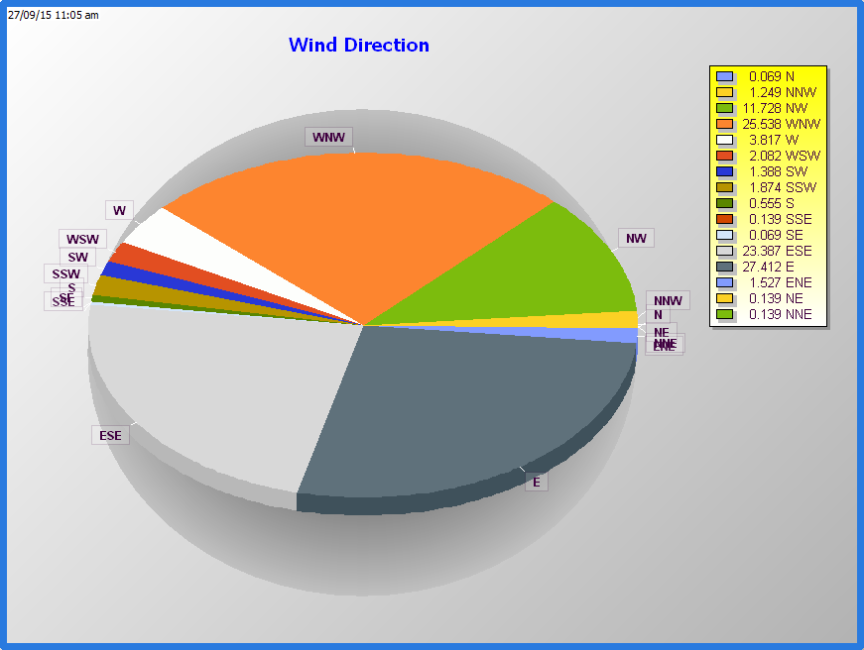

Graph of Excellence:

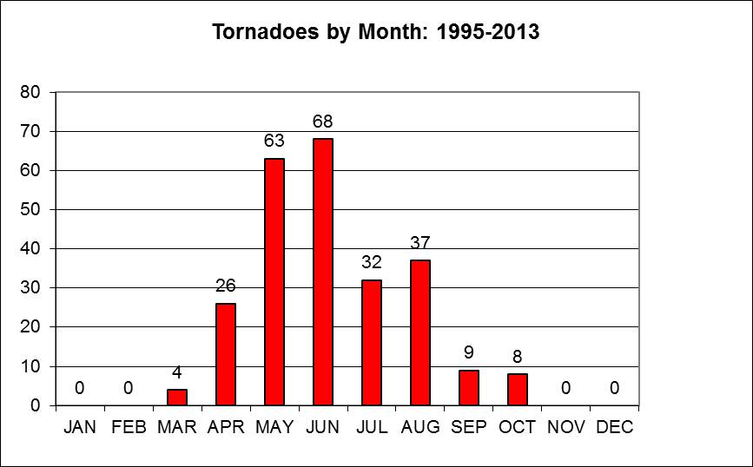

Let’s start with talking about the graph that I picked to be Mediocre. The reason I think so is because it has too many colors going on. It is 3D. There is a lot of business going on in the graph that I even got confused reading it. It is doubled labeled. It has Abbreviations, chart junk and the text is overbearing. The Chart I picked for excellence is simple. It is readable and I understand what is going on in it. The type is upper case and attractive. Easy to read. This type of graph could be drawn by hand.

- Summary of Tufte's The Cognitive Style of Powerpoint:

In Tufte’s writings he explains to us the disappointing evolution of the powerpoint. He discusses the Microsoft vision of creating the powerpoint program in their image. Instead of creating it for analysis data they created it more for marketing. The program has a number of features that creating a more propaganda atmosphere. In the presentation he takes powerpoint and analysis it piece by piece. He mentions the dodgy build sequence where revealing one line at a time is obnoxious.

Going into more detail he brings to light that the powerpoint model is the image of the corporation who created it. He says that it mimic’s Conway’s law which states that it, “…a copy of corporations communication structure.”

With that Tufte’s argument goes into how PP is creating a disturbing learning environment saying that teacher’s instead of making them write a paper they have to do a powerpoint instead. This creates less work and less learning for the students. He further goes into how NASA engineers uses powerpoint. In this example he used the Columbia spacecraft incident. He goes on explaining how many powerpoints, how many bullet points and information given within powerpoints. These presentations showed optimism for the spacecraft safe return home. Even though the engineers wanted to take photos of the Columbia while in orbit, NASA thought there was no need to do so. Bring to the conclusion that the ship orbit the earth with a hole in its wing. In this example he shows the slides that were use and picks them apart. He states that Powerpoint uses abbreviations for things making it unclear to the viewers what the topic is about. It also brings in different bureaucracy into play on the slides. In the report each slide had an outline full of bullet points. He states that in the engineer’s presentation he noticed that it had used Conway’s law to present the information. It had little information and bias opinions on the subject. At the end of that the board responded with saying, “that technical reports are better than power points.”

Tufte than goes into the imagery aspect of power point. He goes on saying that boring presentations are brought on by low content so power point provides images to perk it up. These images tend to dilute the information even more. He then rips at bullets list. Bullet lists are something to show false organization. They tend to be bias without cause.

He also mentions the designs of graphs and data, templates, PowerPoint style and printed out sheets of the power point. This all shows how inefficient power point is when it comes to being analytical. It is a program that creates an atmosphere to where people when creating a presentation have to leave out information. It becomes a flashy tool to try to get the audience’s attention without telling them the full story.

Last he goes into what people could do to present, like using Microsoft word or pass out an agenda. Creating a presentation without the flashy power point program would be more analytical rather than using it. Focusing more on the data than bullet points or photos.

