The School of International Letters & Cultures
Cordially invites you to attend a reception to honor and
Recognize Aleksandra Gruzinska, on the occasion of her
Nomination to the rank of chevalier dans l’ordre des
Palmes Académiques,
At the University Club at Arizona State University
On Tuesday, November 25, 2014
4:00 – 6:00 PM
11/25/2014
Aleksandra Gruzinska, Ph. D.
Induction as Chevalier in
The Ordre des Palmes Académiques
Arizona State University Club [ASU, Tempe, AZ]
https://asunews.asu.edu/20140915-gruzinska-palmes-academiques
This is a very special moment for me. Let me share with you some recent discoveries I have made related to this event.
This past June I attended a truly awesome conference at the University of Warsaw, in Poland and the name of Arthur Szyk entered into my intellectual landscape for the first time. In August, when I returned to ASU, I found some wonderful news from the French Embassy in New York. Antonin Baudry, the French Attaché culturel, let me know that the January Assembly in France made me a Chevalier in the Order of the Palmes Académiques. Although it came as a surprise, I felt deeply honored.
Bill Hendrickson, a past colleague at Arizona State University, now retired, wrote to tell me that I was joining the ranks of two famous scientists, Pierre and Marie Curie. My ego soared at the idea of sharing the honor with these two Nobel giants in science. I decided to check it out. I could not locate any proof that Marie received the Palms. She received, instead, la Légion d’honneur for her pioneering work in radiology on the French battle front of World War I. As for Pierre Curie, his immediate superior, Prof. Schutzenberger, an Alsatian, planned to recommend him for the Palmes Académiques. Pierre Curie asked him not to do so, and that was the end of it. Unless proven otherwise, Pierre never received the Palms, but Prof. Schutzenberger did receive them, thanks to the Curies pioneering hard work. The 1990 film, Les Palmes de M. Schutz tells the story of Schutzenberger’s obsession with obtaining the Palms. In order to get them, he imposed one deadline after another on his two scientists, they succeeded and Schutzenberger received the Palms.
Next I searched for a list of French recipients, but instead found one of foreign recipients and decided to take a peek. Most names meant nothing except for two: – Arthur Szyk, a wonderful artist whose name I heard for the first time at the June Conference in Warsaw and who inspired a tremendous interest among scholars who knew nothing about him, Arthur Szyk, a Polish Jew, an immigrant to the United States, and presidential artist under President Franklin Delano Roosevelt, received Les Palmes Académiques. I read with utmost disbelief his truly awesome biography and the fantastic work he did.
The other recipient of the Palmes Académiques was Raymond Féderman. He is known to specialists of Samuel Becket. Féderman was born in France [this remains to be verified], he immigrated to the USA, enlisted in the army, served in Korea and Vietnam, and used the GI bill to get his BA, MA and also a Ph.D. from Berkley. Upon graduation he accepted a 20th Century French literature position in 1965 at the State University of New York at Buffalo.
I was a graduate student at SUNY in Buffalo, in search of a topic for my MA Thesis. I consulted the chair of the French department and proposed to write on Franco/Polish relations. He told me he had no faculty to guide such a project, but suggested I see Prof. Féderman, he might be able to suggest something. I made an appointment. Prof. Féderman showed no enthusiasm whatsoever for anything Franco/Polish. He sent me to the library to explore E. M. Cioran, a Romanian no one knew or heard about. Start with his Breviary of Decay, Précis de décomposition (1949), he told me. I did and fell in love with the French writings of Cioran. The rest is history. As everything that I do, the defense of “E.M. Cioran, Témoin de la décadence européenne” [Cioran, the witness of European decadence] was excruciating. The committee tore me apart, but approved the thesis as is, with no corrections. Féderman and I went over it with utmost care. He was unforgiving. This was his first faculty apointment, he had no tenure as yet. I was probably his first graduate student. He was not going to take any risks. The thesis had to be nothing short of perfect. After the ordeal was over, he told me in private: You are the person who knows most about Cioran. Go ahead and publish it. It was the finest recommendation that a graduate student could hear from a graduate mentor. I did not follow the advice. I thought Cioran deserved better. He is considered today to be the finest French essayist of the 20th century.
I clicked on Féderman’s name and read his biography. It is as awesome as that of Arthur Szyk. And having read those two biographies loaded with many awards and impressive accomplishments, I wondered if my more modest contributions deserved the title of Chevalier in the Order of the Academic Palms? Szyk’s and Féderman’s biographies are loaded with glory.
Let me mention briefly another ceremony, that of an admired Professor, Charles Beyer, a dix-huitièmiste, an eighteenth century scholar, and author of Nature et Valeur dans la philosophie de Montesquieu. Analyse méthodique de la notion de rapport dans L’Esprit des Lois (1748). I once approached him for a possible doctoral dissertation topic under his guidance. He suggested one on L’Esprit des lois by Montesquieu. I started the project, stumbled much too often, and with an imminent application deadline for a Fulbright, Pierre Aubéry suggested I check out Octave Mirbeau, another French writer, novelist, playwright, critic, a great friend of the Impressionists and Auguste Rodin at a time when they needed a friend, and a very forgotten writer in the 1960s and 1970s. I read his Le Journal d’une femme de chambre, [The Diary of a chambermaid], fell in love with author and book, got the Fulbright and spent a glorious year in Paris [1968-69].
Today, as I recall Prof. Beyer’s induction, I remember how humble he appeared on the stage. I remember his emotion, and how very touched he felt by the honor bestowed on him. It is his feeling of humility, his emotion and his presence that I feel and share at this moment, and it is he who makes this ceremony very special and unique, and so very meaningful to me. I think, that Charles Beyer, were he here today, would be very proud to see one of his students follow in his footsteps as chevalier.
And last, but not least, I would like to thank the French Government, and Maître Gerrit Steenblik, the French honorary consul who in Arizona represents France, and Claude Prosnier with whom I shared many French and France related activities at the French Mass and the French Alliance in Phoenix, and many thanks to my colleagues in French who perhaps had something to do with this nomination, and Prof. Joe Cutter, the director of the School of International Letters and Cultures [SILC] who made this induction possible. And I thank all of you, my colleagues and friends who came to support me and share with me this important moment.
Let me add that the true stars today are ASU, SILC and the French section. French has now four Chevaliers and one Officier, who, perhaps, someday soon may become a Commandeur. That is quite an honor for ASU. I don’t know of any other French department in the USA that is so distinguished, so very blessed. Thank you all for sharing this very special moment with me. I am sure Prof. Deborah Losse shares it in a very special way since she is one of the four Chevaliers and knows what this moment represents in a faculty member’s academic career. Mine has been especially long. Thank you all.
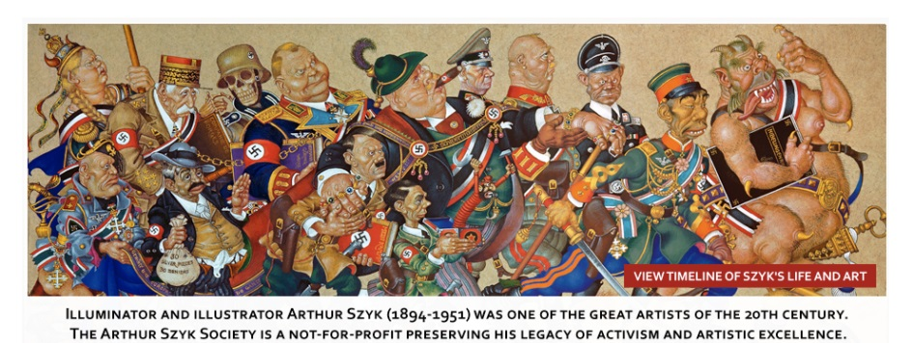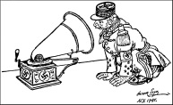
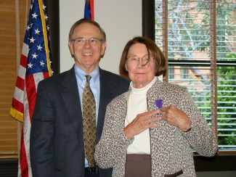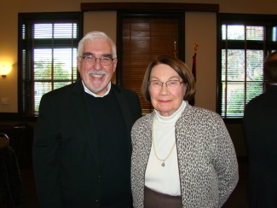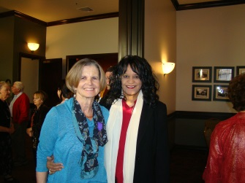
With Gerrit Steenblik With Joe Cutter
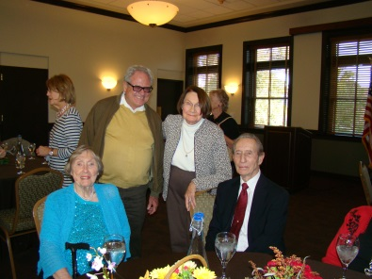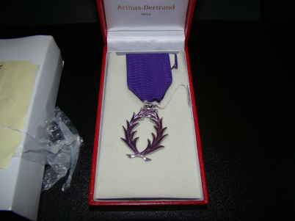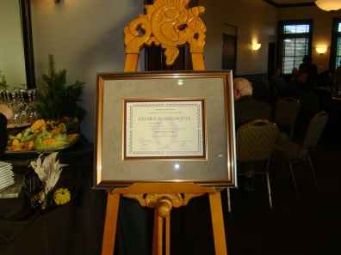

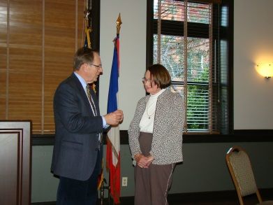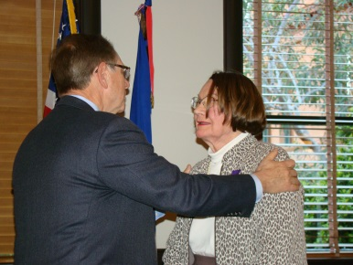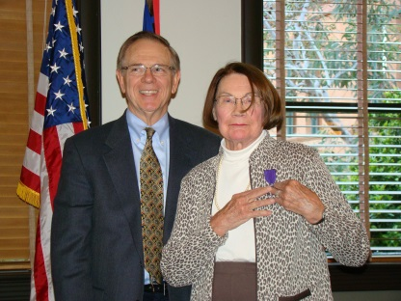

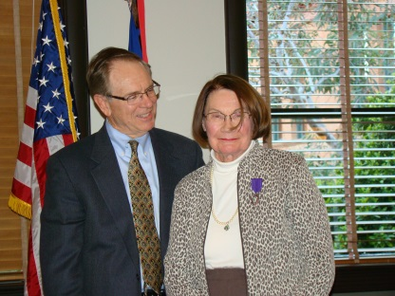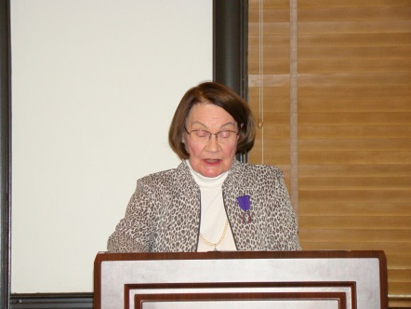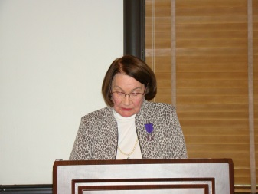

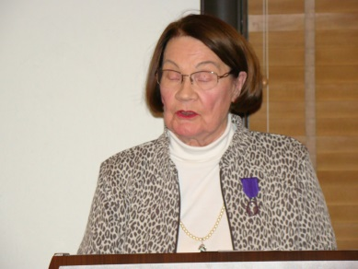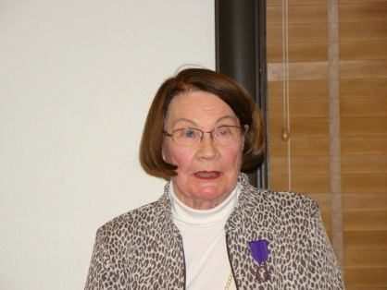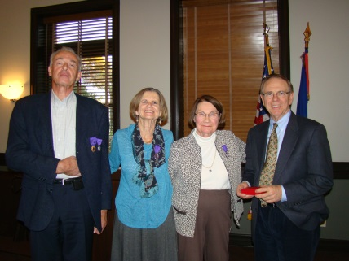
3 Chevaliers dans l’Ordre des Palmes Académiques
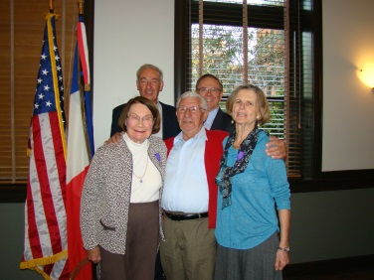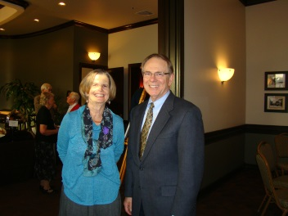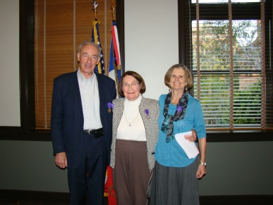
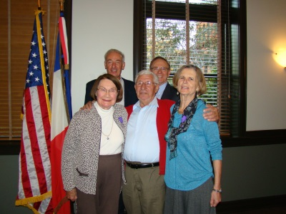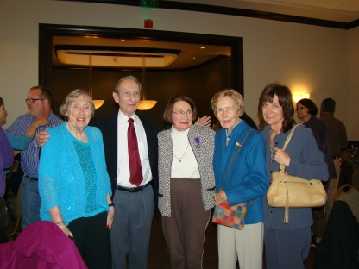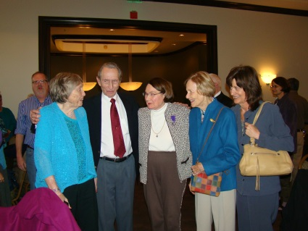

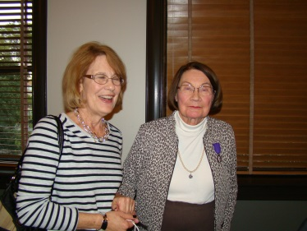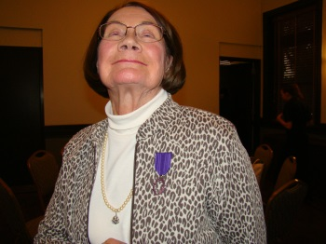
Click here to view Chevalière Aleksandra
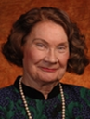
Aleksandra Gruzinska has a B.A. Cum Laude and an M.A. in French from the State University of New York at Buffalo, and a Ph. D. in French from Pennsylvania State University (State College). She has spent a Fulbright year in Paris.
Research interests include 19th Century French Literature, Octave Mirbeau, George Sand, and the 20th century Romanian born philosopher and French essayist E. M. Cioran. She has contributed essays to the Polish Review on Nobel Prize Polish poet Wislawa Szymborska and Polish writer Witold Gombrowicz and essays on unaccompanied Polish children and their trajectory of exile via Germany, Austria, Italy, and Spain from 1939 to 1951, their homelessness, repatriation to Poland or immigration to the USA. She is a member of PHI BETA KAPPA, MLA, PIASA, RMMLA, WIF, Société Octave Mirbeau (Angers, France).
Her main area of interest is in the literature of French 19th Century, and whenever possible in Franco-Polish relations.

Masters Thesis:
« E.M. Cioran, témoin de la décadence européenne » (1966). Raymond Féderman, Director.
Ph.D. Dissertation:
« La Femme et ses paysages d'âme dans l'oeuvre romanesque d'Octave Mirbeau » “Women and Their Mental Landscapes in the Novels of Octave Mirbeau,” (Ph.D., 1973). Lois Boe Hyslop, Director.
Current Position : Assistant Professor of French. School of International Letters and Cultures (SILC). Arizona State University (Tempe).

mailto: gruzinska@asu.edu
http://www.public.asu.edu/~gzl747/#PGID3
http://www.public.asu.edu/~gzl747/#PGID3
http://www.public.asu.edu/~gzl747/#
http://www.asu.edu/clas/silc/RMESC/connections.html
http://www.asu.edu/clas/silc/wif

Note: At the Polish Institute of Arts and Sciences in America [PIASA] conference in Warsaw Poland, in a session on “History through biography,’ Irvin Ungar spoke on a subject no one was familiar with, an artist by the name of Arthur Szyk. The speaker was well informed, unusually eloquent, very lively and dynamic.

