Okun
PSY 230

Study Guide #11

t Tests for Hypotheses about Two Population Means

I. Distinguishing Between Independent and Related Samples

1. What are two limitations of the 1-sample t test?

2. What does it mean for two samples to be independent?

Independent samples. We have independent samples when we (a) use a separate sample for each condition or group; (b) each person is in only one condition or group; and (c) the selection of any one participant into one of the two samples has no implications for the selection of other participants into the first or second sample.

3. How can two independent samples be created?
_____________________________________________________________________________
Study Participant Study ID # Group Assignment via Table of Random Numbers
_____________________________________________________________________________
Andy 1 Lecture
Brandy 2 Acupuncture
Candy 3 Lecture
Dan 4 Acupuncture
Earl 5 Acupuncture
Fred 6 Acupuncture
Georgia 7 Acupuncture
Helen 8 Lecture
Irma 9 Acupuncture
Jessica 10 Lecture
Kari 11 Lecture
Laura 12 Lecture
Mary 13 Lecture
Nikki 14 Acupuncture
Olivia 15 Acupuncture
Peter 16 Lecture
_____________________________________________________________________________

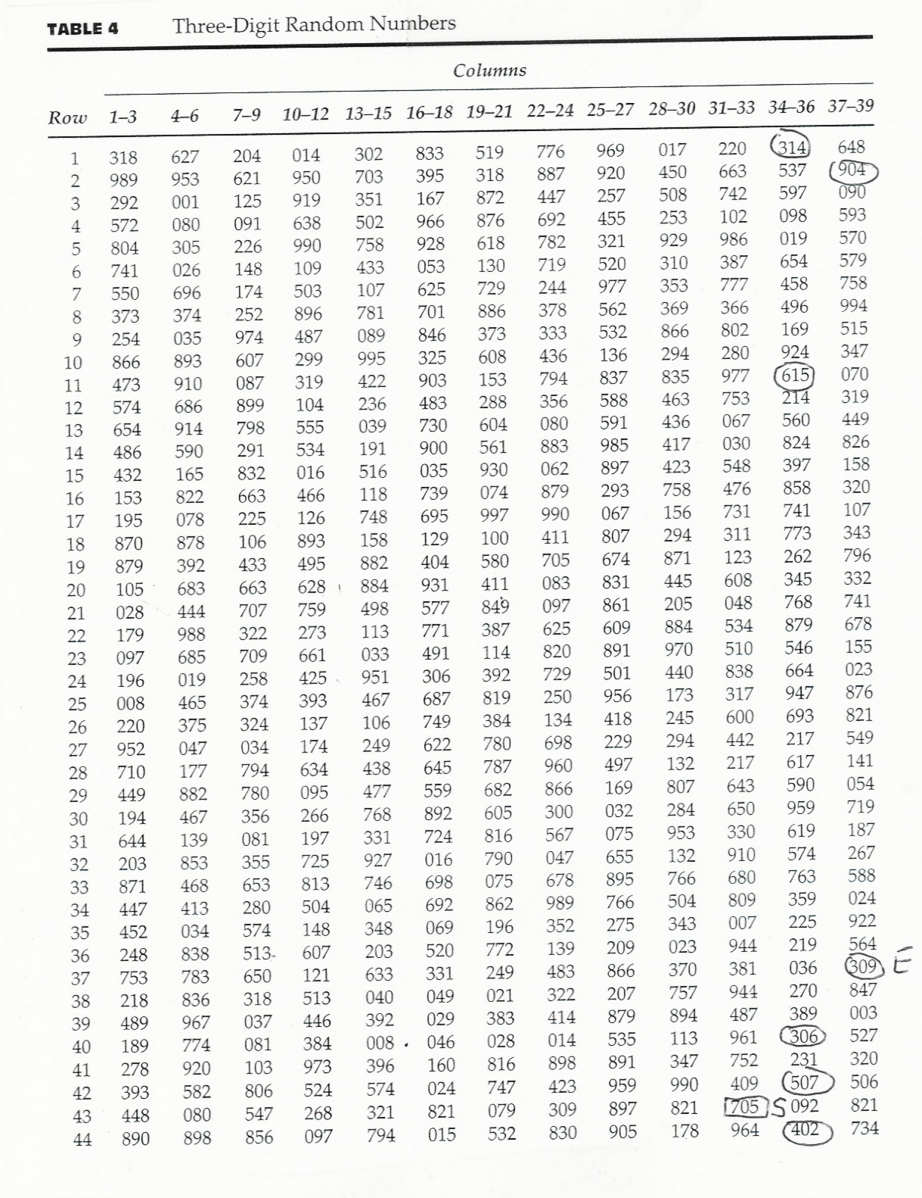
Cigarettes Smoked from Acupuncture versus Lecture Independent Samples Design

_____________________________________________________________________________
Study Participant Study ID # # of cigarettes smoked during the past week
______________________________________________________________________________

Brandy 2 119
Dan 4 63
Earl 5 70
Fred 6 15 ACUPUNCTURE
Georgia 7 154
Irma 9 21
Nikki 14 98
Olivia 15 84
_____________________________________________________________________________

Andy 1 161
Candy 3 140
Helen 8 168
Jessica 10 119 LECTURE
Kari 11 210
Laura 12 126
Mary 13 74
Peter 16 154
______________________________________________________________________________

4. What is the difference between an independent variable and a dependent variable?

The variable that is manipulated by the researcher is known as the independent variable. The variable that is measured after exposure to one of the conditions that comprise the independent variable is called the dependent variable.

5. What is the distinction between a control group and an experimental group?

Often, we can identify one group as receiving the treatment of interest. The group that receives the treatment of interest is called the experimental group. The group that is used for comparison purposes is called the control group. Typically, a control group either receives no treatment or a placebo or the current standard treatment.
Treadmill Time In Minutes to Run a Marathon from Blood Doping versus No Blood Doping: Independent Samples Design

Name Not Blood Doped Name Blood Doped

Quentin 224 Rachel 225
Steven 227 Todd 224
Ursula 228 Venus 228
Warren 227 Xavier 226
Yvette 229 Zack 227

M_{x} = 227 M_{x} = 226
S_{x} = 1.87 S_{x} = 1.58

6. How are related samples created?

There are two ways to create related samples.

First, we can test each participant prior to and after exposure to the treatment. This approach is known as repeated measures because we repeat the administration of our measure of the dependent variable before and after each participant is exposed to the treatment.

Repeated Measures Study of Acupuncture: A Related Samples Design
_____________________________________________________________________________
Study Participant Study ID # Posttest Pretest Difference Score (Post-Pre)
_____________________________________________________________________________

Brandy 2 119 161 -42
Dan 4 63 140 -77
Earl 5 70 168 -98
Fred 6 15 119 -104
Georgia 7 154 210 -56
Irma 9 21 126 -105
Nikki 14 98 74 +24
Olivia 15 84 154 -70
_____________________________________________________________________________

A second type of related samples design involves matching pairs of participants. With a matched samples design, samples are created by pairing up participants and then by assigning one member of each pair to one group and the other member of each pair to the other group.

Matching Study of Blood Doping: A Related-Samples Design

Rankings based upon best time to complete the Boston Marathon

Name Rank

Todd 1
Quentin 2

Rachel 3
Steven 4

Warren 5
Xavier 6

Ursula 7
Zack 8

Venus 9
Yvette 10

Not Blood Doped Blood Doped Difference Score

Name Rank Time Name Rank Time Not Doped-Doped

Quentin 2 224 Todd 1 224 0
Steven 4 227 Rachel 3 225 +2
Warren 5 227 Xavier 6 226 +1
Ursula 7 228 Zack 8 227 +1
Yvette 10 229 Venus 9 228 +1

M_{D} = +1 S_{D} = 0.71 n_{pairs} = 5

II. t Tests for the Hypothesis about Two Population Means: Related Samples

7. How can we test the null hypothesis that the difference between two population means from related samples equals zero from raw data?

With related samples, we have paired observations in the two samples. Therefore we can compute a difference score for each of the paired observations. The related sample t test is carried out on the difference scores, symbolized by the letter D.

t = M_{D} / S_ where
^{D}
___
S_ = S_{D} / √ n_{p}
^{D}

Repeated Measures Design for Acupuncture Study
_____________________________________________________________________________
Study Posttest Pretest Difference Score D_{i}-M_{D} (D_{i}-M_{D})²
Participant (Post-Pre)
_____________________________________________________________________________
Brandy 119 161 -42 +24 576
Dan 63 140 -77 -11 121
Earl 70 168 -98 -32 1024
Fred 15 119 -104 -38 1444
Georgia 154 210 -56 +10 100
Irma 21 126 -105 -39 1521
Nikki 98 74 +24 +90 8100
Olivia 84 154 -70 -4 16
 |  | ∑D = -528 |  | ∑ (D_{i}-M_{D})² = 12902

When working with raw data, we must first compute M_{D} and S_{D.}

M_{D} = ∑D_{i} / n_{p} = -528/8 = -66
_______________ _______ _________
S_{D} = √∑( D_{i}- M_{D})² / n_{p}-1 = √12902/7 = √1843.1428 = 42.93
___
Next we must compute S_ = S_{D} / √ n_{p}
^{D}
___
S_ = 42.93/ √ 8 = 42.93/2.83 = 15.17
^{D}

t = -66/15.17 = -4.35

df = n_{p} – 1 where n_{p} = number of pairs of observations.

If we set α = .01 and df = 8-1 or 7, the CV of t = plus or minus 3.449.

Decision: Reject the null hypothesis. The number of cigarettes smoked after the acupuncture treatment is significantly (p < .01) less than the number of cigarettes smoked before the acupuncture treatment.

8. How can we test the null hypothesis that the difference between two population means from related samples equals zero from summary data?

Treadmill Time in Minutes from Blood Doping Matched-Participants Design

Not Blood Doped Blood Doped Difference Score

Name Rank Time Name Rank Time Not Doped-Doped

Quentin 2 224 Todd 1 224 0
Steven 4 227 Rachel 3 225 +2
Warren 5 227 Xavier 6 226 +1
Ursula 7 228 Zack 8 227 +1
Yvette 10 229 Venus 9 228 +1

When working with summary data, we will be given D, S_{D}, and n_{pairs}.

M_{D} = +1 S_{D} = 0.71 n_{pairs} = 5

First, df = 5-1 or 4. If alpha = .01, with 4 degrees of freedom, CV = /4.604/.

Second, we must compute S_
^{D}
___
S_ = = 0.71/ √ 5 = 0.71/2.24 = 0.32
^{D}

Third, we compute t.

t = +1/0.32 = +3.125.

Decision: Retain the null hypothesis. Blood doping does not appear to significantly (p > .01) lower the time to run a marathon.
III. Transition to Independent Samples t test

9. How is the structure of the related samples t-test similar to the structure of the 1- sample t-test?

1-Sample t test:

t = M_{X}-H_{O}: μ_{X} / S_ where
^{X}
__
S_ = S_{x} / √ n
^{X}

Related Samples t test

t = M_{D}-H_{O}: μ_{D} / S_ = M_{D} / S_ where
^{D D}
___
S_ = S_{D} / √ n_{p}
^{D}

S_
^{X} tells us how much, on average, we should expect a sample mean to deviate from the hypothesized value of the population mean due to sampling fluctuation.

S_
^{D} tells us how much, on average, we should expect a sample mean computed from difference scores to deviate from zero due to sampling fluctuation.

10. Why is the standard error more complex in the case of the independent samples t-test?

When we consider the case of the t-test for independent samples, we have two sources of sampling error--the sampling error for the sample mean drawn from the first population and the sampling error for the sample mean drawn from the second population.

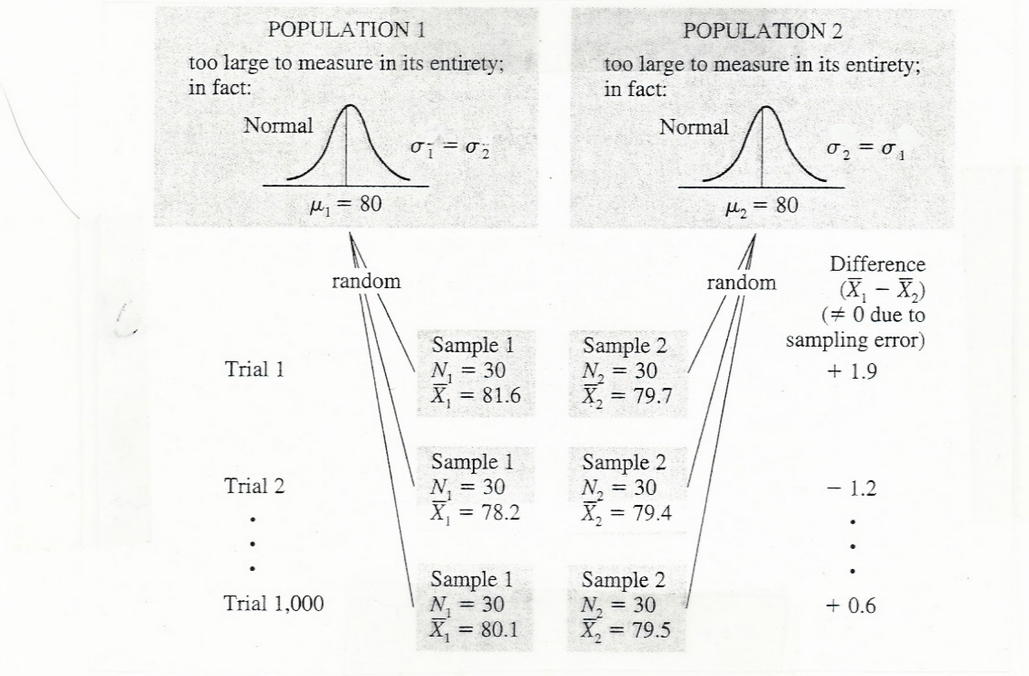

S_ _
^{X1-X2} tells us how much, on average, we should expect two independent sample means to deviate from each other due to sampling fluctuation.
IV. Computing the Independent Samples t-test

- What does the sample variance (S_{x}²) equal?

∑ (X_{i}-M_{x})² SS
S_{x}² = _________ = _____
n-1 n-1

12. How can we derive a formula for S_ _ ?
^{X1-X2}

If n₁ = n₂:

______________ ___________

S_ _ = √ S₁² / n₁ + S₂² / n₂ = √ S₁² + S₂² / n_{g}
^{X1-X2}

where n_{g} = number of participants in each group.

If n₁ does not = n₂,

you must first compute the pooled variance (S²_{pooled}).

(N₁-1)S₁² + (N₂-1)S₂²
S²_{pooled} = ____________________
N₁ + N₂ -2

_____________________

S_ _ = √ S²_{pooled} / n₁ + S²_{pooled} / n₂
^{X1-X2}

13. How can we test the null hypothesis that the difference between two population means from independent samples equals zero from raw data?

M_{x1} - M _{x2}
t = _________

S_ _
^{X1-X2}

Cigarettes Smoked from Acupuncture versus Lecture Independent Samples Design
_____________________________________________________________________________
Acupuncture # of cigarettes smoked X_{i}-M_{x} (X_{i}- M_{x})² S_{x}² = SS/n-1

Alice 119 41 1681
Bill 63 -15 225
Dave 70 -8 64
Hal 15 -63 3969
Ivanna 154 76 5776
June 21 -57 3249
Nikki 98 20 400
Paula 84 6 36
______________________________________________________________________________

M_{x} = 624/8 = 78 SS = 15400 S_{x}² = 15400/7 = 2200
______________________________________________________________________________
Lecture # of cigarettes smoked X_{i}- M_{x} (X_{i}- M_{x})² S_{x}² = SS/n-1

Carl 161 17 289
Erin 140 -4 16
Felicia 168 24 576
Gina 119 -25 625
Kari 210 66 4356
Laura 126 -18 324
Mary 74 -70 4900
Oliver 154 10 100
______________________________________________________________________________
M_{x} = 1152/8 = 144 SS = 11186 S_{x}² = 11186/7 = 1598
______________________________________________________________________________

______________ ________
(1) Compute S_ _ = √ 2200 + 1598 / 8 = √ 3798 / 8 = 21.79
^{X1-X2}

(2) Compute M_{x1} – M_{x2} = 78 – 144 = -66

(3) Compute the t test statistic

t = -66/21.79 = -3.02

degrees of freedom = n₁ + n₂ – 2 If α = .05 and df = 14, CV = plus or minus 2.145.

14. How can we test the null hypothesis that the difference between two population means from independent samples equals zero from summary data?

Treadmill Time (min.) from Blood Doping versus No Blood Doping Independent Sample Design

Name Not Blood Doped Name Blood Doped

Quentin 224 Rachel 225
Steven 227 Todd 224
Ursula 228 Venus 228
Warren 227 Xavier 226
Yvette 229 Zack 227

M_{x} = 227 M_{x} = 226
S_{x} = 1.87 S_{x} = 1.58

______________ ___________ ___ ____
(1) Compute S_ _ = √ 1.87² + 1.58² / 5 = √ 2.5 + 3.5 / 5 = √ 6/5 = √ 1.2 = 1.10
^{X1-X2}
(2) Compute M_{x1} – M_{x2} = 227 – 226 = 1

(3) Compute the t test statistic

t = 1/1.10 = 0.91

degrees of freedom = n₁ + n₂ – 2 If α = .05 and df = 84, CV = plus or minus 2.306.

15. When is it appropriate to use each of the three t tests used to test null hypotheses about population means?

Summary of three types of t tests

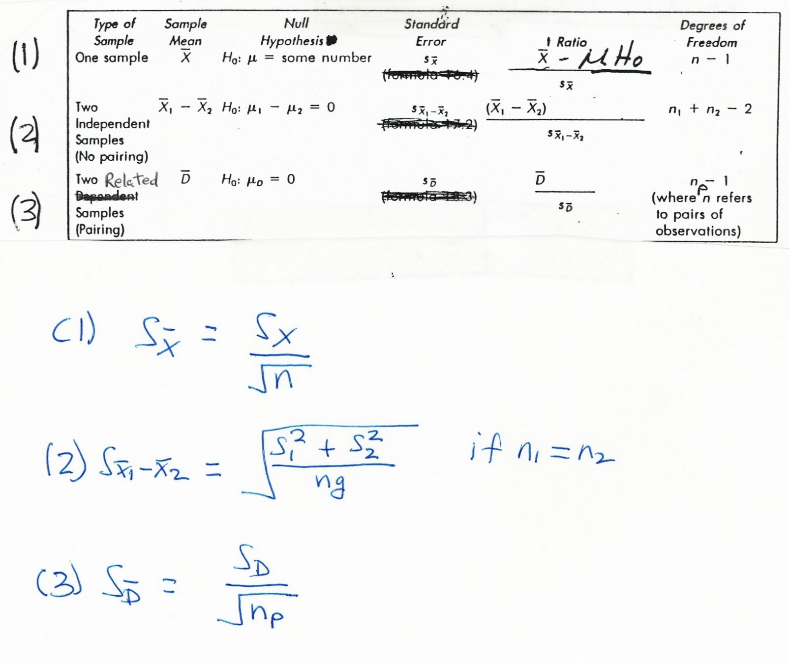

- What are the advantages and disadvantages of the repeated measures related-sample design, the matched samples related samples design, and the independent samples design?

17. How is the value of the independent samples t test affected by the (a) the difference in the sample means; (b) standard deviations; and (c) sample sizes (n)?

18. How can the strength of the effect of the independent variable on the dependent variable be computed in the case of the independent samples t test?

When we reject the null hypothesis that two independent population means are equal, it is useful to report an index of how strong the effect of the independent variable is on the dependent variable.

The index that we will use is the square of the point-biserial correlation coefficient.

r²_{point biserial} = t² / [t² + df]

For the cigarette smoking studying, t = -3.02 and df = 14

r²_{point biserial} = -3.02² / [-3.02² + 14] = 9.1204/[9.1204 + 14] = 9.1204/23.04 = .39.



