Okun
PSY 230

STUDY GUIDE #6

Hypothesis Testing

1. What is hypothesis testing?

Hypothesis testing is an inferential procedure that uses sample data to evaluate the credibility of a hypothesis about a population parameter. In very general terms, the logic underlying hypothesis testing is as follows:

1) We state a hypothesis about a population parameter. For example, before the Democratic presidential primary, we might hypothesize that the population proportion of registered Democrat voters who intend to vote for Biden versus Dodd is .50.

2) Next, we obtain a random sample from a population. For example, suppose a polling firm draws a random sample of 300 registered Democrat voters.

3) Finally, we compare the sample proportion calculated from the data we collected with the hypothesized value of ∏, i.e., .50. Unless the sample p_{BIDEN} is very unlikely given our hypothesized value of ∏, we would retain our hypothesis.

I. Specific Steps in Hypotheis testing

1-State the hypotheses.
2-Specify a probability value for making a decision about the null hypothesis
3-Select an appropriate test statistic
4-Determine the critical value of Z
5-Determine information available and collect data
6-Compute the value of the test statistic
7-Draw a conclusion regarding the hypotheses

2 . What is the null hypothesis? What is the counterpart to the null hypothesis called? Which hypothesis do we start out assuming to be true?

The null hypothesis is a statement at the outset of the study indicating a single numerical value about a parameter that is assumed to be true in the population from which the sample will be drawn.

The alternative hypothesis is the hypothesis that will be retained if the null hypothesis is rejected.

3. What is alpha (α)?
Before a study starts, a researcher must define the criterion probability (or p value) for rejecting the null hypothesis. This p value is called alpha (α). As we shall see, researchers typically set α at .05 although sometimes .01 is used. Let’s assume we set α at .05. Then, we shall reject the null hypothesis when the p value associated with the difference between the sample statistic and the hypothesized value of the population parameter equals or is less than .05.

4. How is a z score different from a Z test statistic?

For an individual, a z score = X - µ_{x}
σ_{x}

X_{i} = the raw score of an individual.

µ_{x} = the population mean.

σ_{x} = population standard deviation

A z score is the difference between an individual score and the population mean expressed in standard deviation units.

For a test of a null hypothesis about a population proportion,

Z test statistic = p -_∏
σ_{p}
p = the sample proportion.

H_{o} of ∏ = the hypothesized value of the population proportion.
___________
σ_{p} = standard error of the proportion = √(∏) (1-∏) / n

n = the size of the sample.

A Z test statistic is the difference between a sample proportion and the hypothesized value of the population proportion expressed in standard error of the proportion units.
5. What are critical values? What are the regions of retention and rejection?

Whenever we use a Z test statistic, the critical values are the values of Z that will lead us to reject the null hypothesis. The critical values of Z can be obtained from the standard normal curve table.

Note that for alpha = .05, .025 is the proportion of the area under the normal curve that is in each tail (.025 + .025 = .05). Note that with the Z test statistic, the critical value for the left tail is
-1.96 and the critical value for the right tail is +1.96.

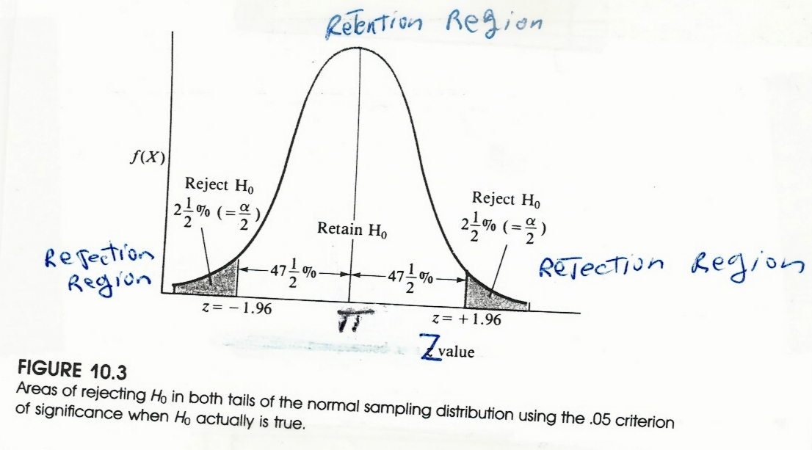
For alpha equal .01, .005 is the proportion of the area under the normal curve that is in each tail (.005 + .005 = .01). Note that with the Z test statistic the critical value for the left tail is -2.58 and the critical value for the right tail is +2.58.

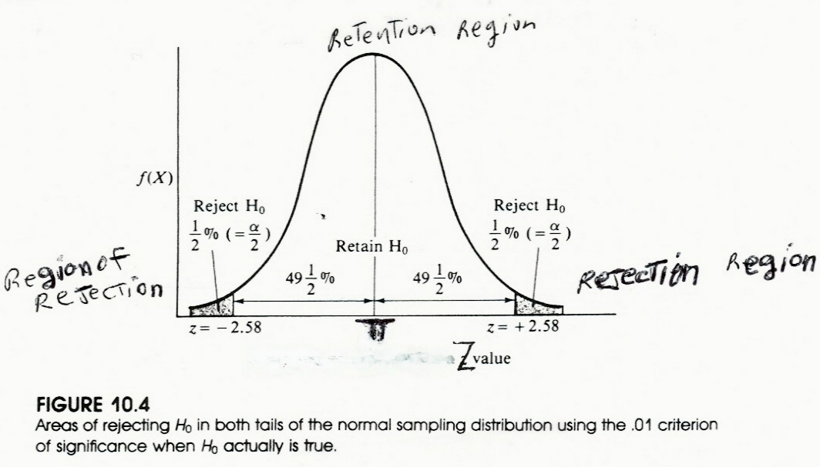

The null hypothesis should be rejected whenever the Z test statistic equals or is greater than the positive critical value or equals or is less than the negative critical value. These two regions are called the regions of rejection. The null hypothesis should be retained whenever the Z test statistic is a value that falls between the critical values. This region is called the region of retention.

For alpha = .05, we will reject H₀, whenever our Z value is either equal to or less than -1.96 OR equal to or greater than +1.96. We will retain H_{o} whenever our Z value falls between
-1.96 and +1.96.

For alpha = .01, we will reject H₀, whenever our Z value is either equal to or less than -2.58 OR equal to or greater than +2.58. We will retain H_{o} whenever our Z value falls between
-2.58 and +2.58.

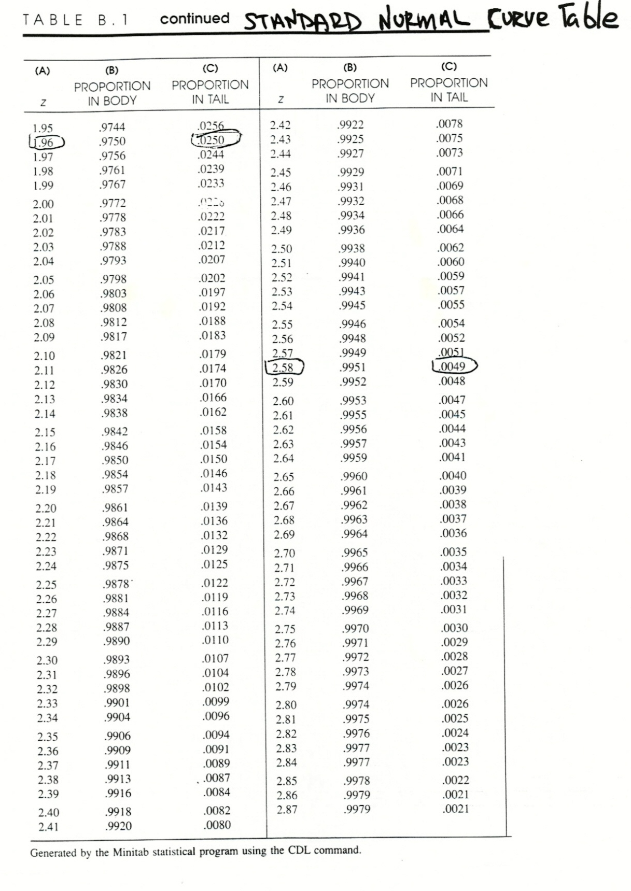
6 . How can the Z test statistic be computed?

Z = p - H_{o} of ∏
σ_{p}
p = the observed value of the sample proportion.

H_{o} of ∏ = the hypothesized value of the population proportion.
__________
σ_{p} = standard error of the proportion = √(∏) (1-∏)/n

7. How do we draw a conclusion regarding whether to retain or reject the null hypothesis?

8. How is the retention versus the rejection of the null hypothesis linked to claiming statistical significance?

When we retain the null hypothesis, we claim that the difference between the sample proportion and the hypothesized value of the population proportion is nonsignificant, that is, the difference represents a chance difference. Retention of the null hypothesis is often accompaned by a statement such as, “the difference in intention to vote for Biden versus Dodd in the Democrat presidential primary is not significant (p > .05).”

Rejection of the null hypothesis allows us to claim that the difference between the sample proportion and the hypothesized value of the population proportion is significant, that is, the difference represents a real difference. Rejection of the null hypothesis is often accompanied by a statement such as, “the academic advising program has a significant (p < .01), positive effect on the retention rate among college students.”

II. The Outcomes of Hypothesis Testing

9. What are the 4 possible outcomes of hypothesis testing before a study is conducted?

A correct acceptance occurs when we retain a true null hypothesis. Accepting a true null hypothesis represents a type of "hit." For example, if the null hypothesis is true and we conclude that the difference between the hypothesized population mean and the sample mean is due to chance, then we have made a correct acceptance of the null. The probability of a correct acceptance equals 1 - α
A Type II error occurs when we retain a false null hypothesis. A type II error can be thought of as a "false negative." For example, if the null hypothesis is false and we conclude that the difference between the hypothesized population mean and the sample mean is due to chance, then we have made a false negative error. The probability of a Type II error equals BETA (β).

A Type I error occurs when we reject a true null hypothesis. A type I error can be thought of as a "false positive." For example, if the null hypothesis is true and we conclude that the difference between the hypothesized population mean and the sample mean is significant, then we have made a false positive error. The probability of a Type I error equals α.

A correct rejection occurs when we reject a false null hypothesis. Rejecting a false null hypothesis represents a second type of "hit." For example, if the null hypothesis is false and we conclude that the difference between the hypothesized population mean and the sample mean is significant, then we have made a correct rejection of the null. The probability of correctly rejecting a false null hypothesis is referred to as POWER. POWER = 1 - β.

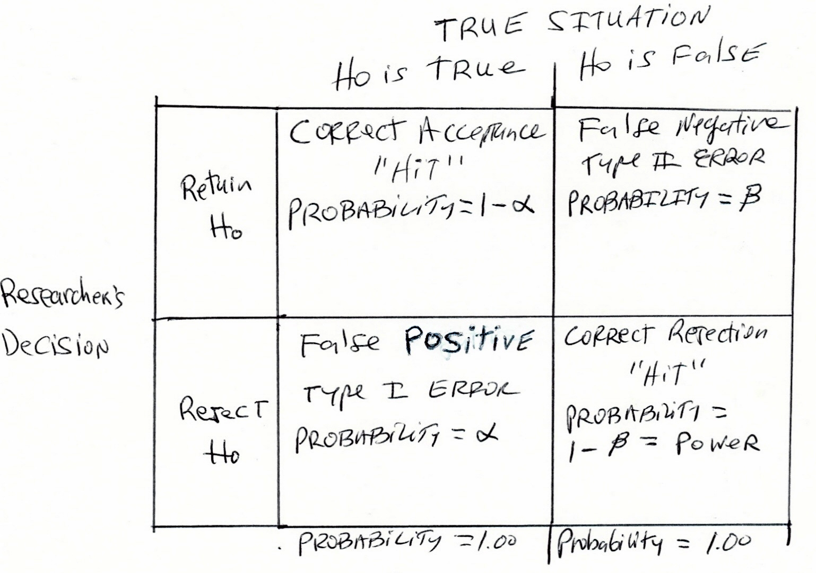
10 . When a researcher decides to retain H_{o}, what type of error may she be making? How does this type of error occur?

Suppose we go back to our example of a deck of cards:

Population Size (N) = 52
Population proportion red = ∏ = .50

Deck of Playing Cards

Spades Hearts Clubs Diamonds

Ace Ace Ace Ace
King King King King
Queen Queen Queen Queen
Jack Jack Jack Jack
10 10 10 10
9 9 9 9
8 8 8 8
7 7 7 7
6 6 6 6
5 5 5 5
4 4 4 4
3 3 3 3
2 2 2 2

Now, suppose an unfair dealer alters the deck as follows:

Population Size (N) = 52
Population proportion red = ∏ = .75

Deck of Playing Cards

Spades Hearts Diamonds Diamonds

Ace Ace Ace Ace
King King King King
Queen Queen Queen Queen
Jack Jack Jack Jack
10 10 10 10
9 9 9 9
8 8 8 8
7 7 7 7
6 6 6 6
5 5 5 5
4 4 4 4
3 3 3 3
2 2 2 2

Suppose in a hand of 11 cards, you receive the following cards:

KH 9D 6D 4D 8H QD JS 7D 3S 10S 10D

11. When a researcher decides to reject H_{o}, what type of error may have been made? How does this type of error occur?

Suppose the dealer uses a fair deck of cards and in a sample of 26 cards, the following cards are drawn:

QH JD
7D AS
10H 2D
5C 2H
9H 6D
AD 8H
KS AH
4D KH
3H 4C
KD 10C
6H 9D
8C 3S
QD 7H

12. Which of the four outcomes equals α? As α decreases what happens to the probability of the four possible outcomes? How is α related to the probability of (a) rejecting H₀; and (b) retaining H_{o}?

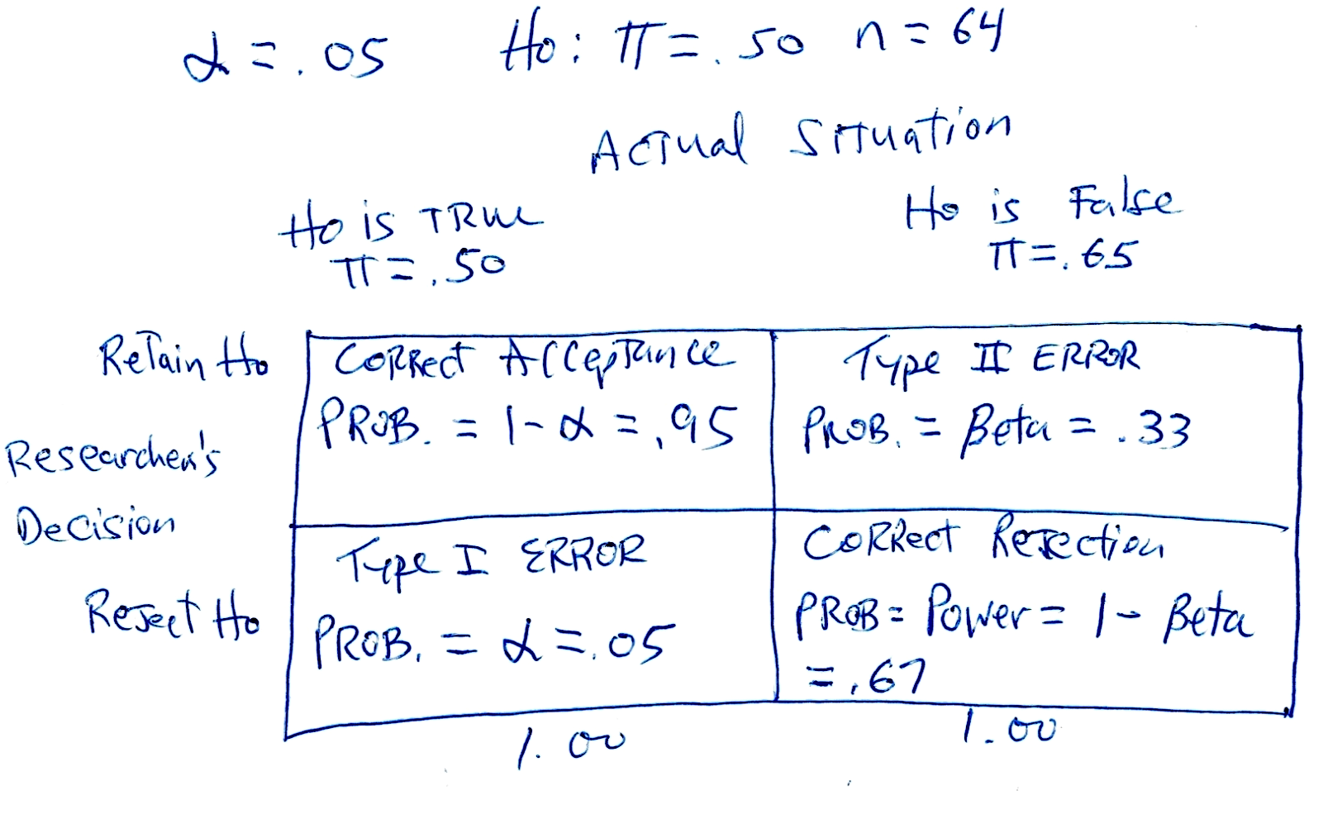
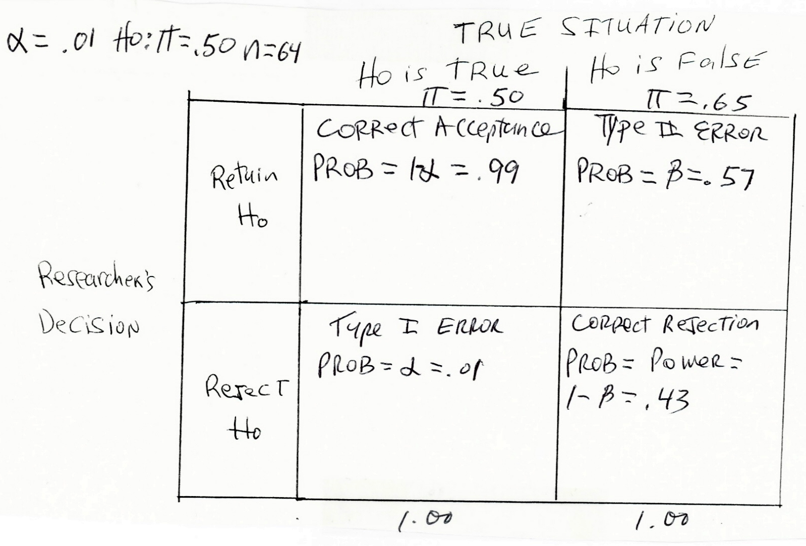

13. Is a Type I error or a Type II error considered to be more serious?

Scenario that we generally strive for:

P (Correct Acceptance) = 1- α = .95
P (Type I Error) = α = .05
P (Correct Rejection) = power = 1-β = .80
P (Type II Error) = β = .20
Summary of Statistical Errors

TYPE I ERROR

Definition: The researcher concludes that the treatment has an effect when, in fact, there is no treatment effect.

How does it happen?: By chance, the sample consists of individuals predisposed to change prior to exposure to the treatment. Consequently, the sample proportion looks different from what would be expected by chance if the hypothesized value of the population proportion was true.

Negative Consequences: Because the researcher claims a treatment effect, the program may be adopted and many other studies with similar treatments may be performed.

TYPE II ERROR

Definition: The researcher concludes that the treatment has no effect when, in fact, there is a treatment effect.

How does it happen?: One way that it could happen is by having a small sample and a small treatment effect. With a small sample, the standard error of the proportion is large and the small effect of the treatment appears to represent a chance difference from the hypothesized value of the population proportion.

Negative Consequences: Because the researcher claims no treatment effect, the program may not be adopted and other studies with similar treatments may not be performed.
14. What pieces of information do we need to compute power?
- The hypothesized value of ∏₀. We will always assume that ∏₀ equals .50.
- The actual value of ∏ in the population, designated ∏_{A}.
In other words, we need to estimate the magnitude of the difference between the hypothesized value of ∏ and the actual value of ∏. If we believe that the treatment has a small effect, we will estimate ∏_{A} to be .55, if we believe that the treatment has a medium effect, we will estimate ∏_{A} to be .65, and if we believe that the treatement has a large effect, we will estimate ∏_{A} to be .75.

- The sample size (n).

(4) α

15. How can power be computed?

Let’s set ∏_{O} = .50, ∏_{A} = .65, n = 64, and α =t .05. This is the scenario we described on the bottom of p. 10 of the Handout.
To determine power, we need to do two computations.
First, we must compute gamma (γ), the population effect size.
When ∏₀ = .50, γ = 2(∏_{A} - .50).
In our situation,γ = 2(.65-.50)= 2(.15) = .30.
Second, we must compute delta (δ). Delta combines the population effect size (gamma) and sample size (n) into a single index.

___
δ = (γ) √ n
____
In our situation, δ = (.30) √ 64 = (.3) (8) = 2.4.
Table H from the Text (Power Determination for 1 population proportion)
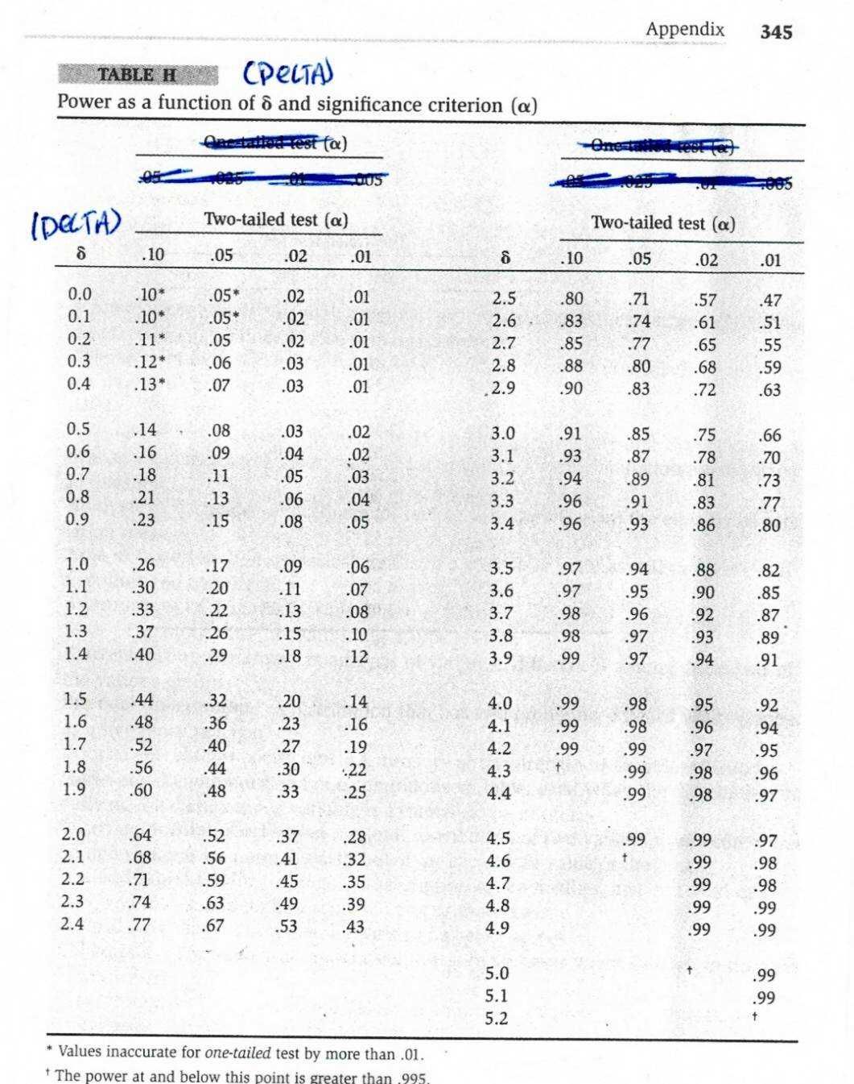
16. What factors affect power and what is the direction of influence?

Assuming ∏₀ = .50, there are 3 factors that affect power:(1)α, (2)n, and (∏_{A}). Power increases as α, n, and ∏_{A} increase.

17. How can the sample size be determined so that power = .8?
alpha = .05 and ∏_{A} = .65.
- Determine delta from table I. To find delta, we use the desired power of .80 and a .05 value of alpha. As can be seen in Table I, delta equals 2.8.
- Compute gamma, the population effect size. Gamma = 2(∏_{A}-∏₀) = 2(.65-.50) = 2(.15) = .3 Now that we have determined gamma, we can solve for our sample size, n, using the formula: n = (Delta/Gamma)²

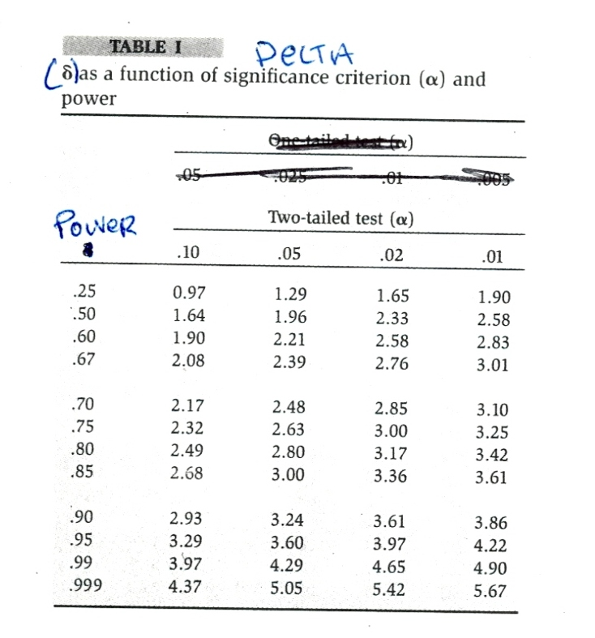
18. What is a confidence interval?

A confidence interval is a range of plausible values for the population parameter.

Once a 95% C.I. is established, we are able to conclude that we are 95% certain that the population parameter falls somewhere between its lower and upper bound.

Once a 99% C.I. is established, we are able to conclude that we are 99% certain that the population parameter falls somewhere between its lower and upper bound.

19. What do we need to compute to determine the lower and upper limits of the confidence interval?

To find the lower and upper limits of the confidence interval, we need to know (1) the sample p; and (2) the margin of error.

p is computed from the sample we have drawn.

The margin of error for a proportion =
the Critical Value of Z for the specified level of confidence x σ_{p}.

If we want to be 95% confident, the critical value of Z always equals 1.96.

If we want to be 99% confident, the critical value of Z always equals 2.58.
__________
For a confidence interval σ_{p} = √(p) (1-p)/n

20. How can a confidence interval be constructed around a sample proportion? How can we interpret the meaning of a confidence interval around a sample proportion?

Suppose we go back to our example, where we draw a sample of 300 registered Democrat voters and 165 intend to vote for Biden. We wish to construct a 95% confidence interval.

Because we want a 95% confidence interval, the Critical Value of Z = 1.96.

The sample p_{BIDEN} = 165/300 = .55.
____________
σ_{p} = √(.55 (.45)/300 = .0287

The margin of error = 1.96 x .0287 = .0563.

We place the sample p at the center of our confidence interval. To determine the lower limit (LL) of the confidence interval, we subtract the margin of error from p. To determine the upper limit (UL) of our confidence interval, we add the margin of error to p.
LL = p - margin of error
UL = p + margin of error
LL = .55-.0563 = .4937
UL = .55+.0563 = .6063

Our 95% confidence interval ranges from .4937 to .6063.

We are saying that we are 95% confident that the population of Democrat voters who intend to vote for Biden ranges from .4937 to .6063.

Because this confidence interval captures .50, it is plausible that at least half of the voters intend to vote for Dodd. Therefore, Biden should not feel confident of victory.

Another way that we could report the results of our confidence interval is as follows:

“The poll based upon 300 eligible Democrat voters revealed that 55% of the voters intend to vote for Biden. The margin of error associated with the poll was + or – 5.63% points.”
21. How do the desired level of confidence and the sample size affect the margin of error? Which factor should be altered to achieve a smaller margin of error and a narrower confidence interval?

As the desired level of confidence increases, the margin of error increases.

As n (the sample size) increases, the margin of error decreases.

Let’s stick with the same problem, but change our desired level of confidence from 95% to 99%.

Because we want a 99% confidence interval, the Critical Value of Z = 2.58.

The sample p_{BIDEN} = 165/300 = .55.
____________
For a confidence interval, σ_{p} = √(.55 (.45)/300 = .0287

The margin of error = 2.58 x .0287 = .0740.

Note that when our desired level of confidence increased from 95% to 99%, the margin of error increased from .0563 to .0740.

LL = p - margin of error = .55-.0740 = .4760
UL = p + margin of error = .55 + .0740 = .6240

Our 99% confidence interval ranges from .4760 to .6240.

We are saying that we are 99% confident that the population of Democrat voters who intend to vote for Biden ranges from .4760 to .6240.

Because this confidence interval captures .50, it is plausible that at least half of the Democrat voters intend to vote for Dodd. Therefore, Biden would not have felt confident of victory from this poll.

Another way that we could report the results of our confidence interval is as follows:

“The poll based upon 300 eligible Democrat voters revealed that 55% of the voters intend to vote for Biden. The margin of error associated with the poll was + or – 7.4% points.”

Okay, let’s go back to a 95% confidence interval but this time our sample size has increased from 300 to 500 and 275 Democrat voters indicate that they intend to vote for Biden. So the sample p_{BIDEN} still is = .55.

Because we want a 95% confidence interval, the Critical Value of Z = 1.96.
_____________
For a confidence interval, σ_{p} = √(.55) (.45)/500 = .0222

The margin of error = 1.96 x .0222 = .0436.

Note that when our n increased from 300 to 500, the margin of error decreased from .0563 to .0436.

LL = p - margin of error = .55-.0436 = .5064
UL = p + margin of error = .55 + .0436 = .5936

Our 95% confidence interval ranges from .5064 to .5936.

We are saying that we are 95% confident that the population of Democrat voters who intend to vote for Biden ranges from .5064 to .5936.

Because the entire confidence interval is above .50, it is plausible that over 50% of the Democrat voters intend to vote for Biden. Therefore, Biden would feel confident of victory from this poll.

Another way that we could report the results of our confidence interval is as follows:

“The poll based upon 500 eligible voters revealed that 55% of the Democrat voters intend to vote for Biden. The margin of error associated with the poll was + or – 4.36% points.”

Professional polls are often based upon 1,000 to 2,000 respondents in order to end up with a small margin of error and a narrow confidence interval.

In we increased our sample size to 1,500 and if 55% of the sample intends to vote for Biden, and if we desired a 95% confidence interval, our margin of error would be 1.96 x .0128 = .0252. Our results would be reported as follows:

“The poll based upon 1,500 eligible voters revealed that 55% of the Democrat voters intend to vote for Biden. The sampling (or margin of) error associated with the poll was + or – 2.5% points.”

