Okun
PSY 230

STUDY GUIDE #8

Pearson Correlation Coefficient

I. Pearson Correlation Coefficient

1. What is the difference between the experimental and correlational approaches to research?

2. What question is addressed with correlational research with continuous variables?

“Is there a relationship between the relative standing of individuals on one variable (low, medium, or high) and their relative standing (low, medium, or high) on a second variable?”

Person # of hours slept Mood
(X) (Y)
______________________________________________________________
Aaron 9 10
Brooke 8 7
Carole 5 4
Donald 3 2
Elvis 1 1
_______________________________________________________________

3. When is the correlational approach useful?

4. What is a bivariate distribution? How can a bivariate distribution be plotted on a graph?

A bivariate distribution involves pairs of scores from each individual in the sample or population.

A scatter plot is a graph that represents the pair of observations for each person. Each pair of observations for an individual is represented by a dot placed at the intersection of the X score and the Y score. Thus, a scatter plot is a graph of a bivariate distribution.

Person Manual Number of Typing Errors (Y)
Dexterity (X)
______________________________________________________________
Fred 50 15
Gene 50 12
Heidi 100 12
Irene 150 6
Janet 150 0
_______________________________________________________________

Mean 100 9

Standard Deviation 50 6
________________________________________________________________

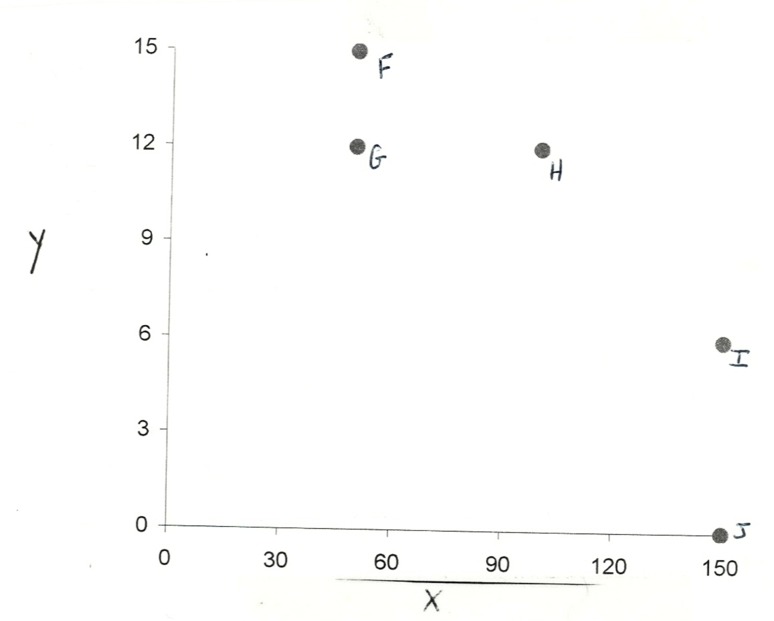

5. How can scatter plots be interpreted in terms of direction and degree of relationship between two variables?

Characteristics of Relationships

(1) Direction of the relationship. Relationships can be classified into two basic categories: positive (+) and negative (-). With a positive correlation, the two variables tend to move in the same direction--when X increases, Y increases; when X decreases, Y decreases. With a negative correlation, the two variables tend to move in opposite directions--when X increases, Y decreases; when X decreases, Y increases. The direction of a relationship is indicated by the sign associated with the correlation coefficient. A positive (+) sign indicates a direct relationship; a negative (-) sign indicates an inverse relationship.

(2) Degree of relationship. The closer the points on the scatter plot cluster around a straight line, the stronger the linear relationship between X and Y.

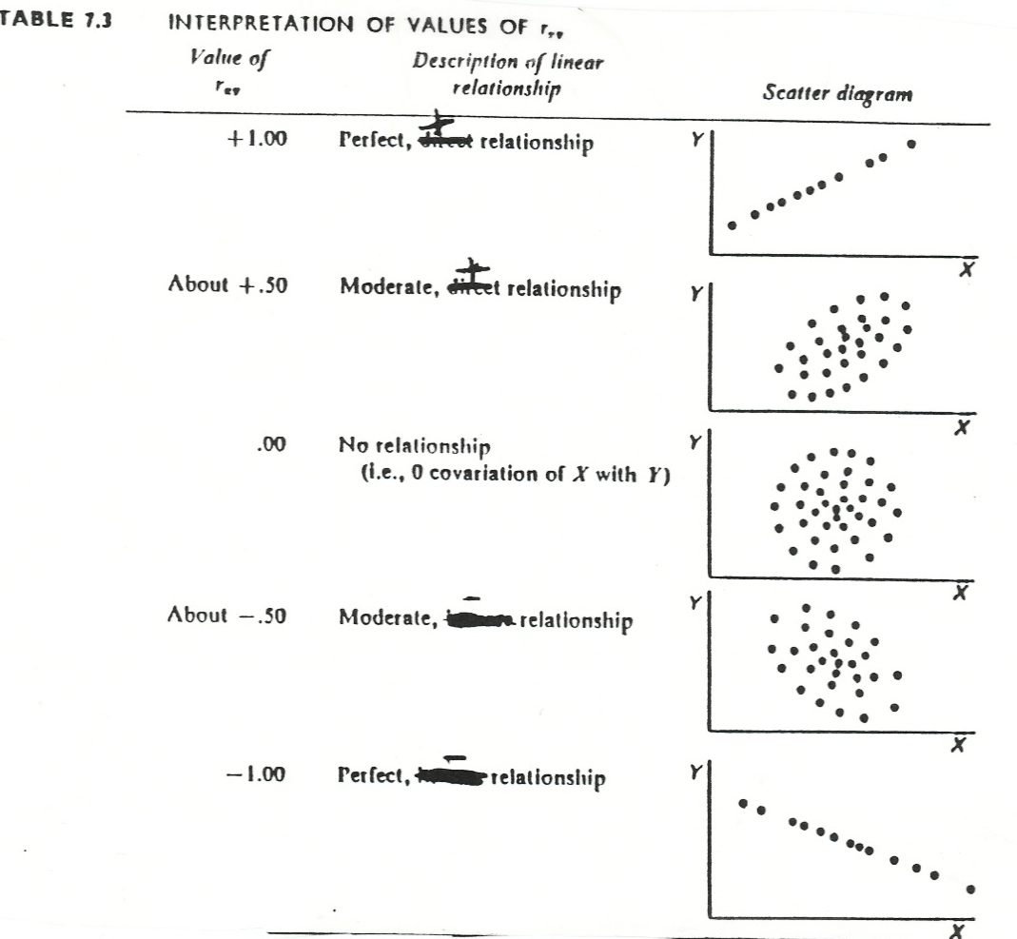
6. How can the Pearson r be defined?

The Pearson Product Moment Correlation Coefficient is an index with a sign that indicates the direction and a numerical value that indicates the strength of the linear relationship between two variables.

The population symbol for the Pearson Product Moment Correlation Coefficient
is rho [ρ].

The sample symbol for this correlation coefficient is r.

The Pearson r can take on values ranging from -1.0 to +1.0.

The direction of the relationship is indicated by the sign, positive or negative, associated with the Pearson r.

The strength of the relationship is indicated by the absolute value of the numerical value associated with the Pearson r.

A perfect positive relationship is associated with a Pearson r of +1.0, whereas a perfect negative relationship is associated with a Pearson r of -1.0. A Pearson r of .00 indicates the absence of a linear relationship. A correlation coefficient indicates whether each person’s relative standing in the X distribution is related to his or her relative standing in the Y distribution.

A researcher is interested in determining whether there is a relationship between a manual dexterity test and number of errors made on a typing test. She draws a sample of 5 high school students learning to type. Below are the scores on the manual dexterity test and number of errors made on the typing test. In addition means and standard deviations are provided for both variables.

Raw Data for Computing the Correlation between 2 Interval Variables

Person Manual # of Typing Errors (Y)
Dexterity (X)
______________________________________________________________
Fred 50 15
Gene 50 12
Heidi 100 12
Irene 150 6
Janet 150 0
_______________________________________________________________

Mean 100 9

Standard
Deviation 50 6
________________________________________________________________

for the X variable, z = [X_{i}-M_{x}] /S_{x}

for the Y variable, z = [Y_{i}-M_{y}] /S_{y}
7. How can r be computed and defined?

r = ∑ (z_{x}) (z_{y})
_______
n

The Pearson r can be thought of as the mean of the product of the paired z scores.

1. Convert the X scores to z scores and convert the Y scores to z scores.

2. Multiply each participant’s z score for the X variable by his or her paired z score for the Y variable.

3. Compute the mean of the product of the paired z scores by dividing the sum the products of the paired z scores by n.

Manual Dexterity # of Typing Errors
Person Raw Dev. z Raw Dev. z

X X-M [X-M]/S_{x} Y Y-M [Y-M]/S_{Y} (z_{X}) (z_{Y})
______________________________________________________________
Fred 50 -50 -1 15 +6 +1 - 1.0
Gene 50 -50 -1 12 +3 +.5 - .5
Heidi 100 0 0 12 +3 +.5 0.0
Irene 150 +50 +1 6 -3 -.5 - .5
Janet 150 +50 +1 0 -9 -1.5 - 1.5
______________________________________________________________

Mean 100 9 r=-3.5/5=-.70

Standard
Deviation 50 6
______________________________________________________________

8. What is the null hypothesis?  = .00

9. What needs to be computed to test this null hypothesis?

10. How many degrees of freedom are associated with this test?

Df = n-2

11. How can the critical value be determined given an alpha level?

[See Page 8 of the Study Guide.]

12. How can a conclusion be drawn regarding the null hypothesis?

13. What cautions need to be considered in interpreting Pearson rs?

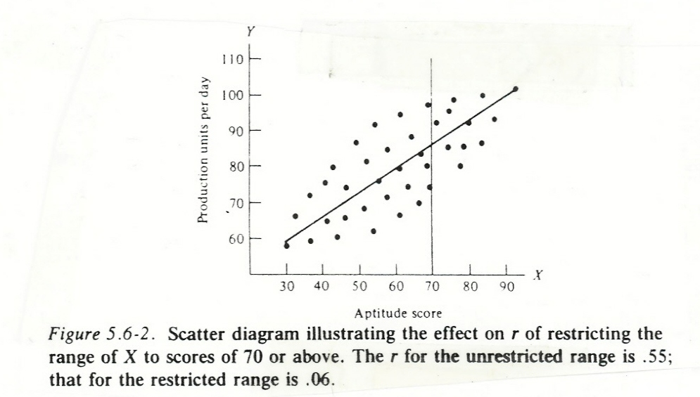

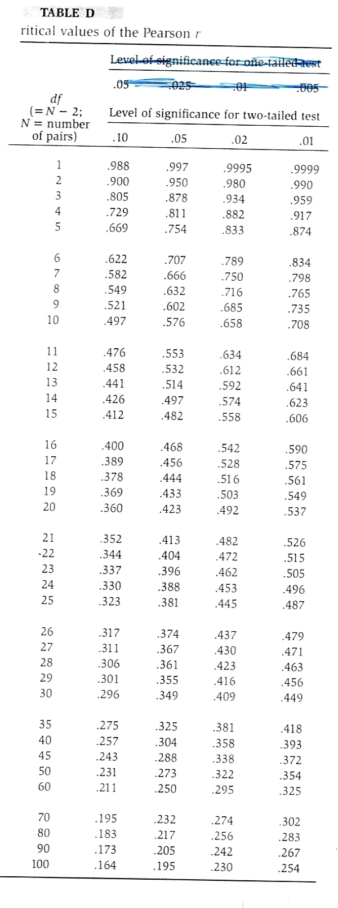
II. Different Types of Correlation Coefficients

14. Which type of correlation coefficient is used when the two variables are (1) continuous; (2) ordered categories; and (3) unordered categories (with 2 categories per variable)

Correlational Coefficient Type of Variables
____________________ _____________________________
Pearson r 2 continuous variables
Spearman Rho 2 ordered categories
Phi 2 unordered categories (dichotomous variables)
_____________________________________________________

1. You are interested in examining the relationship between years of playing golf and average golf score for 18 holes.

2. You are interested in the extent to which two members of a search committee agree in their rankings of the list of candidates for a position.

3. You are interested in the association between gender and living in the inner city versus the suburbs among single adults.

III. Power and Sample Size Determination

15. How can power be computed for a Pearson correlation coefficient?

Power is the probability of rejecting a false null hypothesis. Typically we desire that power = .8.

The value of ρ  specified under the alternative hypothesis is designated ρ_{A}.

.10 = small ρ_{A}; .30 = moderate ρ_{A}; .50 = large ρ_{A.}

Steps in Computing Power.
STEP 1: Determine gamma (γ), the population effect size. In the case of the correlation coefficient, gamma equals the absolute value of ρ_{A}.

STEP 2: Determine delta (δ). Delta combines the estimate of the population effect size and sample size.
____
delta = /ρ_{A}/ x √ N-1

STEP 3: Enter Table H with an a priori specified value for α and the value of delta that was just computed.

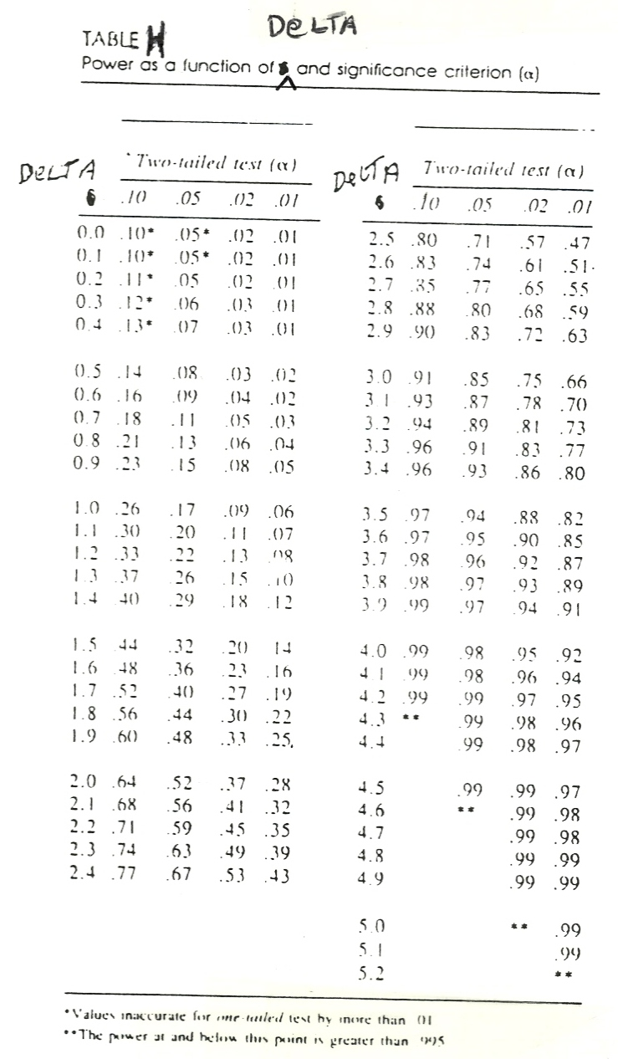
Given the desired power, α, and ρ_{A} how can the sample size be determined for a study examining a Pearson correlation coefficient?

STEP 1: Entering Table I with the desired power and a priori specified value of α, determine delta.
STEP 2: Solve for n using the formula, n = (DELTA/ρ_{A})² + 1.


