ENGLISH 500 (Fall 2011)
“Research Method (Literature)”
LL 145, Tuesday, 4:40 – 7:30 PM
Professor Mark Lussier

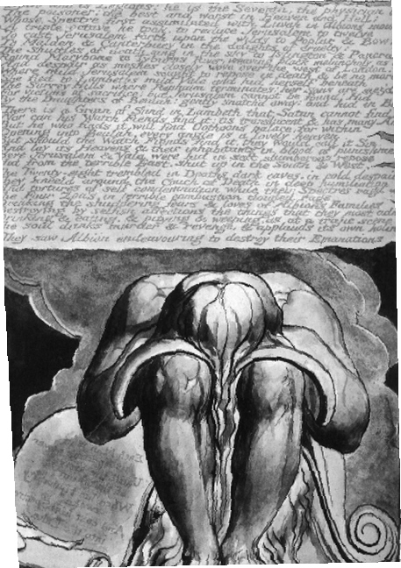
William Blake, Jerusalem, plate 41

I. Relevant Information
Office = Languages & Literatures 547C
Hours = Tuesday & Thursday, 1:00 – 4:00 PM
Phone = (480) 965-3925
Email = mark.lussier@asu.edu
Webpage = www.public.asu.edu/~idmsl
II. Description of the Course
The primary focus for our class will be to inculcate research skills to support your work in the graduate program, yet this represents only one level of our effort this semester. A secondary aspect of the course will introduce you to a large number of faculty members teaching in virtual every area of literary studies at ASU. Beyond the opportunity to speak with research scholars about their experiences (and respond to aspects of their work read beforehand), the other purpose of these presentations is to bring you into contact with potential chairs and/or committee members to serve on your committees as your near the end of your work here. A tertiary dimension of the class will survey various schools of critical theory, since most literary analysts would concur with the view that all positions are informed by theoretical commitments. Finally, the class explores the expanded view of what precisely defines “English Studies” within higher education by examining the historical development of and mutations within our discipline and the current state of things (the direction of study, the state of the market, the fate of the humanities).
The graded assignments for the class reflect these commitments and also reflect my tendency to approach the tasks for the course pragmatically: 1) your largest assignment will be the preparation of an annotated bibliography in your proposed area of expertise, and you will deliver a brief (5-minute maximum) overview of your research at the end of class. This bibliography should be as extensive as possible relative to the limitations of time and space (only sixteen weeks from conception to completion) and should take as its aim research support for the thesis/dissertation you envision; 2) you will write a bibliographical essay (2,500+ words) that surveys both the discrete aspects and broad planes of inquiry as presented in your annotated bibliography, which therein creates a potential sample for the opening chapter of the thesis/dissertation; 3) given the role that critical theory plays in literary analysis, you will prepare a small-scale annotated bibliography (10-15 entries) on a particular critical theorist/school of theory that potentially can inform your research or help structure future directions for your studies; you will then present an overview to the class of your findings (10-minute maximum: feel free to construct power points for this endeavor); the aim for this project is to cultivate pedagogical abilities and to locate potential analytic support for the thesis/dissertation; 4) you will be required to interact with your colleagues in on-line discussions of various topics through Blackboard, and I will generate these topics across the semester; in these instances, you must post an initial response to a discussion question/topic and then post another response to one of your colleagues in the class, and the purpose of the exercise is to encourage cooperation and collaboration among classmates through dialectical exchanges (thus, pedagogical support for classroom and dialogical support for the thesis/dissertation).
As you will note from the breakdown for grade calculation below, participation weighs heavily here, but such engagement is difficult to achieve when you are elsewhere and/or otherwise. I won’t necessarily take attendance every evening (I actually loathe this type of compulsion but recognize its utility), but I strongly encourage you to come to class prepared for whatever drives us that particular evening. Thus, your grade will be calculated as follows:
Annotated Bibliography 30%
Bibliographical Essay 20%
Critical Theory Bibliography/Presentation 20%
Participation (On-Line/Discussions, Attendance) 30%
III. Textbooks
Given the plenitude of on-line sources, the arrival of copious amounts of reading from faculty in the department, my modest hope to save a few branches (if not whole trees), and my sincere desire to save you some much needed capital, I have only required the purchase of three relatively inexpensive books.
Booth, Wayne et al., The Craft of Research, 3rd Edition
Culler, Jonathan. Literary Theory: A Very Short Introduction
Harner, James L., On Compiling an Annotated Bibliography
IV. Faculty Presenters (In Whole or Part): As essays become available, I will post them onto the Blackboard for the class and alert you to their presence. I have listed for you the major of the literature faculty (except those on leave) and their areas of expertise. I don’t anticipate presentations by everyone in the literature cohort.
Lee Bebout (American Ethnic Literature); Dan Bivona (Victorian + Colonial/Postcolonial); Robert Bjork (Medieval Studies); Gregory Castle (Modernism, Post-Colonialism, Theory); Deb Clarke (Modernism/Contemporary American); David Hawkes (17th Century Literature); Christine Holbo (American Literature and Narrative Theory); Cynthia Hogue (Modern & Contemporary Poetry); Neal Lester (African-American Literature and Culture); Lockard, Joe (Early American, Critical Technology); Mark Lussier (Romanticism + Theory); Edward Mallott (Post-Colonial + Contemporary); Heather Maring (Medieval); Richard Newhauser (Medieval + Early Modern); Simon Ortiz (Indigenous Literature); Bradley Ryner (Renaissance + Shakespeare); Claudia Sadowski-Smith (Borderland Literature, Theory); Robert Sturges (Medieval + Bible as Literature); Ayanna Thompson (Shakespeare/Renaissance + Theory)
V. Reading Schedule: while this schedule looks easy at the moment, remember that individual essays/works by faculty presenters will also be distributed and read (as these are available)
08/23 Introduction to Class + Harner (entire text) + Culler (121-32)
08/30 Hayden Library: On-Line Research Instructional Session + Booth, “Research, Researchers, and Readers” (1-30)
09/06 Booth, “Asking Questions, Finding Answers” (31-102)
Lussier, “Buddhism and Romanticism” (PDF/Blackboard)
09/13 Booth, “Making a Claim and Supporting It” (103-70)
09/20 Booth, “Planning, Drafting, and Revising” (171-270)
09/27 Booth, “Some Last Considerations” (271-312)
10/04 Culler, “What is Theory” and “What is Literature and Does It Matter?” (1-41)
10/11 Culler, “Literature and Cultural Studies” and “Language, Meaning, and Interpretation” (42-68)
10/18 Culler, “Rhetoric, Poetics, and Poetry” and “Narrative” (69-93)
10/25 Culler, “Performance Language” and “Identity, Identification, and the Subject” (108-20)
11/01 Theory Presentations
11/08 Research Day
11/15 Theory Presentations
11/22 Research Day: No Class
11/29 Short Research Presentations
12/06 Short Research Presentations

