Salvaging Flexible Electronic Circuits
Jovan Trujillo, Edward J. Bawolek, Robert Blanchard
Flexible Electronics and Displays Center
Arizona State University
5/15/2015
- Research Goals
  - To develop a robust and automated defect analysis and repair tool for large area flexible electronics manufacturing.
- Project Background
  - This research project focuses on the creation of custom hardware and software to analyze and mitigate the damage caused by defects in our manufacturing process. We develop active matrix transistor arrays for building display prototypes as well as X-ray detectors. These arrays range in size from 6” wafers to Gen-II sized panels. The defects are typically caused by particles trapped on the surface during material deposition and pattern lithography. The source of the particles can be attributed to the polymer substrates we use in flexible electronics manufacturing. The particles are visible under a microscope and quantified using image processing software.
These defects typically create metal-to-metal bridges in the circuit and effectively cause electrical shorts during operation. Since we are a research facility and our resources are limited every item manufactured must be salvaged for future use in the prototypes developed with our partner companies. Cutting our an electrical short found within an active matrix array allows the rest of the array to stay addressable and eliminates the high operating current which can damage attached peripheral circuitry. We have developed tools to isolate electrical traces using fuses built within the circuit. These fuses can be blown out using a high voltage pulse delivered via probe card, or through the use of a laser.
Defects can be identified by biasing the active matrix array in the “off” state, and measuring the current of each trace using a probe card. A more efficient method has been developed using an infrared camera. Lines carrying more than 1 mA of current glow under the infrared (IR) camera. Hardware has been developed to automate the scanning of an array using either probe card or infrared camera.
  - Array Inspection and Repair Tool
    - First tool prototype developed on granite block using EZ-Laze laser, FLIR SC620 IR camera, two probe cards, an inspection camera, and pogo-pin contactor. Two X-axis, two Y-axis, and five Z-axis for a total of 9 degrees of freedom. Control is through PLC communicating through NI-OPC server to a set of custom LabView applications. (see figures 1 and 2)
    - The IR camera can find electrical shorts as low as 1 mA on glass, polyimide, and polyethylene naphthalate substrates. LabView software has been created to scan an array with the IR camera. An image database is created which is then processed using an image filter developed with the NI Vision Assistant to create a list of defect coordinates. This file is then used in another LabView app to drive to the defective region and isolate the line using laser cuts. Much of the process has been automated but the accuracy and reliability of the process can be improved. (see figures 3, 4, and 5).
- Future Work
  - There is plenty of room for improving the inspection and repair process. Here is a list of what we are working on.
    - Further improvement in the resolution of the IR camera.
      - We use image subtraction and image averaging to amplify the differences caused by leakage current. Phase-lock analysis would improve our resolution to below 1 mA but we need an IR camera with an external trigger.
    - Improve accuracy of automated defect identification.
      - Current image processing flags one defect per image. Sometimes there are false positives. Other times faint point defects are not detected by the image filter. Work continues on improving the accuracy of the image filter by working with the NI Vision Assistant. Automated optimization of filter parameters might also be possible through convolutional neural networks.
    - Automate the whole line cutting process using probe cards and electrical line by line testing.
      - Current work shows that this is a very long test. We need to figure out how to speed things up.
      - Data analysis and line cutting is still done manually. Need to integrate these steps into LabView for full automation.
    - Build a second inspection tool to improve our repair throughput.
      - We don’t have the building infrastructure to add another granite block based system. It’s too heavy for our floors so we are designing a lighter system using active stabilization and improved motion control.
      - Current prototype is plagued with vibration problems. The possibility of replacing our current PLC control system with new motors and a LabView based control system may greatly improve motion control on the new system. Tuning the system using NI software has been easier to do on other projects. Boot up times for the software would be faster than using OPC Server.
    - New circuits are being developed that allows re-routing bus lines cut by our laser system. These metal traces are activated into the circuit by welding metal crossovers using the laser in a low power annealing mode. With this the display or X-ray detector does not show missing rows/columns when operated.
      - Work has started on this and an example of a metal weld is shown in figure 6.
      - Reliability of process shows that the process needs improvement.
- Conclusions
  - If we won the National Instruments grant it is most likely that we would use the award for replacing our PLC controllers with something National Instruments based and evaluate the improvement in vibration control, motion accuracy, tenability, and software performance improvements.

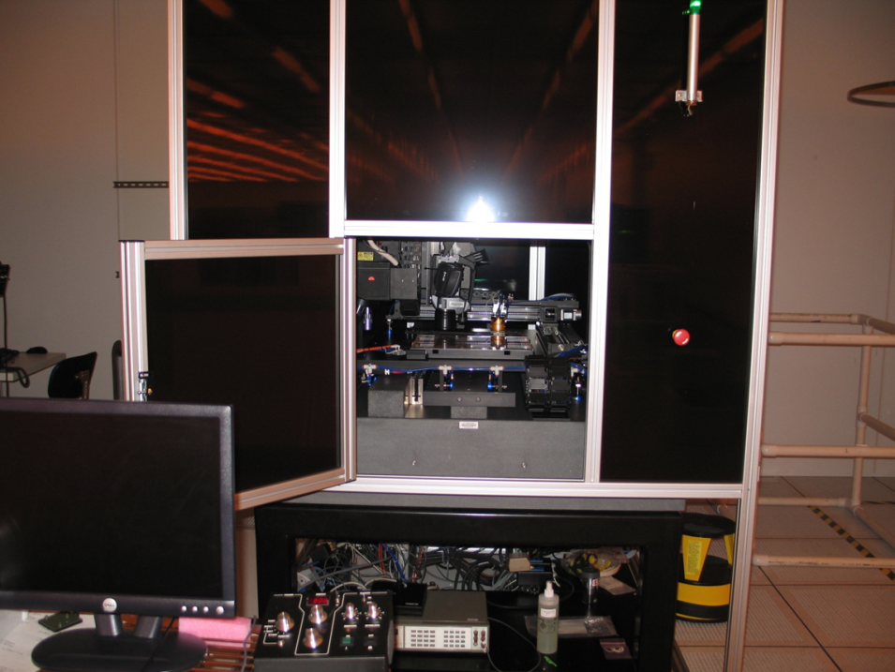
Figure 1 Custom inspection and repair tool developed at FEDC
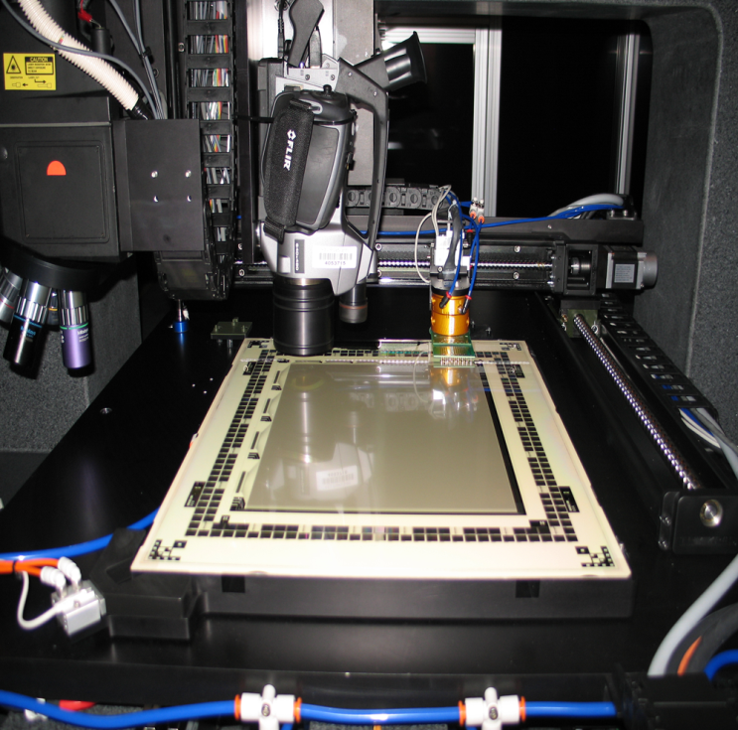
Figure 2 Close up of active matrix display inside our inspection tool.

Figure 3 IR image sample showing glowing defect within array.

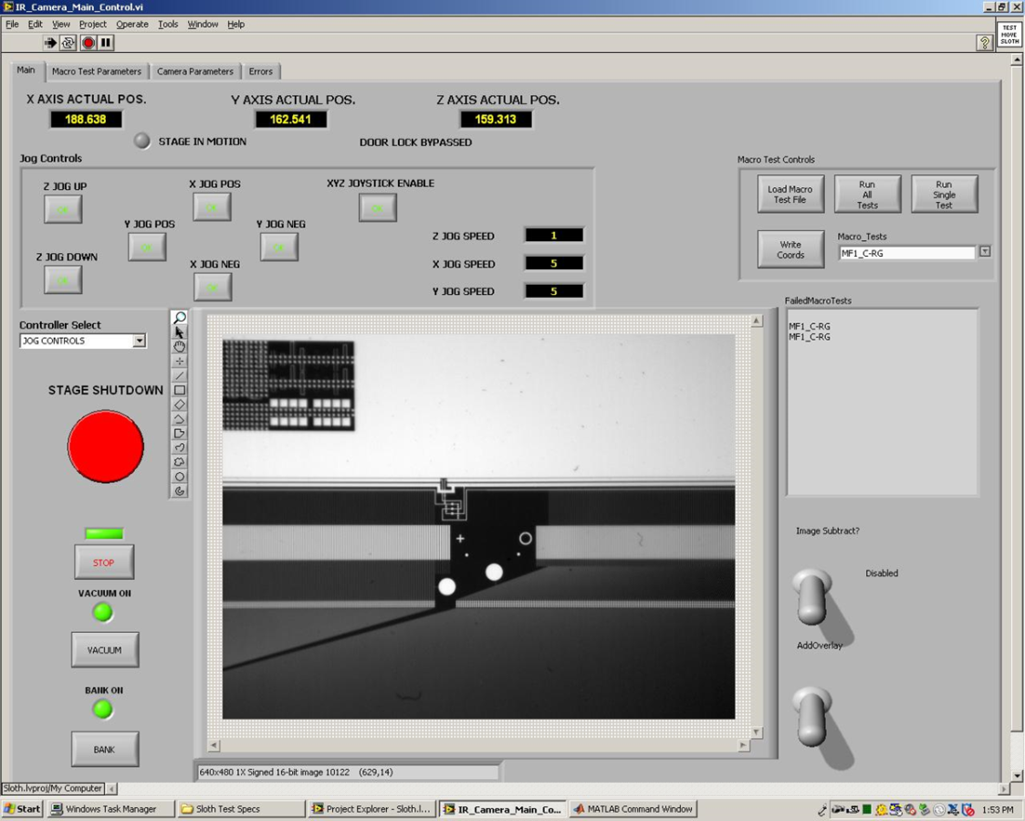
Figure 4 IR image before powering up.

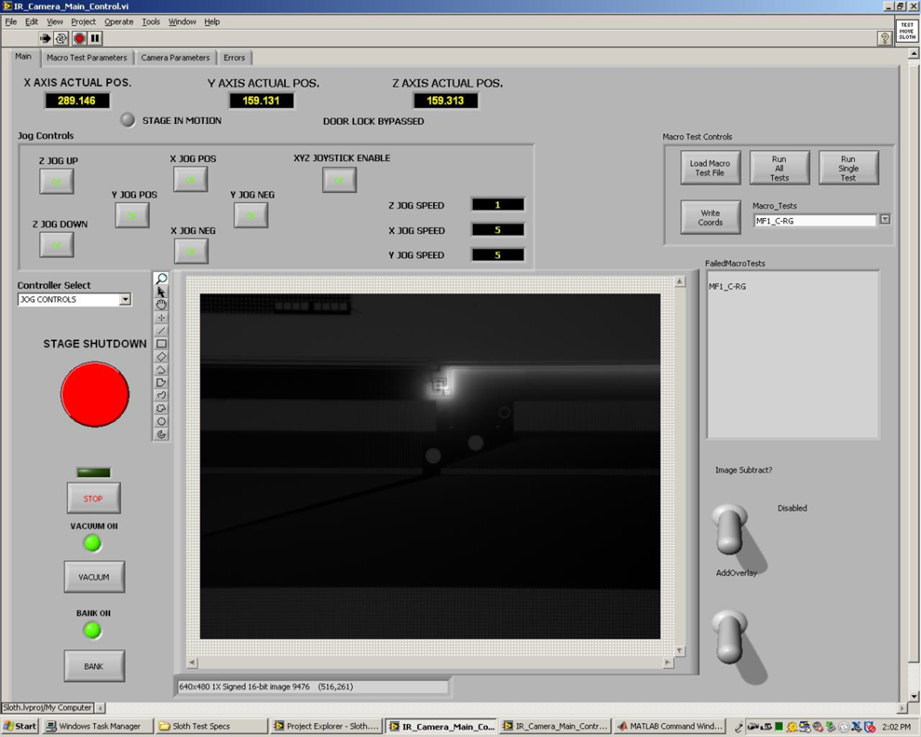
Figure 5 IR image after powering up showing short.

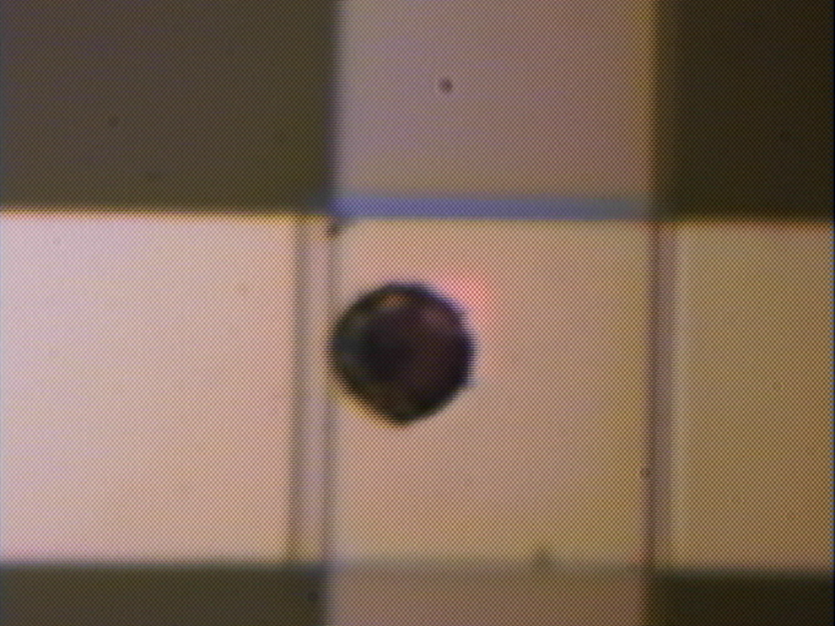
Figure 6 A metal crossover showing the laser shot used to weld the two layers together.

