TRAVEL TO RUSSIA
Why travel to Russia with Barrett Honors College?  In comparison with other study abroad programs…  This trip is completely unique from the locations we visit to the activities we do. Not only will we visit the most famous cities in Russia (Moscow and St. Petersburg) but we will also travel to a previously closed city (Samara) and even to the Russian countryside. By combining literature, philosophy, and history we provide a holistic approach to understanding the events and people that have shaped modern Russia. For example, we will discuss the Russian Chronicles while exploring the medieval fortress at Novgorod and read Pushkin’s poetry |  | 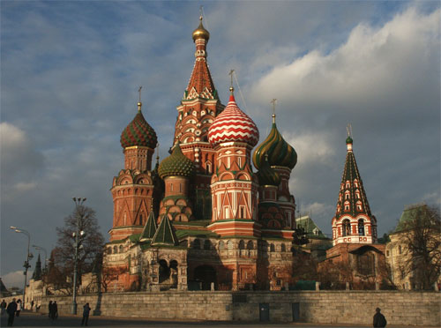
while visiting his home on the Arbat in Moscow. Although we will chiefly rely on discussing primary texts in context, the end of the program will be devoted to excavating part of a Late Bronze Age (1,800 BC) settlement near the city of Samara, allowing the students a rare opportunity to participate in the discovery of Russia’s prehistory.

In comparison to traveling to Russia alone…
Individual travel in Russia can be challenging, because in order to obtain a visa you must declare beforehand where you intend to be during your entire stay in the country. Most visitors stay in large tourist hotels left over from the Soviet era and travel on package tours. Although they see the monuments, they don’t necessarily get to meet the people! We will be staying in dormitories which will keep the cost of the trip down, allow you more flexibility to explore the cities we visit, and provide an opportunity to interact with Russian students.

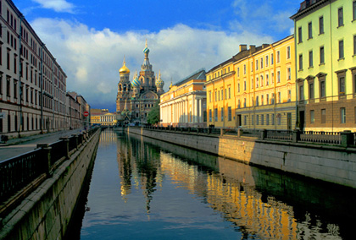 | What are Russians like?  Politicians and journalists alike have often commented that Russians are incomprehensible. Perhaps this is because Russians rarely smile at people they don’t know, yet they are overwhelmingly warm and hospitable to the people they do know. Cultured and witty, it is not uncommon to hear Russians recite poetry at a party or sing songs while playing the guitar. They love to meet people from other countries and will happily tell you what they think of Russia and eagerly ask you what you think about the world.
Do I need to know Russian?  No. There will be an immersion one-credit travel-skills class offered once we arrive in Russia in which you will learn how to shop, travel, and eat anywhere you find yourself. This will include learning the Cyrillic alphabet and basic phrases in Russian that will help you navigate the cities we visit. Although most Russians do not speak English, though this is changing, they are very sympathetic to people who make an effort to speak their language and will often go out of their way to help you. | 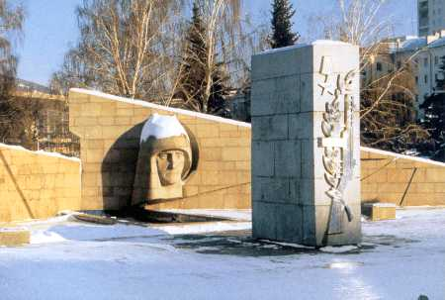
What will an average day be like on the trip?

Normally our class schedule will begin Monday at 10am and end Friday at noon. Classes focus on the historical, cultural, and philosophical aspects of Russian life and culture. The weekends, however, are reserved for you to explore Russia on your own. Whether you decide to tango dance in St. Petersburg, wander the grounds and have a picnic at Pavlovsk, lounge all weekend on the beaches that line the Volga river, or hike Russia’s national parks is entirely up to you. With ample museums, public squares, parks, markets, night clubs, cafes and restaurants, you will never run out of things to do. Plus, the Russian students you meet may want to show you around as well.

 |  |  | How much will it cost?  This is the first year the Honors College will be offering this program and we are still planning much of the trip. Costs, however, will be similar to the other study abroad programs. The Honors College offers competitive scholarships. Most students who demonstrate need can also use their financial aid package to help them pay for the trip. Contact the Student Financial Assistance Office on the second floor of Student Services or call 965-1160.
Want to know more? Contact Dr. Laura Popova at :
Laura.Popova@asu.edu
480-965-8327

