Likelihood Inference for Dynamic Panel Data Models

Seung C. Ahn

Department of Economics

Arizona State University

Gareth M. Thomas

Department of Economics

Arizona State University

October, 2003

1. Introduction

• Dynamic panel data model:
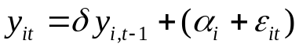.

• Fixed effects (FE) Vs. random effects (RE)
• FE treats the α_{i} as parameters.
• RE treats the α_{i} as random variables.

• FE MLE is inconsistent: MLE = OLS on 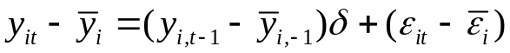.
→ “Incidental parameters” problem (Neyman and Scott).

• Solutions:
• Random effects MLE.
• GMM (Arellano and Bond, 1991; Arellano and Bover, 1995; Ahn and Schmidt, 1995, 1997; and Blundell and Bond, 1998)

• GMM is a cure-all?
• Poor finite-sample properties especially when data are persistent.
• Too many moment conditions when T is large.

• Recent FE ML approach:
• Lancaster (2002)
• Hsiao, Pesaran and Tahmiscoglu (2002, HPT)
• Kruiniger (2002a)
• Hahn and Kuersteiner (2002): MLE when T, N → ∞.

• Motivation of this paper:
• How these estimators compared to the RE MLE?
• The properties of ML when data are persistent?
• Finite sample properties?
• Focus on small T and large N.

• Main findings:
• Theoretical link between the different ML estimators.
• Asymptotic distributions of the RE ML estimator when unit root.

• The information matrix is singular, but the ML estimator is consistent.

• Nonstandard distribution.
Found based on Rotnitzky, Cox, Bottai and Robins (2000, RCBR)
• Wald-type unit root tests fail.
• Suggests use of LR tests.

2. ML Estimation

• Model:
(1)

• y_{i0}: the initial observed value of y (for individual i).
• 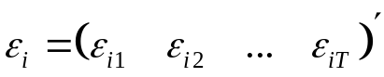 is uncorrelated with y_{i0} and α_{i}.
• The ε_{i}, y_{i0} and α_{i} are cross-sectionally independent.
• All normal: 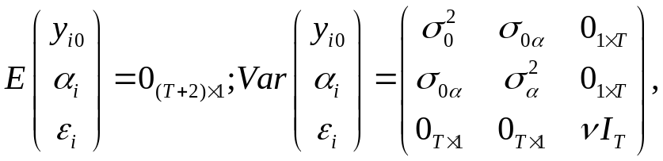 where 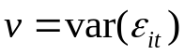.
[RE assumption].
• Assume that the y_{i0} and α_{i} have zero means, for convenience.

2.1. Random Effects Maximum Likelihood Estimation

• Wish to transform the model into a differenced form.
.

• Define:
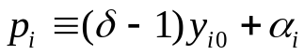; 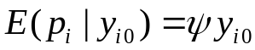; 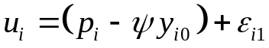,
where 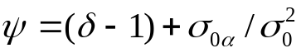.

• A one-to-one transformation of model (1):
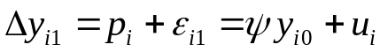; (2.A)
(2.B)
→
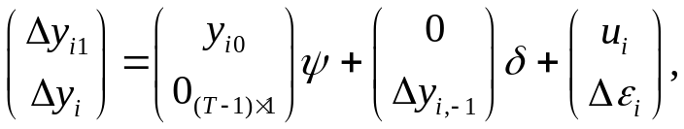 (3)
where,
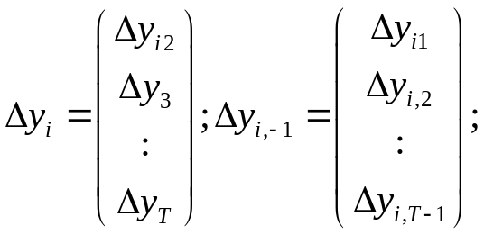 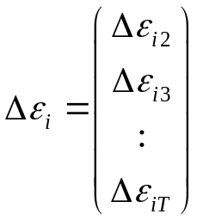;
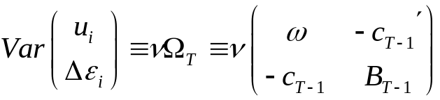; 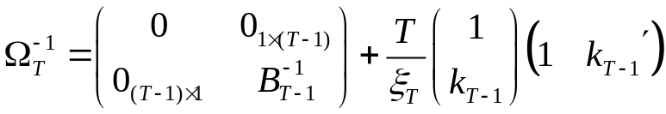 (4)

where 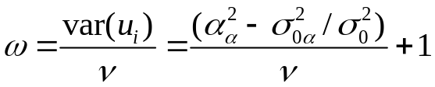, 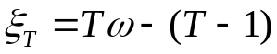,
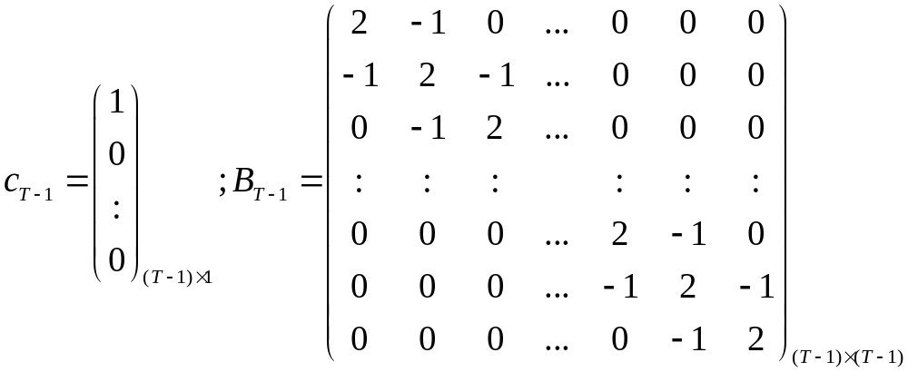; 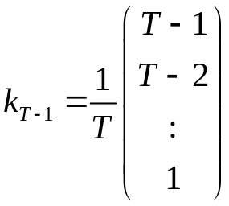.
• The parameter vector: 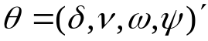.

• In model (3), y_{i0} is uncorrelated with the error vector h_{i}. So, we can construct a likelihood function treating y_{i0} as strictly exogenous:
.

• The log-density function of 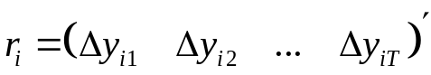 conditional on y_{i0}:
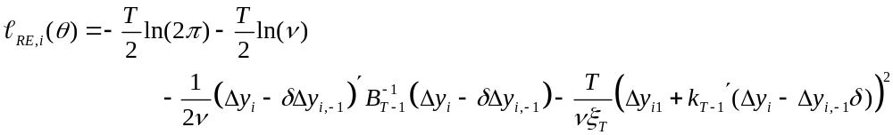

2.2. Fixed Effects Maximum Likelihood of HPT

• The HPT model:
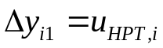; (4.A)
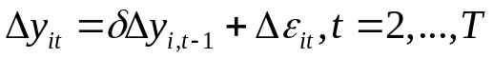, (4.B)
where 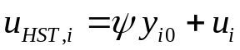.

• Define:
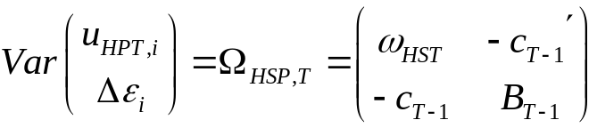,
where 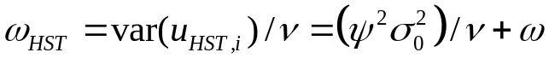.

• Observe that HST treat y_{i0} as an unobservable error term.

• The HPT density is the unconditional density of 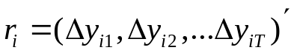:
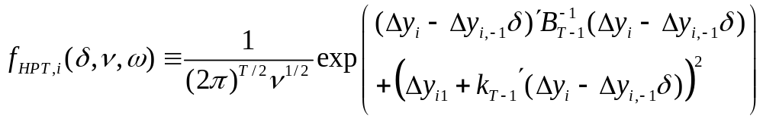.

• The HPT log-density:
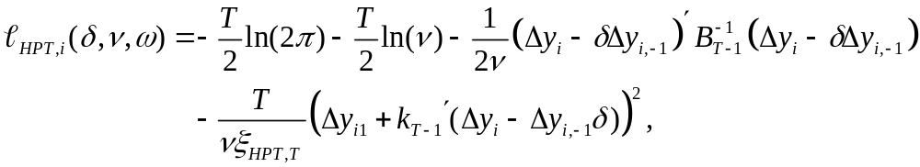
where 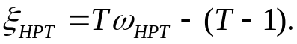

• Is it really a FE treatment?
• Requires the normality of u_{HPT,i} = (δ-1)y_{i0} + α_{i} + ε_{i1}.
- Normality of y_{i0}, but not necessarily the normality of α_{i}.
- Suppose that the y_{it} follow a stationary process:

→ p_{i} = (δ-1)y_{i0} + α_{i} = (δ-1)v_{i0}.
→ As long as y_{i0} is normal conditional on α_{i}, u_{HPT,i} is normal.

• When the stationary condition does not hold, the normality of u_{HPT,i} requires the normality of α_{i}.

• The RE ML does not require the normality of y_{i0}, but it requires the normality of α_{i} conditional on y_{i0} to secure the normality of 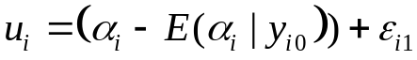.
2.3. Fixed Effects Maximum Likelihood of Lancaster

• Bayesian flavor.
• Rewrite Model (1) as:
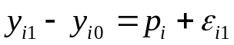;
where p_{i} = (δ-1)y_{i0} + α_{i}.

• Define: 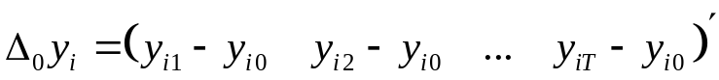; 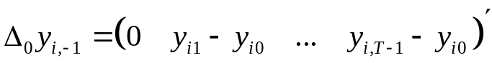.

• The density of 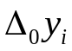conditional on δ, ν and p_{i} equals
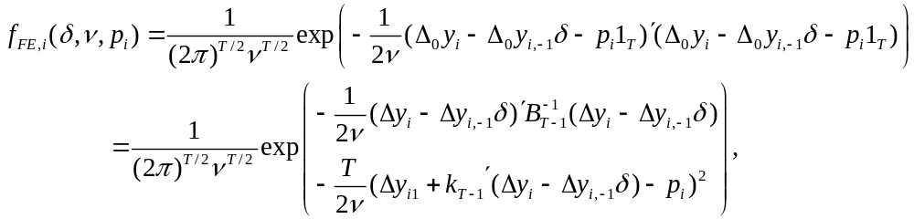
where 1_{T} is a T×1 vector of ones.

• Since 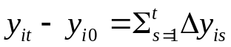, the above density can be also viewed as a conditional density of r_{i.}

• Reparameterization:
• 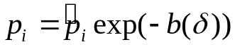 where 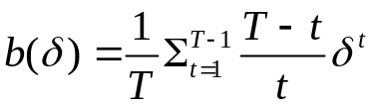.
• The 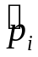 are information orthogonal to (δ,ν)′, in the sense that
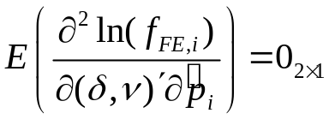.
• Assuming uniform priors to the , integrate them out from 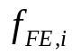:
.

• Variance matrix of the Lancaster estimator:
• 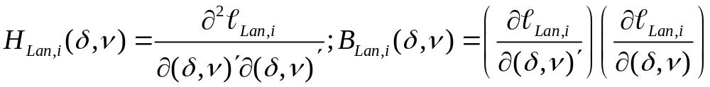.
• 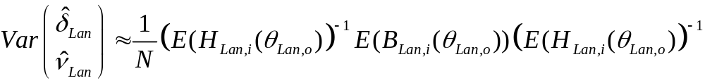.
• Not of the inverted Hessian form, because 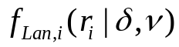 is not a proper density:


• Is it really a FE treatment?
• Yes, but it is not ML.

• Link between HPT and Lancaster?

Proposition 1: Suppose that the prior density of p_{i}, f_{i}(p_{i}|ω_{HPT},ν), is given N(0,(ω_{HPT}-1)ν). Then,
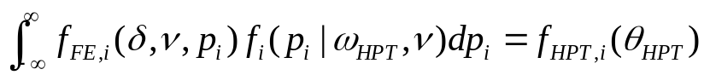.

Remark 1: If 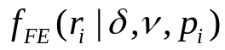 were integrated with a normal prior f_{i}(p_{i}), Lancaster = HPT.

Remark 2: The HPT estimator is more efficient (if T > 2). Because, under our assumptions, the prior f(p_{i}) is informative.

3. Maximum Likelihood When Data Are Random Walks
3.1. Random Walks without Drifts

• Random Walk without Drift:
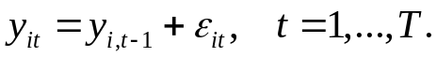

• Let 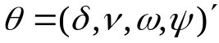 and 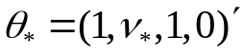, where 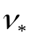 remains unrestricted.

• The random walk hypothesis implies 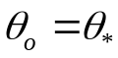.
• Define 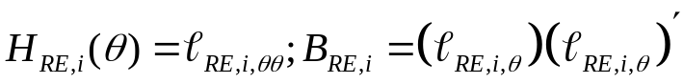.

Proposition 2: When , 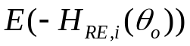 and 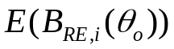 are singular.

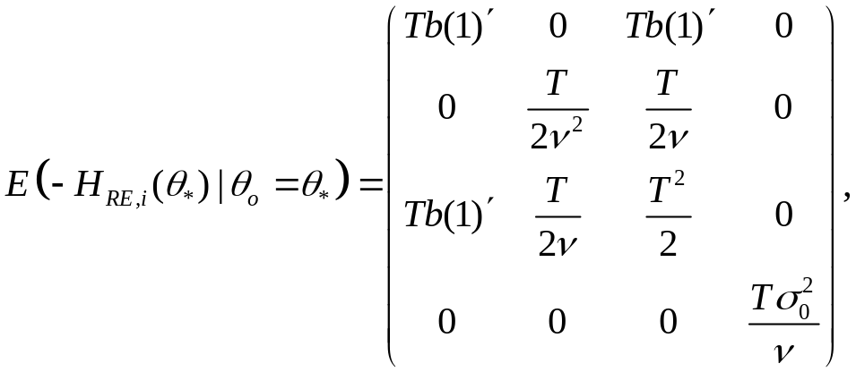 where b(1)′ = (T-1)/2.

• Observe that the 1st column – (the 3rd column – ν × the 2nd column) = 0.

• Is θ* a global maximum point when θ_{o} = θ*?
• Concentrated expectation of the RE log-density when and T = 2:
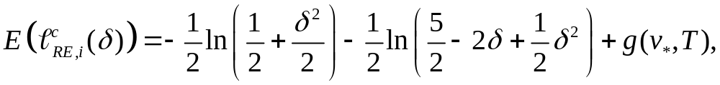
• At δ = 1,
,
• The first-order derivative:
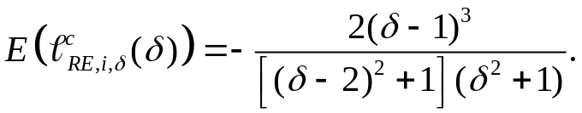
→ 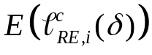 is always increasing when δ < 1 and decreasing when δ > 1.

Proposition 3: Suppose . Then, θ* is a unique global maximizer of 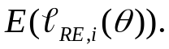 Thus, the RE estimator, 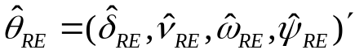, is a consistent estimator when .

• This proposition also applies to the HPT estimator.
Figure 1: The Value of the Expected Concentrated Likelihood for T=2

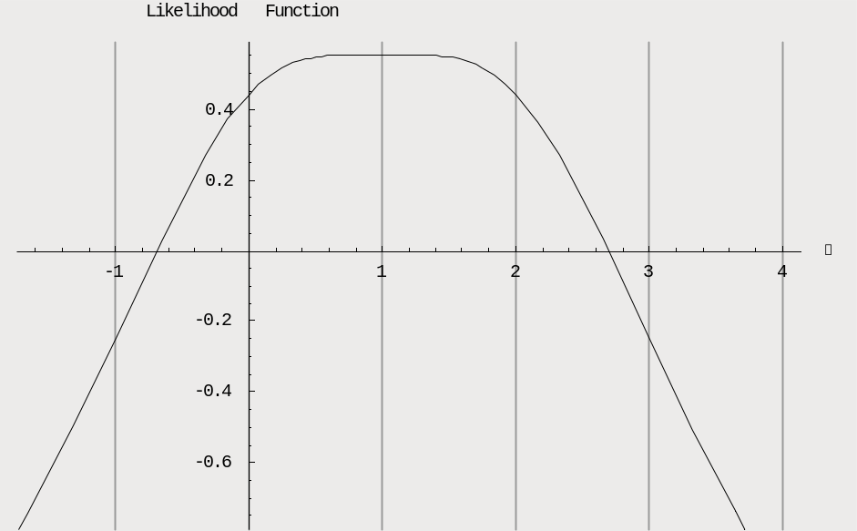

Proposition 4: Suppose . Then, θ* does not maximize 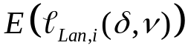. In fact, θ* is an inflexion point.

• For T = 2, 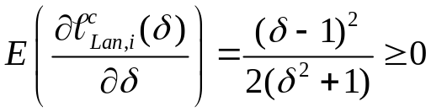.

Figure 2: The Value of the expectation of Lancaster’s Likelihood function for T=2
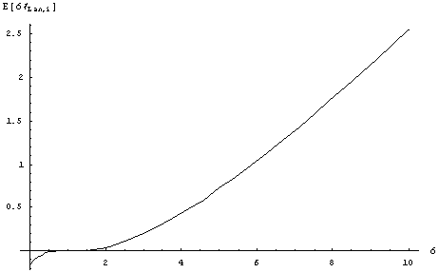

Digression to Rotnitzky, Cox, Bottai, and Robins (2000, Bernoulli 6)

• Let 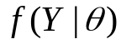 is a density function a random vector Y.
• Let 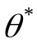 be the true value of the parameter.
;
;
.

• Assume: 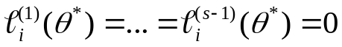, and 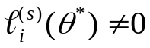.

• A Taylor expansion of the log-likelihood function 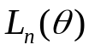 around :
.

• Define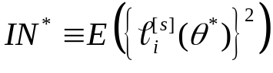; and let Z_{o} be a generic normal random variable with 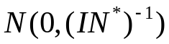.
• After some algebra,
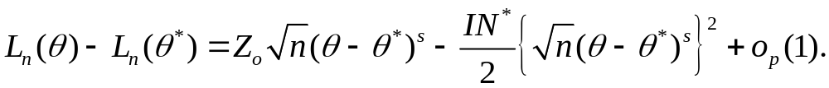

• Case 1: When s is odd. G_{n}(θ) is unimodel and has a unique maximum.
• 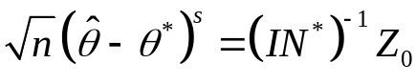, or 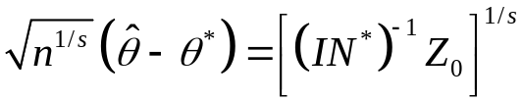.
• 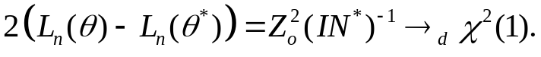
• Case 2: When s is even.
Case 2.1: When Z₀ < 0 (prob =1/2). G_{n} is unimodel and has a unique maximum: 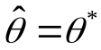.
Case 2.2: When Z₀ > 0 (prob = 1/2), G_{n} is bimodal and has two maxima:
• 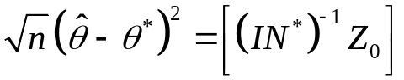, or 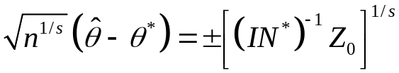.
•

Return to the RE estimator

Proposition 5: .

• Reparameterization:
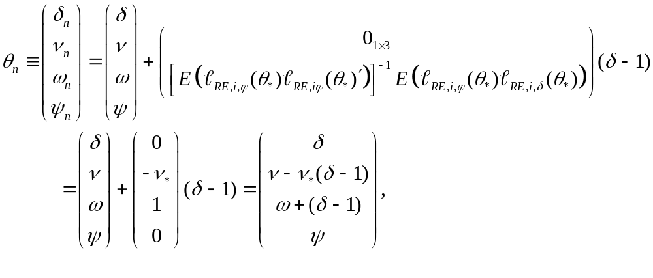
where 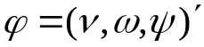.

• This parameterization is chosen to secure that when 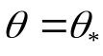, 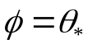.
• .
• Let 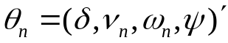; 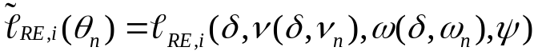;
;
; 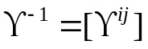.

• Under our reparameterization, .

Proposition 6: Let 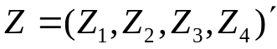 denote a mean-zero random vector with 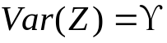. Let 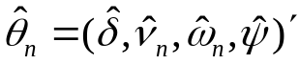 be the ML estimator of the reparameterized model. Then, when 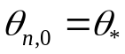,

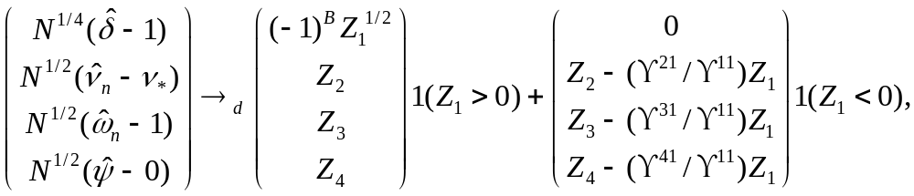

where B is a Bernoulli random variable with success probability equal to half and independent of Z. In addition, the LR test statistic for 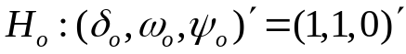 is a mixture of χ²(2) and χ²(3) with mixing probabilities equal to half.

Remark 1: The ML estimator of 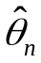 is not normal even asymptotically.
Remark 2: The convergence rate of 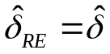 is N^{1/4}. The ML-based t-test for H_{o}: δ_{o} = 1 would not be properly sized.
Remark 3: The probability that the ML estimator 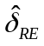 is equal to the true value of δ converges to half as N → ∞.
Remark 4: The LR statistic for testing H_{o}′: δ_{o} = 1 follows a mixture of χ²(1) and zero. Similarly, the LR statistic for testing H_{o}′′: (δ_{o},ψ_{o}) = (1,0) follows, when θ_{o} = θ*, a mixture of χ²(2) and χ²(1).
Remark 5: We can obtain the similar results for the HPT estimator. The HPT-based LR test for the hypothesis that 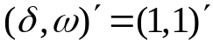 follows a mixture of χ²(2) and χ²(1).

3.2. Random Walks with Drifts

• Model:
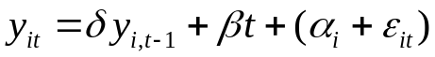, (5)

• All normal: 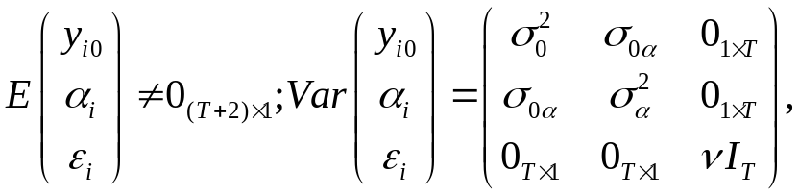 where .
• 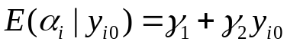.
• Transform model (5):

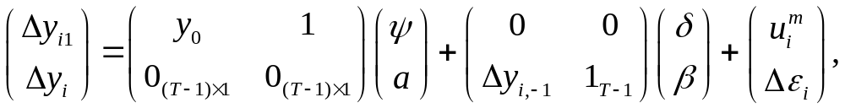 (6)

where 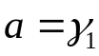, 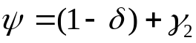 and 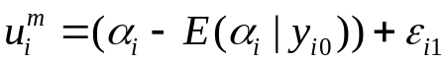.

• The log-density function for this model is given:
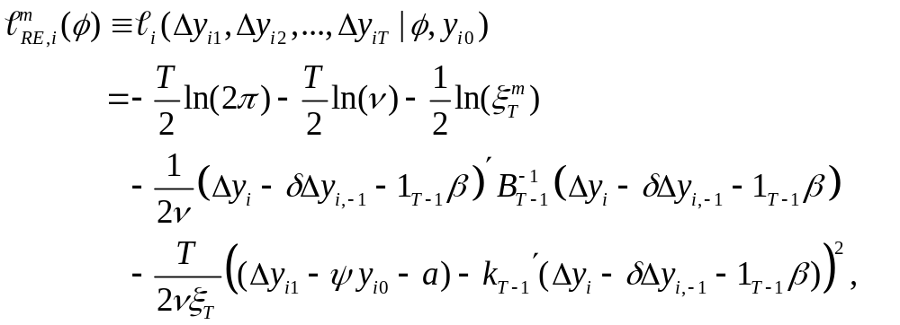
where,
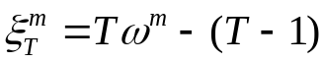,
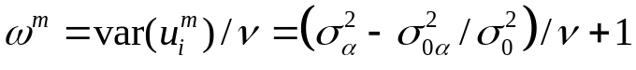,
, and 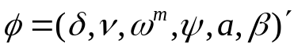.

• Parameter vector: 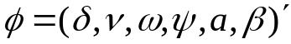.

• Random walks with drifts: 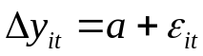.

• The hypothesis of random walks with drifts impose the restrictions:
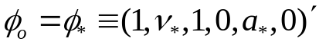,
where ν* and a* are unrestricted.

Proposition 7: .

Proposition 8: Let 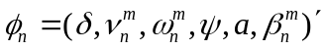 such that 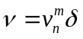; 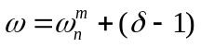; 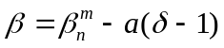.
Let ; and
; 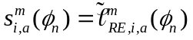; 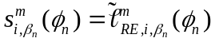;
;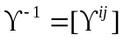.
Let 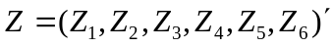 denote a mean-zero random vector with 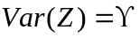. Let 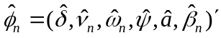 be the ML estimator. Then, when 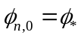,
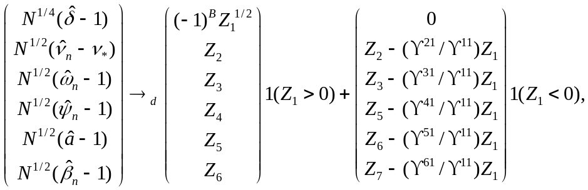
where B is a Bernoulli random variable with success probability equal to half and independent of Z. In addition, the LR test statistic for 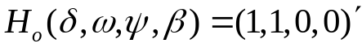 is a mixture of χ²(3) and χ²(4) with mixing probabilities equal to half.

4. Monte Carlo Experiments

• Foundation:
,
where η_{i} ~ N(0,σ_{η}²), q_{i0} ~ N(0,σ_{q}²), and ε_{i} ~ N(0,σ_{ε}²).

• Set var(η_{i}) = 2, var(q_{i0}) = 2, var(ε_{i}) = ν = 1, T = 5.
• δ_{o} = 0.5, 0.8, 0.9, 1
• When δ_{o} = 1, the y_{it} are random walks without drifts.
• 1000 iterations.
• 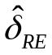, 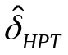, 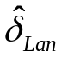.
• N = 500, 100
Table 1:
• Bias and MSE (mean square error) of the RE estimator of δ.
• Finite-sample size and power properties of t-tests.
• The biases are small, even when δ_{o} = 1.
• As δ_{o} increases, the test tends to over-reject correct hypotheses.
• The bias and MSE of the RE ML estimator do not seem to be sensitive to the sample size. The size of the t test is also not too sensitive to the sample size.
• When δ_{o} = 1, the t test rejects the correct hypothesis too much. This trend does not depend on the sample size. This result is consistent with Proposition 6.
• The performances of HPT are similar to those of RE.
• Lancaster ML often fail to locate mixima (consistent with Proposition 5).
Figures 2-3:
• Distributions of the estimators.
• Figure 3 is for N = 500 and Figure 4 is for N = 100.
• The distribution of the RE estimator becomes wider as δ_{o} increase. Up to δ_{o} = 0.9, the estimator is roughly normally distributed. Then, when δ_{o} = 1, the estimator is no longer normally distributed. Its distribution has a hump near δ = 1.

Figures 5-12:
• Compare the distributions of the three different ML estimators.
• Somewhat surprisingly, all of the estimators are similarly distributed.

Figure 13-14:
• LR test for H_{o}: 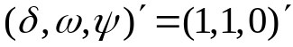.
• Figure 13 for N = 500; Figure 14 for N = 100.
• Compared to χ²(3) and the mixed distribution of χ²(2) and χ²(3).
• When N = 500, the distribution of the LR statistic ~ the mixture of χ²(2) and χ²(3).
• When N = 100, the distribution of the LR statistic is more skewed to the left than the other two distribution. Suggests that LR under-rejects.

Table 4:
• The normal size is 5%. When N = 500, the LR test with the mixed distributions are reasonably well sized. When N = 100, the LR test tends under-reject the unit root hypothesis.
• Not bad power properties. If the size distortion of the test could be corrected, the LR test could have even better power property. Bootstrap methods may be helpful.
• N is large, the test is powerful.

Summary of Monte Carlo:
• The finite-sample performances of the RE, HPT and Lancaster estimators are quite similar, despite the fact that the RE estimator is most efficient estimator under our Monte Carlo setup.

• When the true value of delta is near one, the distributions of the estimators do not follow the usual normal distribution even if the sample size is large.

• When the data follow the random walks without drifts, the Wald unit root tests based on the ML estimators reject the correct hypothesis too often.

• In contrast, the LR test for unit root performs better. When N is small, the test tends to under-reject the unit root hypothesis. But it retains a good power property. Thus, the LR test would be a useful alternative way to test unit roots.
5. Concluding Remark
• Examine the asymptotic and finite-sample properties of ML estimators.
• Performances of the three ML estimators are similar.
• Wald-type tests for unit root should not be used.
• The alternative LR test performs much better than the Wald tests.
Table 1
Simulation results of the three estimation procedures

 |  |  |  |  |  |  | Rejections of H_{o}: δ = δ₀ |  |  |  | Rejections of H_{o}: δ = 1
 |  |  | Mean | Bias | MSE |  | 1% | 5% | 10% |  | 1% | 5% | 10%
RE | N = 500
 | δ₀ = 0.5 |  | 0.5001 | 0.0001 | 0.0007 |  | 1.22% | 5.06% | 9.98% |  | 100% | 100% | 100%
 | δ₀ = 0.8 |  | 0.8061 | 0.0061 | 0.0032 |  | 4.00% | 8.10% | 12.52% |  | 82.76% | 90.72% | 93.40%
 | δ₀ = 0.9 |  | 0.9053 | 0.0053 | 0.0057 |  | 9.12% | 16.82% | 22.20% |  | 21.44% | 32.48% | 38.78%
 | δ₀ = 1 |  | 0.9982 | -0.0018 | 0.0047 |  | 9.20% | 16.06% | 20.68% |  | 9.20% | 16.06% | 20.68%
 | N = 100
 | δ₀ = 0.5 |  | 0.5011 | 0.0011 | 0.0033 |  | 0.94% | 3.94% | 8.32% |  | 99.98% | 99.98% | 99.98%
 | δ₀ = 0.8 |  | 0.8165 | 0.0165 | 0.0134 |  | 8.68% | 14.46% | 18.64% |  | 31.74% | 36.36% | 54.88%
 | δ₀ = 0.9 |  | 0.8977 | -0.0023 | 0.0144 |  | 9.88% | 17.00% | 22.48% |  | 13.50% | 22.38% | 28.14%
 | δ₀ = 1 |  | 0.9958 | -0.0042 | 0.0112 |  | 9.24% | 16.02% | 21.50% |  | 9.24% | 16.02% | 21.50%
HPT | N = 500
 | δ₀ = 0.5 |  | 0.5001 | 0.0001 | 0.0007 |  | 1.14% | 4.82% | 9.92% |  | 100% | 100% | 100%
 | δ₀ = 0.8 |  | 0.8220 | 0.0220 | 0.0076 |  | 9.56% | 13.74% | 17.40% |  | 69.58% | 77.52% | 80.02%
 | δ₀ = 0.9 |  | 0.9015 | 0.0015 | 0.0056 |  | 5.80% | 12.04% | 17.56% |  | 21.40% | 30.58% | 35.90%
 | δ₀ = 1 |  | 0.9986 | -0.0014 | 0.0043 |  | 8.34% | 14.76% | 19.46% |  | 8.34% | 14.76% | 19.46%
 | N = 100
 | δ₀ = 0.5 |  | 0.5026 | 0.0026 | 0.0046 |  | 1.12% | 4.02% | 8.46% |  | 99.90% | 99.92% | 99.99%
 | δ₀ = 0.8 |  | 0.8229 | 0.0229 | 0.0156 |  | 5.74% | 11.44% | 15.84% |  | 30.24% | 42.38% | 49.56%
 | δ₀ = 0.9 |  | 0.8846 | -0.0054 | 0.0122 |  | 5.40% | 10.08% | 15.52% |  | 12.96% | 21.34% | 26.58%
 | δ₀ = 1 |  | 0.9963 | -0.0037 | 0.0099 |  | 8.10% | 14.26% | 18.94% |  | 8.10% | 14.26% | 18.94%
Lancaster | N = 500
 | δ₀ = 0.5 |  | 0.5012 | 0.0012 | 0.0016 |  | 1.00% | 4.70% | 9.92% |  | 100% | 100% | 100%
 | δ₀ = 0.8 |  | 0.7941 | -0.0059 | 0.0025 |  | 2.24% | 6.04% | 9.94% |  | 72.56% | 82.56% | 86.74%
 | N = 100
 | δ₀ = 0.5 |  | 0.5012 | 0.0012 | 0.0034 |  | 1.42% | 5.92% |  |  | 99.94% | 99.98% | 99.98%

Notes: Table 1 reports the mean, bias and mean square error of 1000 simulations with the number of observations equal to N and the true value of delta equal to δ₀ along with the rejection rate of the likelihood ratio test with significance levels of 1%, 5% and 10% for the Random Effects (RE), Hsaio, Pesaran and Tahmiscoglu (HPT), and Lancaster’s Estimation procedures. Lancaster’s procedure fails to converge for large values of δ₀, thus results for δ₀ = 0.5 and 0.8 only are given for N=500, and 0.5 only for N=100. With N=500 and δ₀=0.8, still 8% of the simulations did not converge, and the results are those for the simulations that did converge.
Figure 3: The distribution of the RE estimator, varying δ, N=500 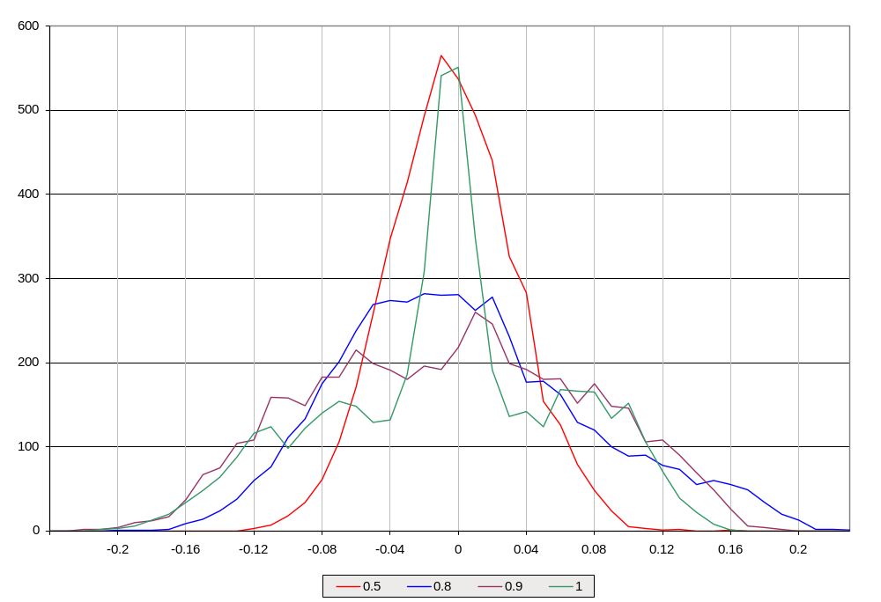
Figure 4: The distribution of the RE estimator, varying δ, N=100 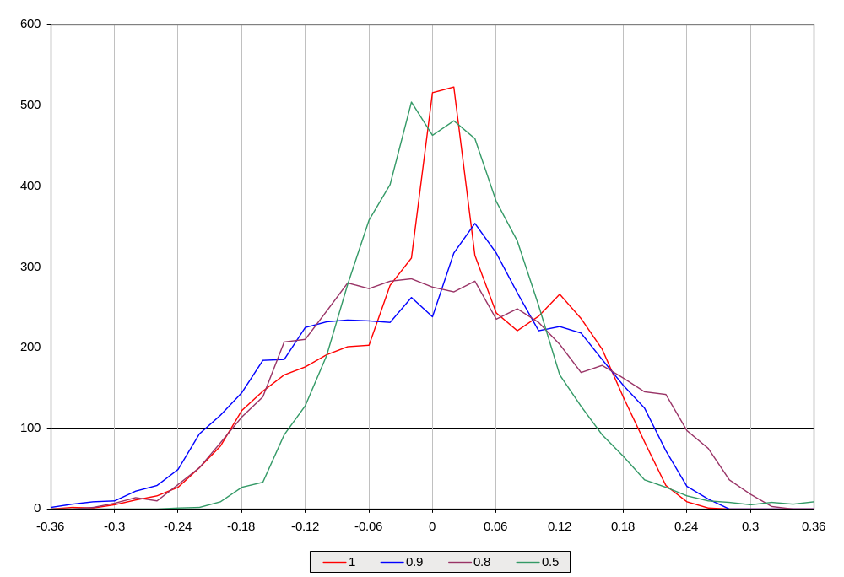

Figure 5: Procedure Comparison, N=500, δ=0.5
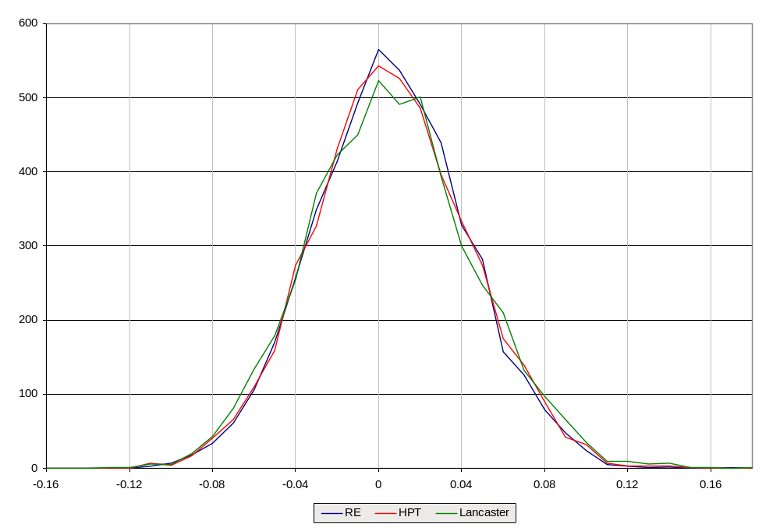

Figure 6: Procedure Comparison, N=500, δ=0.8
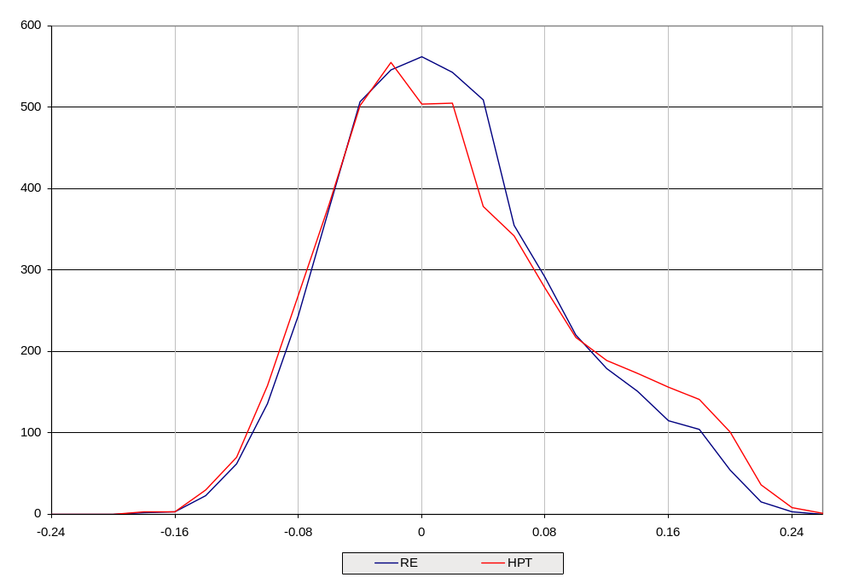
Figure 7: Procedure Comparison, N=500, δ=0.9
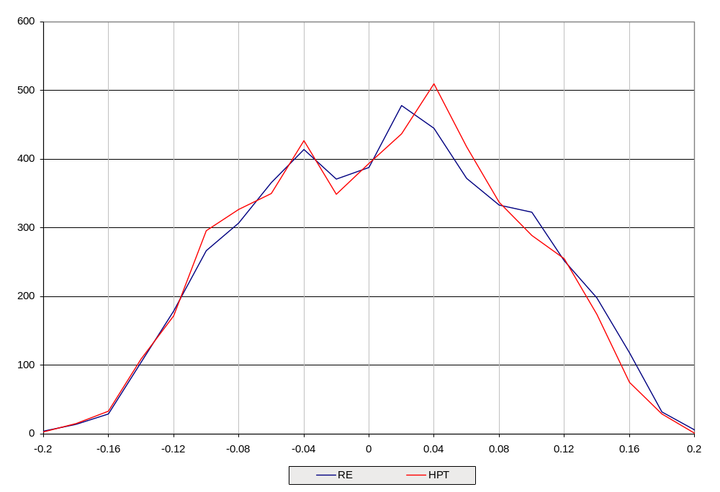
Figure 8: Procedure Comparison, N=500, δ=1
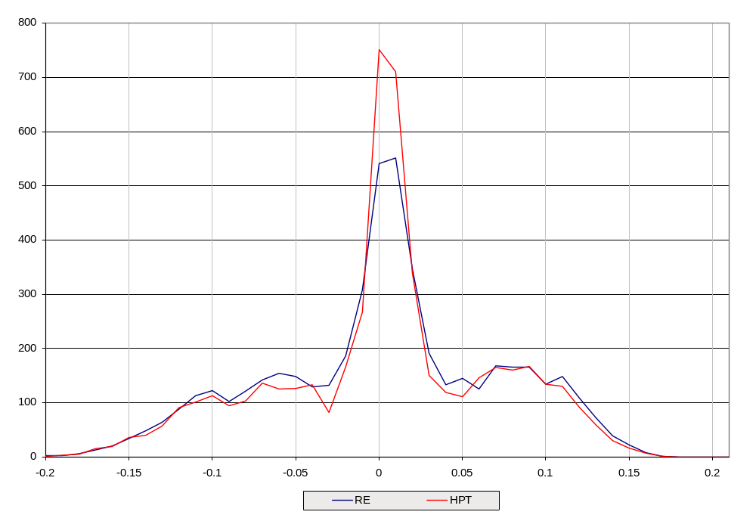

Figure 9: Procedure Comparison, N=100, δ=0.5
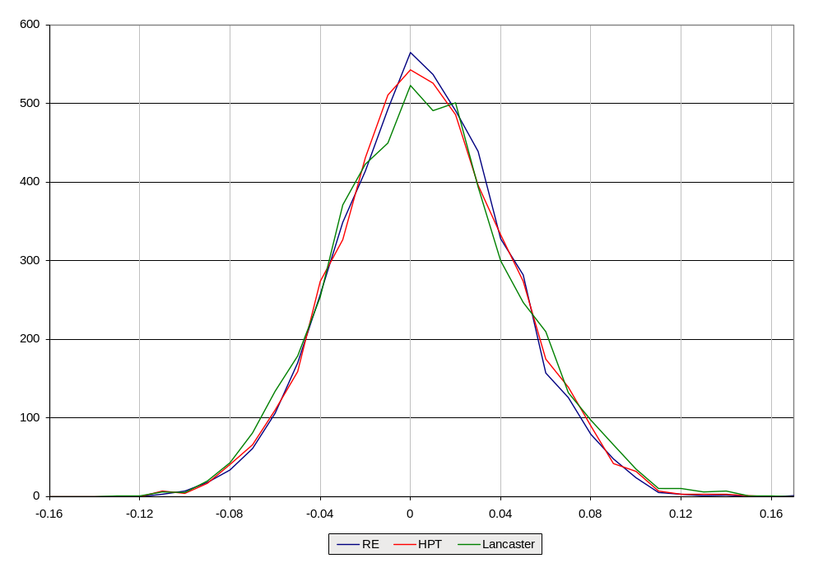

Figure 10: Procedure Comparison, N=100, δ=0.8
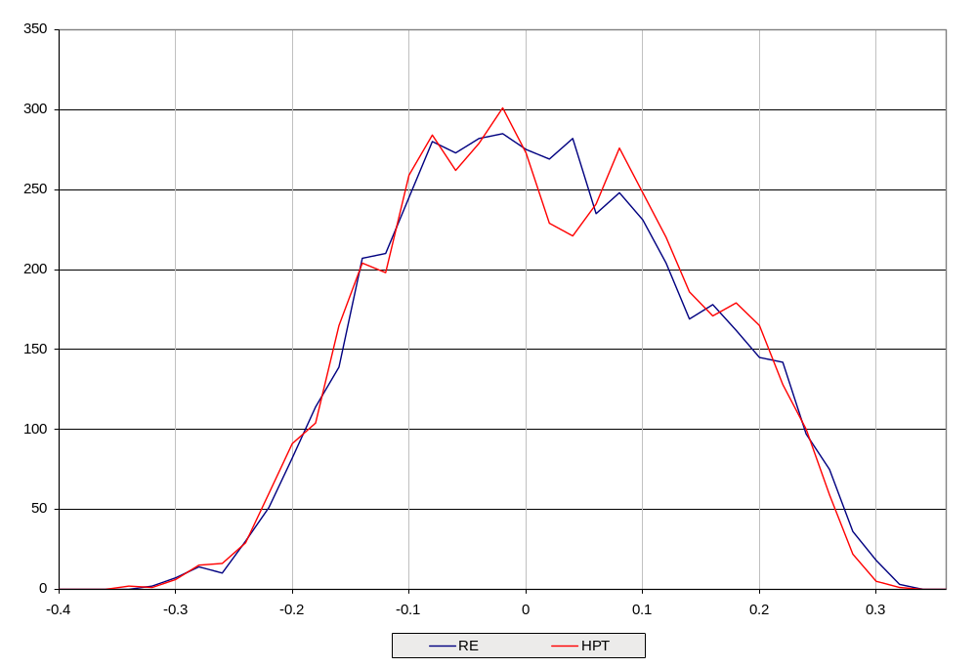

Figure 11: Procedure Comparison, N=100, δ=0.9

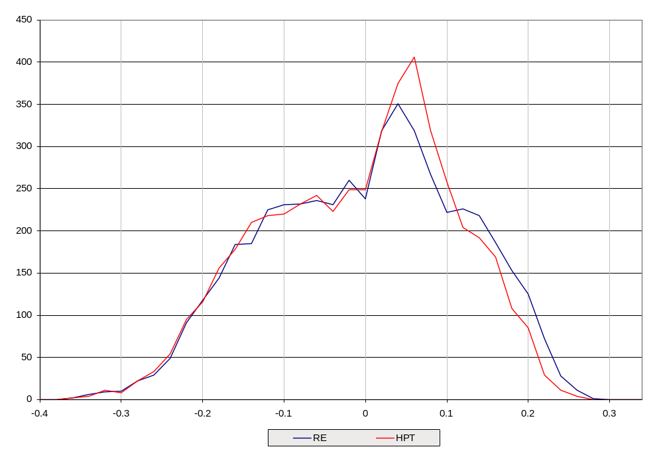

Figure 12: Procedure Comparison, N=100, δ=1

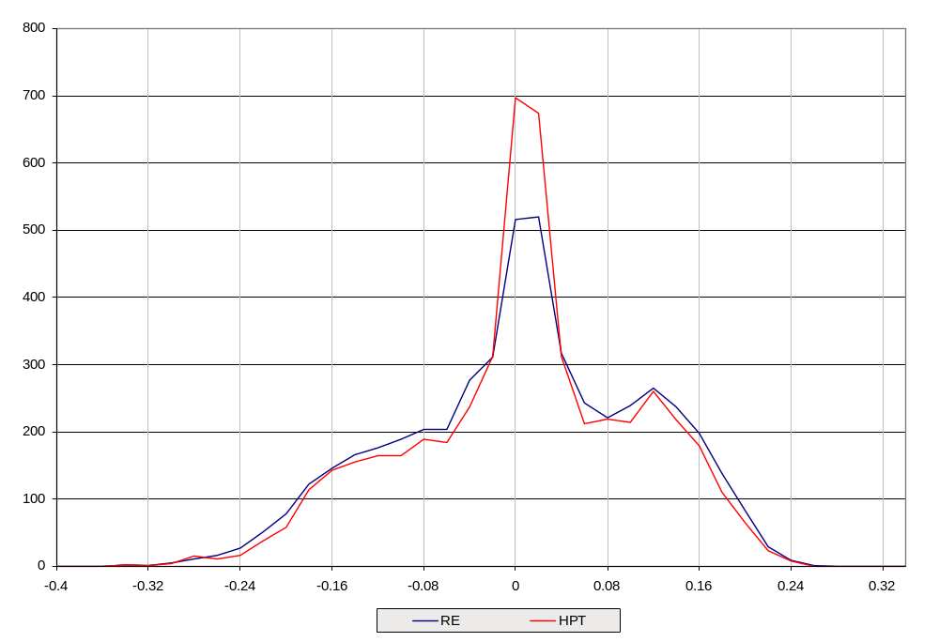
Figure 13: The distribution of the Likelihood Ratio Test, N = 500
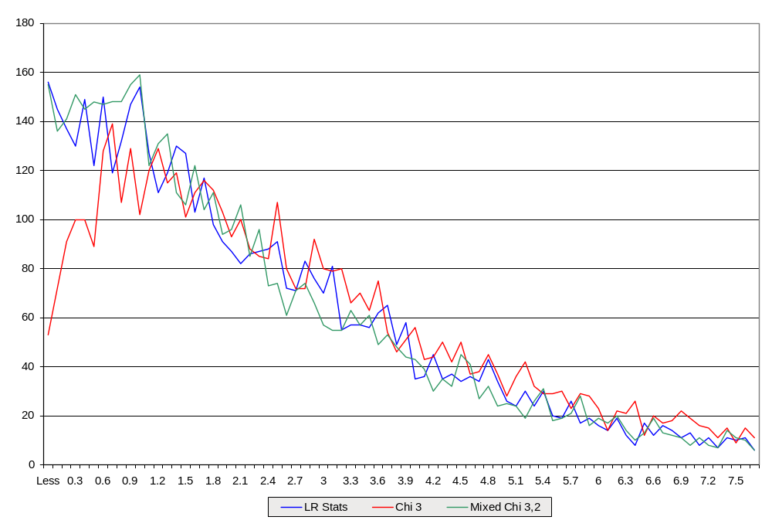

The distribution of LR statistics for the test of H_{o}: δ = 1 using the RE ML estimator with a stationary data generating process, true δ = 1, N = 500, compared with χ²(2), χ²(3), and a mixed distribution of χ²(2) and χ²(3).
Figure 14: The distribution of the Likelihood Ratio Test, N = 100
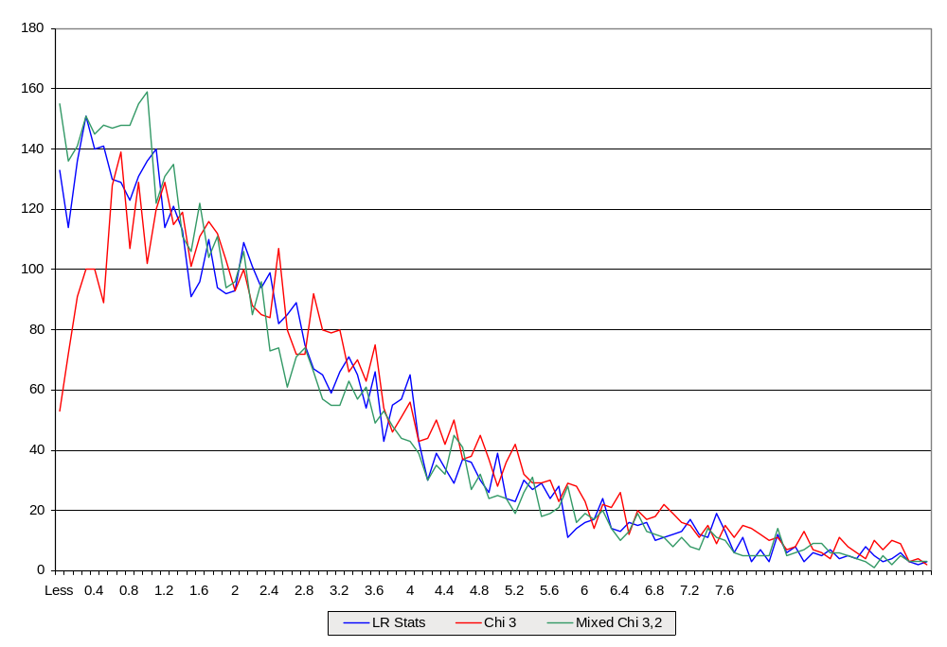
The distribution of LR statistics for the test of H_{o}: δ = 1 using the RE ML estimator with a stationary data generating process, true δ = 1, N = 100, compared with χ²(2), χ²(3), and a mixed distribution of χ²(2) and χ²(3).

