Cassandra Dillman
Eng 105
TTH 7:40
Dr. Beatty

From Space Aliens to Supercomputers: Facing Our Fears in Science Fiction

The dead are walking. They lumber and limp, feet scraping against the asphalt. Suddenly, they lunge and tear down into soft, warm, vulnerable flesh with startling speed. Not far behind, oozing inside-out hellhounds growl around razor fangs, stalking with murderous intent. All because of an innocent little airborne chemical weapon…This can’t be happening, this would never happen, right? It may sound far fetched, and it is. These horrifying creatures grace the screen of current blockbuster hit, Resident Evil 2: Apocalypse. So you’re safe. For now. But why are these images on screen so terrifying to us? Why do we cringe and gasp and sigh with giddy relief when it’s all over? Because we’ve just been given a brush with death. One of our greatest common fears came to life, and we stared it straight in the face and lived to tell about it. And that’s why we’ll keep coming back. After all, that is how science fiction films have maintained their popularity and appeal for over fifty years now – they take whatever common fears our current society possesses and reflect them back at us.
Fifty years ago, computers were as yet unheard of, and the world was still a very large place. Society was not so much concerned with trouble within itself, but with assault from outside forces. According to film critic John Brosnan in Future Tense, the end of World War II sparked the beginning of the “Golden Age” of science fiction (73). The war was over, but the Communist threat was still out there, and with the unleashing of the atomic bomb fear of a full scale nuclear war bordered on paranoia. Families built bomb shelters in their backyards and schools held air raid drills for their children. Science fiction thrived on society’s fear, with films such as The Day the Earth Stood Still, The War of the Worlds, and Invasion of the Body Snatchers. In these films, along with their numerous brethren, the alien invaders were “often a metaphor for Communism” (Dirks).
The Day the Earth Stood Still was an early warning to the world, and a commentary on paranoid society when its main character tried to do just that. The alien Klaatu, along with his robot backup, Gort, lands in Washington D.C. intending to deliver a message to the world’s leaders – Desist with atomic power or be destroyed. However, before he is able to deliver that message, he is promptly shot – a commentary on society’s post-war paranoia and immediate distrust of the unknown. America’s leaders suspect the humanoid Klaatu of being a Communist spy, Russia won’t meet to hear the message unless it takes place on its own soil, and Britain will have none of that. Ultimately, the alien’s attempts to deliver the dire message are futile, with the world’s leaders unable to overcome their pettiness and suspicion to really hear. Unlike films that followed, The Day the Earth Stood Still was an exception to the rule in that the alien was not an invader, but a benign message-bearer.

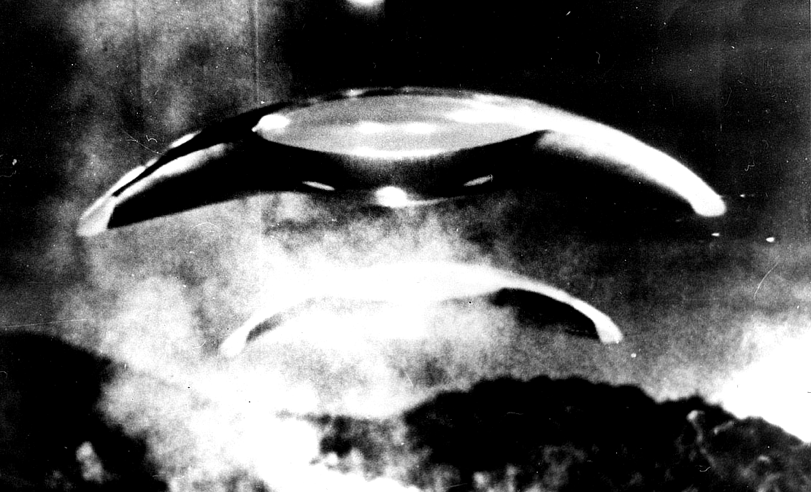
Aliens invade in War of the Worlds
It seemed that words were not enough, and so films like The War of the Worlds and Invasion of the Body Snatchers made good on Klaatu’s promise. Moviegoers watched in horror as America was indeed invaded, not by Communists but aliens in War of the Worlds. H.G. Wells’ novel may have been written in 1898, but as prominent film critic and author Douglas Menville once commented, it stood the test of time “remarkably well” and once updated, still managed to strike fear into the hearts of moviegoers as the Martian invaders decimate the American countryside (100). Overall, the world is unable to fight back and teetering on the verge of extermination. Luckily, the Martian invaders are sorely lacking in germ immunity and the world is saved. However, as Brosnan observes, “[.…]while we hear reports of how other countries are faring [….] we never hear about the Russians or any of the other communist countries” (92). Perhaps this is because they were already there, masquerading under the guise of heat-ray toting Martians. They may not be visible, but moviegoers suspected they were there, much like in Invasion of the Body Snatchers. In society at the time, you could not be sure who to trust – your barbecue-loving neighbor could be a Communist in disguise. Invasion used this paranoia and reflected it back at audiences with the unrecognizable faces of its invaders. Your local police officer, best friend, or even your mother could be out to get you.
Not only were the Commies out to get you, but their itchy trigger fingers were sitting on nuclear bombs as well. Though no science fiction films of the era actually showed nuclear war in progress, they ran rampant with images of the aftermath. Americans cowered in the shadows of giant nuclear ants in Them!, a hundred foot arachnid in Tarantula, and even mutants in World Without End. It may be a stretch for society today to connect giant ants with Cold War politics, but 1950’s society saw nuclear war embodied in these giant creatures laying waste to American towns and cities.
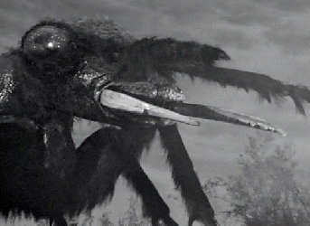
Them!
After a decade of alien invasion and nuclear monsters tearing their way across movie screens, the success of science fiction began to wane. Society was still afraid of Communists and nuclear war, but science fiction films had overcapitalized on their success. They began to be associated more with cheesy B-rated horror flicks and lost sight of their true purpose (Menville 152). It seemed that sci-fi had gone as far as it could go as far as studio budgets and cinematic special effects were concerned, and how could society realize its fears in science fiction if they could not be realistically portrayed? And so science fiction grew quiet until well into the next decade, gathering its strength and energy, lying in wait for the perfect opportunity to confront society once more.
By the late 60’s the Cold War was winding down and, though it didn’t officially end until the collapse of the Soviet Union, after the Cuban Missile Crisis in 1962, it seemed the worst was over. Nuclear weapons had become an ever present danger in society, and it would continue to be fertile ground for sci-fi films to plant their seeds of fear. Planet of the Apes made in 1968 was made famous for its Statue of Liberty-buried-on-the-beach scene. She holds her torch high and stares blankly out into a nuclear aftermath, promising society that the fear would fade, but the threat would forever remain. However, America had more immediate problems on its hands – namely Vietnam and the space race. Oddly enough, science fiction films and Hollywood in general “did its best to ignore the war” (Brosnan 164). For many citizens, Vietnam was just a place on a map, an abstract concept. The war posed no immediate threat to the everyday American and so posed no threat in science fiction.
The space race, on the other hand, was another matter entirely. America was excited, practically frothing at the mouth to get a man on the moon. After the Russians got Sputnik off the ground, it became a matter of national pride. Sci-fi films warned caution against throwing caution to the wind, with films like 2001: A Space Odyssey (Dirks). This film is one of many that illustrate missions into space gone horribly wrong. In 2001 society also got its first look at what happens when you put too much faith in technology. In was the first time that a super-computer stepped into an antagonistic role, when the machine HAL 9000 goes on a berserk, homicidal foray. It was an early recognition of the potential for society’s own technology to overtake society itself.
But Man made it to the moon! In 1969 Neal Armstrong stepped out onto the rocky terrain and triumphantly claimed it with an American flag. With that deed done and America secure with its place in the world once more, society stopped looking outward and turned inward. What was society becoming, and where was it going? It was the era of tree-huggers and flower children, individuals versus The Man. Growing concerns with over-population and loss of individualism were reflected back at society in the dystopian worlds of sci-fi film. Our own fears came to life as the workers were overpowered by their workplace, capitalism ran amok, and the government became the very totalitarian enemy it had spent the past twenty years fighting. George Lucas’ THX 1138 was one of the first, painting a bleak sterile future full of maddeningly white rooms and conformist cubicles. “Here the common worker [….] is a drugged-out drown, reduced to a number [….] and this futuristic society judges everyone by bottom-line economic considerations” (Telotte 48). The government itself was portrayed as faceless and remote. It was the collective nightmare of middle class workers and flower children alike – a world devoid of color and human emotion; a lifeless society living only for its productivity.
Conformism and loss of identity continued in Soylent Green, only this time the world was not sterile and white, but hellish and chaotic. New York City is crammed full of forty million people, and while human life is cheap, food is in short supply. Whole families are crammed into one bedroom, riot squads beat down the masses, and euthanasia is an encouraged practice. There is no privacy to be found and no room to move. Democracy has been thrown to the winds in the face of such extreme stresses and the government is once again faceless and remote. The film sickened audiences when it was revealed that the only food source left was…people. To a society that was growing increasingly concerned with the havoc humanity was wreaking on the world, this must have seemed like a frightening vision indeed. Mmm…Soylent green!

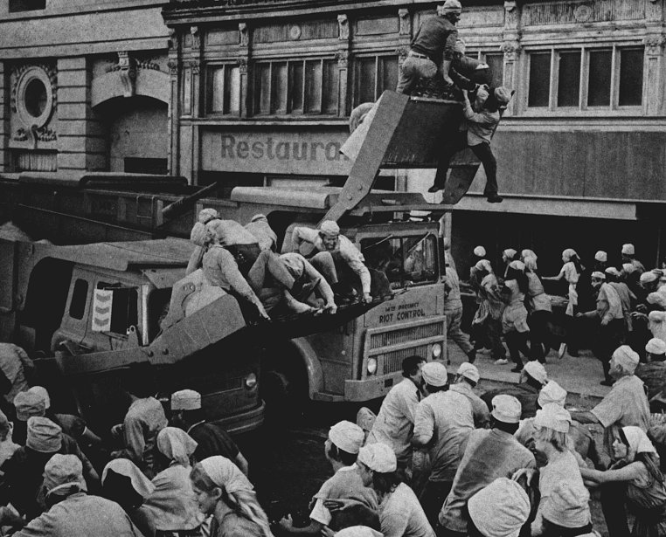
Bulldozing the masses in Soylent Green

The world was no longer a very large place and it was growing smaller by the second. Concern over the direction America was headed in continued to grow into the 80’s, and sci-fi was there to feed Americans’ apprehension. Massive corporate entities began to emerge, bringing globalization in their wake. Japan was becoming an economic force to be reckoned with, and suddenly imperialistic American society feared maintaining its identity in the onslaught of foreign influence. Mix in lingering environmental concerns and you have the backdrop for 1982’s cult hit Blade Runner. It was a dismal future, dominated by retrofitted buildings and massive billboards (many curiously in Japanese). “Outside the rain pours down constantly; the skies are covered by smoke, smog [….] where factories seem volcanoes spewing up ash across the city” (Senior 3). Again, there is a noticeable absence of anything organic and a noticeable absence of government as well. Only the corporations matter. This is the world in which protagonist every-man Rick Deckard lives. He carries out his mission amid this urban nightmare, maneuvering his way among crowds “hiding their features to avoid the corrosive elements and blending into a large amorphous mass” (3). For him, it is depressingly unavoidable. For American audiences, it was the horrible nightmare they just wanted to wake up from. This was the future that our society had to look forward to. Wouldn’t you have been afraid?
With that all said and done, we now move into more familiar territory. You might have scoffed at the idea of giant ants or packaged people, but why do you shiver at the sight of a red-eyed cyborg or rotting zombie? You’re afraid. And if you took a look at the people around you, chances are that they’ll be afraid, too. Science fiction film has entered a new Golden Age, and its not nuclear war or faceless governments that concern us. We’re afraid of the technology that we created. Author for “Film Quarterly” Fred Glass observes, “For most of us the new technologies represent something quite outside our control” (27).

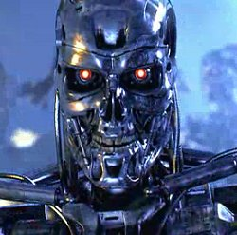
The Terminator

Early illustrations of our lost control are the two Terminator films (I discount the third because it had no place in the original concept and was a sorry attempt to capitalize on earlier success). These films are reminiscent of 2001: A Space Odyssey in that once again, a supercomputer has become the enemy. Only this time, it has a nuclear bomb and an army of murderous cyborg minions at its disposal. The dominance of technology is asserted in images of cold steel skeletons crushing the fragile skulls of human beings beneath them. Their burning red calculating eyes are the very essence of evil as they decide humans are destined for “termination”. And unless you’ve been hiding in a cave somewhere, you must have heard of The Matrix trilogy, a more recent example of our very real and valid fear of technology. As Steven Hawking once commented, “"In contrast with our intellect, computers double their performance every 18 months” (Warwick). Computers can do things that we cannot – they can think faster and have no scruples to get in the way. It’s no wonder that the film makes us so uneasy. Not only have the machines driven humanity to the brink of extinction, but the entire Matrix is a metaphor for our increasing dependence on technology, and our loss of identity because of it. We are no better than the Duracell society onscreen – we log on to the internet on a daily basis, projecting our “digital selves” into cyberspace. Our children are being reared from infancy with a bottle in one hand and a mouse in the other. The Matrix is a warning to take control of our technology before it takes control of us.
Another growing fear reflected back at us in science fiction film is the effect genetic research will have on our society. Jurassic Park used our paranoia of genetic advancement to terrify us with extinct beasts that should never have been brought back to life. In the film, an eccentric billionaire brings a select group of guest to view his new theme park, in which the attractions are real live cloned dinosaurs. The lesson of the film is that if Man chooses to “play God”, Man risks being hunted and destroyed by its own creation. It may not be possible to clone dinosaurs, as was the plot of the film, but neither was it really feasible that giant ants would emerge from nuclear waste in the 50’s. The dinosaurs, free to run wild, represent our fears of genetic research running wild. Genetic research, as with technology, is not a toy for our society’s amusement and should not be taken lightly. Otherwise we risk our fears coming back to bite us.
Our general unease with genetic advancement is further exemplified in Gattaca. Once again, our own creation threatens to outstrip us. The world of Gattaca is inhabited by a society superior to our own. Positions on the social ladder are no longer determined by race, religion, or gender but by genetic makeup. While this may sound all well and good, those who do not level up to the standard are subject to routine discrimination and form the “underbelly” of this new society. The main character, Vincent, is one of the unfortunate few to have been born in what was once the “natural” way. The fact that artificial conceptions are the new norm reveals our society’s fear of dehumanization in the face of such advancement. It’s pretty much a guarantee that none of us would be sitting in cushy office chairs, nope, we’d all be picking up trash or washing windows like the main character. Gattaca is another vision of a possible dystopian future, but this time created from within. Like those that came before it, the society depicted is sterile and faceless. Productivity is the main objective – as displayed by the many workers efficiently tapping away at silent keyboards in pristine cubicles. If we as a society were supposed to applaud the use of genetic enhancement, then those of the upper echelon in Gattaca would not all look the same, and their faces might not be so cold. No, we side with Vincent, rooting him on in his quest for equality, because if he ends up washing windows, we’re destined to be right there with him.
Our fears of advancing technology and genetic research are nothing compared to the panic incited within us with the statement of two words – Biological Weapons. This is one of our most current fears, and all else fades to the background when this topic is mentioned. It’s one of the main reasons we had for invading Iraq, and you can be sure that almost every major world power either has possession or is experimenting with some kind or another. Our government does, and we know it. There’s no telling what it could be or what effects it could have on us, all we know is that we’re praying it never gets loose. Our worst nightmares are realized in films such as 28 Days Later and Resident Evil. In both of these films, a virus escapes through pure accident, emphasizing the real possibility that it could happen to us. 28 Days Later shows the virus escaping into Great Britain first, then the rest of the world, causing its victims to begin vomiting violently and then quickly turn into rasping, blood thirsty undead creatures. We watch with bated breath as the few survivors run from hordes of the sickening things. It is truly the end of the world – there are the lucky dead rotting in cars, decay is everywhere and only hastily written farewells fluttering in the wind stand as evidence of the society that once existed. The rapid breakdown of society scares us as much as the virus-infected creatures – the streets are empty, government is non-existent, and the world is eerily silent.
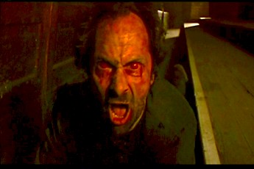
The virus infected walking dead in 28 Days Later

Resident Evil and its follow-up, Resident Evil: Apocalypse, were even more successful than previous bio-weapons films, because not only did the nightmare occur in our own country, but they took us to the very extremes of terror. A chance slip and a vial breaks, unleashing an airborne virus into the air ducts. Thankfully, the victims do not start vomiting uncontrollably. No, they drop twitching to the floor and are soon reanimated zombies thirsting for human flesh. Not even the animals are safe in these films, as we watch man’s best friends turn into oozing hellhounds. A bite, a mere scratch, and you’re already dead. What scares our society most about these films is that we just don’t know. We remain blissfully ignorant of the biological weapon capabilities of even our own government. Somewhere out there could lurk a nasty little virus, just waiting for the opportunity to break free.
Faced with the possibility of deadly viruses and painful deaths, who cares about ridiculous giant ants or even supercomputers gone berserk? We sure don’t! We care about what poses the most immediate threat, and vomiting zombies seem a little bit more threatening than pod people. But if we lived in the society of the 1950’s, ants and pod people would be a heck of a lot scarier, and virus-infected zombies would seem a little absurd. Why such a change in science fiction films over the years? That’s how science fiction films maintain their everlasting appeal – they take what current society is most afraid of and reflect them back at us through a carnival fun mirror. We thrill at the sound of dead feet scraping across the asphalt and tremble with repulsed fascination at the sight of the dead walking. We love to ask ourselves, “This can’t be happening! This would never happen! Right?” Wrong.

Works Cited

Brosnan, John . Future Tense. New York: St. Martin's P, Inc., 1978.

Dirks, Tim. Science Fiction Films. May 1996. 02 Oct. 2004
<http://www.filmsite.org>.

Glass, Fred. "Sign of the Times." Film Quarterly 38 (1984): 16-27.

Menville, Douglas . A Historical and Critical survey of the Science Fiction
Film. Diss. U of Southern California, 1959. New York: Arno P Inc., 1974.

Senior, W.A.. "Blade Runner and Cyberpunk Visions of Humanity." Film
Criticism 21 (1996): 1-12.

Telotte, J.P.. "The Problem of the Real and THX 1138." Film Criticism 34
(2000): 45-57.

Warwick, Kevin. "The Matrix - Our Future?" The Philosophy of the Matrix. 20 Nov.2002: 14 Oct. 2004

