Introduction - July 2023 Elly van Gelderen

Why go back to manuscripts?
How do spelling, punctuation conventions, the frequent lack of a distinction between main and subordinate sentences, the contractions, and the abbreviations affect a linguistic analysis?
(1) a. ðe ricses folc min Lindisfarne
b. seþe ræccet folc min israhæl Rushworth
c. seþe recð min folc israhel 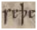 West Saxon
(2) ham seoluen `themselves’ (Katerine)
(3) wastu `know you’ (Katerine)

Linguistic background
Synthetic – analytic (Table 1.1; Figure 1.1)
Nominal and verbal endings
Clause structure

Background to OE and ME morphosyntax
External history
Grammaticalization (Table 1.3) and internal history
Appendix I

From older to less old
A Nu scylun hergan hefaenricaes uard metudæs maecti end his modgidanc uerc uuldurfadur
Now shall praise heavenkingdom's guardian Lord's might and his thought work wonderfather
B On þyssum geare man halgode þet mynster æt westmynstre on cyldamæsse dæg . 7 se cyng eadward forðferde on twelfts mæsse æfen ...
C THere be two causes, which moue me to the penning of this Elementarie, whereof the one is mine own promis, the other is the argument it self. The argument it self persuades me to the penning thereof, bycause it is so fit for the training vp of childern, as nothing can be fitter: and the stream of discourse in my former book, which I name Positions, did carie me on to promis it, and binds me to perform it.
General trend
OE late OE early ME late ME early ModE
Free word order but often V2 and OV OV > VO SV with some V2 loss of V2
Case endings on nouns and pronouns loss of case on nouns
Inflection on V for Subject and Tense less inflection
No articles, only demonstratives articles
Some omission of subject pronoun pronoun is obligatory
Limited use of auxiliaries and prepositions more `to’ and ‘of’ many auxiliaries
Negation before the V reinforcement with second negative negative after the auxiliary
Table 2.1: Changes in the syntax and morphology of English

An example
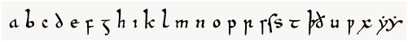
a b c d e f g h i k l m n o p r s t þð u w x y

Beowulf (Figure 2.2)
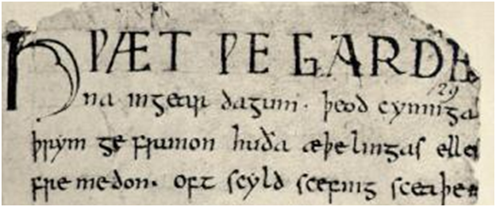

Beowulf transliterated
H ǷÆT ǷE GARDE indeed we spearda
na inƷear daƷum . þeod cynninƷa nes inyore days kings
þrym ge frunon huða æþelingas ellen glory heard howthose nobles courage
fre medon . Oft scyld scefinƷ sceaþe did Often Scyld Scefing shadow
'Indeed, we have heard of the courageous deeds of the Danes (and) their kings in earlier times, how the noble ones accomplished courageous deeds. Often, Scyld Scefing ...'

