HW2 - Naxos Summerschool
Havelok is a story about a Danish prince, Havelok, who is sheltered in his youth in England by a fisherman called Grim and then assumes the rule of Denmark. Preserved in the Bodleian Library as Laud Misc. 108, it is from the end of the 13th century and from the Northeast Midlands. The excerpt describes Havelok’s arrival in England and his stay with Grim. A transcription and translation appear below.
A What type of script is this? Are there words you recognize?

B How is the [th] rendered? What does this tell you about the time period or region?

C What can you say about negatives, articles, and word order (about 250 words)? Give specific examples.

D What stage is this text in, in terms of analytic or synthetic? Give evidence.

E Do you see any influence from the languages we discussed? Scandinavian? Can you determine the dialect?

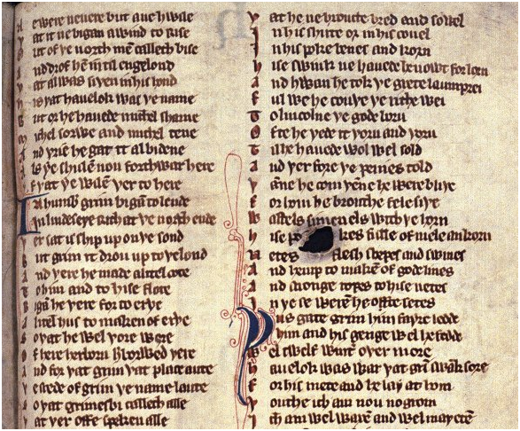
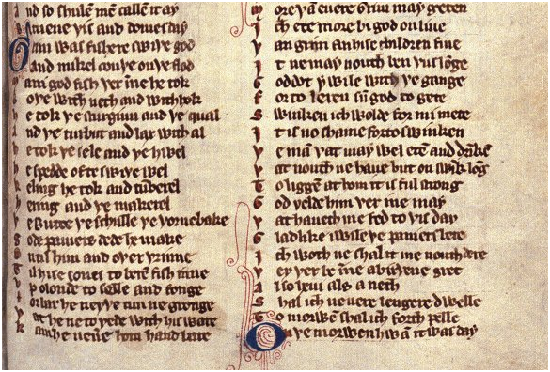
Figure 1: Havelok, folio 208, lines 722-811

In the transcription, I have used the wynn for the th even though sometimes it is a thorn.
Newere neuere but ane hwile  Ƿat it ne bigan a wind to rise  Out of ƿe norƿ mẽ calleth bise  And drof hẽ intil engelond  Ƿat al was siƿen in his hond  His ƿat hauelok was ƿe name  But or he hauede michel shame  Michel sorwe and michel tene  And yete he gat it al bidene  Als ye shulen now forthward lere  Yf ƿat ye wilẽ ƿerto here  I n humber grim bigã to lende  I n lindeseye rith at ƿe north ende  Ƿer sat his ship upon ƿe sond  But grim it drou up to ƿe lond  And ƿere he made a litel cote  To him and to hise flote  Bigã he ƿere for to erƿe  A litel hus to maken of erþe  So ƿat he wel ƿore were  Of here herboru herborwed ƿere  And for ƿat grim ƿat place aute  Ƿe stede of grim ƿe name laute  So ƿat grimesbi it calleth alle  Ƿat ƿeroffe speken alle  And so shulẽ mẽ callẽ it ay  Bitwene ƿis and Domesday  Grim was fishere swiƿe god  And mikel couƿe on ƿe flod  Mani god fish ƿer ĩne he tok  Boƿe with neth and withhok  He tok ƿe sturgiun and ƿe qual  And ƿe turbut and lax withal  He tok ƿe sele and ƿe hwel  He spedde ofte swiƿe wel  Keling he tok and tumberel  Hering and ƿe makerel  Ƿebutte ƿe schulle ƿe ƿornebake  Gode paniers dede he make  On til him and oƿer ƿrinne  Til hise sones to beren fishe inne  Up o londe to selle and fonge  Forbar he neyƿer tun ne gronge  Ƿat he ne to yede with his ware  Kam he neuere hom hand bare | Ƿat he ne broucte bred and sowel  In his shirte or in his cowel  In his poke benes and korn  Hise swink he hauede he nowt forlorn  And hwan he took ƿe grete lamprey  Ful wel he couƿe ƿe rithe wei  To Lincolne ƿe gode boru  Ofte he yede it ƿoru and ƿoru  Til he hauede wol wel sold  And ƿerfore ƿe penies told  Ƿanne he com ƿẽne he were bliƿe  For hom he brouthe fele siƿe  Wastels, simenels with ƿe horn  His pokes fulle of mele and korn  Netes flesh, shepes and swines  And hemp to maken of gode lines  And stronge ropes to hise netes  In ƿe se werẽ he ofte setes  Ƿusgate Grim him fayre ledde  Him and his genge wel he fedde  Wel twelf winter oƿer more  Hauelok was war ƿat grĩ swãk sore  For his mete and he lay at hom  Ƿouthe Ich am now no grom  Ich am wel waxẽ and wel may etẽ  More ƿã euere Grim may geten  Ich ete more bi god on liue  Ƿan grim an hise children fiue  It nemay nouth ben ƿus lõge  Goddot! I wile with hem gange  For to leren sũ god to gete.  Swinken ich wolde for my mete  It is no shame for to swinken  Ƿe mã ƿat may wel etẽ and drĩkẽ  Ƿar nouth ne haue but on swink lõg  To liggẽ at hom it is ful strong  God yelde him ƿer I ne may  Ƿat haueth me fed to ƿis day  Gladlike I wile ƿe paniers bere  Ich woth ne shal it me nouth dere  Ƿey ƿer be ĩne a birƿene gret  Also heui als a neth  Shal ich neere lengere dwelle  Tomorwẽ shal ich forth pelle  On ƿe morwen hwan it was day
Table 2: Havelok, lines 722-811
When they were but a mile from land the wind began to rise out of the north and drove them to England, which would be Havelok’s. But first he would have much shame, sorrow and pain, yet he got it all, as you will learn if you are willing to listen. Grim landed in Humber, at the north end of the district of Lindsey. The ship sat on the sand, but Grim drew it onto the land, and he built a small cottage for his group. He made a little house of earth so that they were well protected. Because Grim lived there, the place was called Grimsby and will be until doomsday. Grim was an excellent fisherman and caught many good fish, both with net and hook. He took sturgeon, turbot, salmon, eel, cod, porpoise, seal and whale, flounder, herring, mackerel, halibut and many others. He made good baskets, one for himself, and one for each of his sons for carrying the fish to sell and trade. He went to every town and farm with his wares, and never came home empty-handed | without bread and grain; his work was not wasted. When he caught the great lamprey, he knew the way to the borough of Lincoln. He went through the town until he sold everything and counted his pennies. They were happy when he came home, bringing fine breads and meat of cattle, sheep and swine, as well as hemp to make strong ropes for the nets he set. In this way, Grim fed his household well for twelve years or more. Havelok was aware that he lay at home while Grim worked hard to feed him. “I am no longer a boy,” he thought. “I am grown and may eat more than Grim can get; by God, I eat more than Grim and his five children! This cannot go on. I will go with them to learn how to be useful and work for my food. There is no shame in working; to eat and drink without working is wrong. God reward him who has fed me to this day! I will gladly bear baskets, which will not harm me even if the burden they contain is as heavy as an ox. I will no longer stay at home, but hurry forth tomorrow.” In the morning, when it was day
Table 3: Translation of Havelok, folio 208

