Media Coverage of DMML activities

Ask the Experts: Social Media and Conflict Prevention
by Micah Zenko
January 23, 2013
http://blogs.cfr.org/zenko/2013/01/23/ask-the-experts-social-media-and-conflict-prevention/
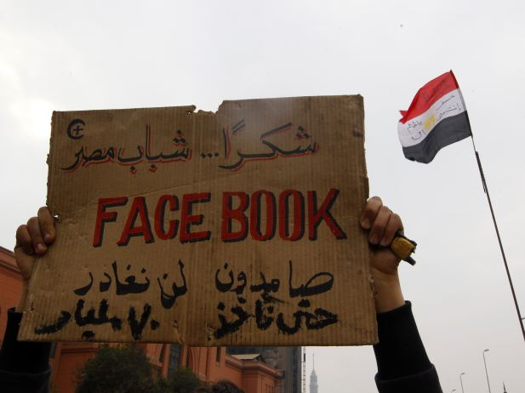An opposition supporter lifts a placard at the front line near Tahrir Square in Cairo, Egypt, in July 2011 (Yannis Behrakis/Courtesy Reuters).

Share
57
155
An increasing number of policymakers and think-tank residents are championing the power of social media and big data to pressure governments, empower civil society, deter human rights abuses through the power of witness, and semi-accurately forecast political instability and conflict without the false positives. In a column today, Thomas Friedman endorsedutilizing existing social networks “to our advantage to gain leverage in diplomacy” by speaking directly to Iranians, Israelis, and Palestinians, who will then somehow force their governments to finally do what they have not (because, of course, ordinary citizens are aligned with U.S. interests once they are addressed in Persian, Hebrew, or Arabic).
In an effort to better understand how social media and big data can practically be used prevent and mitigate conflict, the Center for Preventive Action (CPA) recently held a workshop, “Social Media and Conflict Prevention,” convening experts from academia, industry, and the U.S. government. Building on that workshop, we asked several of the panelists to address the following question:
“How can social media be leveraged to prevent and manage violent conflict?”
Dr. Sheldon Himelfarb is director of the Centers of Innovation: Media, Conflict, Science, Technology, and Peacebuilding at the U.S. Institute of Peace (USIP). He tweets at@shimelfarb.
The best answer to this question can be found in what communities around the globe are already doing with social media to try and mitigate causes of violence. It’s hard to overstate the extent and diversity of efforts we see in the conflict countries where USIP works. Here are just a few examples:
Fostering interethnic dialogue: In Iraq, there is a very solid conflict resolution curriculum underpinning the SalamShabab.com (Peace Youth) online youth network, TV program, and Facebook group of about thirty thousand active users—with research showing shifting attitudes about ethnic tolerance among them. There is also the larger two hundred thousand–member YaLa-Young Leaders network taking shape between Israelis, Palestinians, and others in the Middle East, actively campaigning against violent conflict.
Managing elections: Virtually every election these days will have voting actively monitored for everything from violence to fraud using a range of social media platforms. In Kenya and South Sudan, for example, referenda were held that were considered successes in terms of violence prevention—with social media networks being a key part of the civil society toolkit.
Preventing gang violence: Twitter penetration in Brazil is among the highest on the planet, and communities in Brazilian favelas say it has been a factor in helping bring down both gang and police violence. We’re also seeing similar programs elsewhere.
Preventing resource disputes: Early-warning networks like CEWARN in sub-Saharan Africa try to leverage social media, along with satellite information and traditional media reports, to prevent conflict over land, water, and other resources.
Constitution-building: We’ve seen efforts to use social media in transitional nations like Egypt to help build constitutions with public input, although it wasn’t very successful there. But even in Egypt, as in Morocco and Iceland, communities are learning a lot about crowdsourcing input on constitution-writing, and it will certainly continue.
Protesting violence: By now, many have heard of the 2008 Facebook campaign—A Million Voices Against the FARC—used to rally millions of people all across Colombia and around the world to protest the violent tactics of the FARC guerilla movement.
Actually, it’s difficult to think of a single issue we work on in the conflict management field—election violence, refugee resettlement, interethnic hatred, land disputes, gender violence, and so on—in which we haven’t seen an effort to use social media networks to inflect the causes of conflict. Social media is rapidly becoming an almost ubiquitous tool everywhere we work, and people are using it, with mixed success, to prevent violence.
Can we improve the success rate? I expect we will, as these tools become increasingly familiar to local communities and governments alike. Early warning systems are improving, earlier response should follow.

Kalev Leetaru is a university fellow at the University of Illinois Graduate School of Library and Information Science. His research focuses on the application of “big data” to studying global society and is the author of Data Mining Methods for the Content Analyst.
The rise of social media alongside mobile Internet, smartphones, and consumer geolocation has created a worldwide sensor network of society, a live historical documentary, powered and largely funded by citizens themselves, that offers our first glimpses into the global heartbeat. Facebook receives more than three hundred million new photographs every day, over one billion photographs have been uploaded to Instagram, and seventy-two hours of video are uploaded to YouTube every minute—of which three hours are uploaded directly from mobile devices, recording the world as it happens. As conflict unfolds today, the stream of images and videos from participants allow us to see what kinds of weapons are being used, how well-trained local forces are, evaluate morale, and examine conditions on the ground hour by hour. These images, movies, and words offer us something akin to Google’s “Street View” on a real-time basis from nearly anywhere in the world to assess and manage conflict and its precursors in ways never before possible.
Moreover, we can watch global reaction as a situation unfolds, looking at which elements and themes are resonating halfway across the world, assessing possible interventions, and the impact of enacted interventions, before situations unravel to violence. As the United States unveils a new policy or as it officially confirms military action, such as bin Laden’s death, we are able for the first time to watch the world react moment by moment, which regions and social groups are paying the most attention to the event, and what cultural narratives the event is tapping into. Most critically, it allows us to see how global events are being contextualized locally around the world, potentially in unexpected ways, and to be able to reach and react to communities instantly that we historically could not. In the past, an amateur video attacking the Prophet Muhammad would never have seen the light of day, while today it generates a firestorm on the other side of the globe. Yet, that same social media that allows video to reach a worldwide audience allows us to watch reaction to it in real-time, and to eventually participate and potentially help shape that dialogue, or at the very least have advanced warning of potential reaction.

Patrick Meier is director of Social Innovation at the Qatar Computing Research Institute (QCRI). He blogs at iRevolution.net and tweets at @patrickmeier.
Today’s social media ecosystem can be leveraged to prevent and manage violent conflict in at least four ways: 1) early warning; 2) real-time awareness; 3) real-time feedback; and 4) self-organization.
The early detection of violent conflict is critical for early response. As Hillary Clinton observed in 2010, the spread of social media is forming a new “nervous system” for our planet. This nervous system can help to identify early signs of conflict. Monitoring a conflict situation in real time is also important to inform appropriate and timely interventions. To be sure, social media (big data) can help us capture the pulse of our planet in ways that were inconceivable only five years ago. Social media can also provide real-time feedback on what interventions may or may not be working. This means that social media can potentially serve as a complementary channel of information for impact evaluation.
Finally, social media can facilitate self-organization for early response. Social media can provide situational awareness and more importantly shared situational awareness. Recall Habermas’s treatise that “those who take on the tools of open expression become a public, and the presence of a synchronized public increasingly constrains undemocratic rulers while expanding the right of that public.” The capacity to self-organize also renders conflict prevention networks more resilient. In other words, social media can be used to power civil resistance in nonviolent movements that seek to end oppression and bloodshed. As one Egyptian activist reported during the revolution, “We use Facebook to schedule our protests, Twitter to coordinate, and YouTube to tell the world.” Social media can be similarly leveraged to facilitate a resilient people-centered approach to conflict prevention.

Lea Shanley is director of the Commons Lab in the Science and Technology Innovation Program of the Woodrow Wilson International Center for Scholars. Follow @GeodataPolicy and @STIPCommonsLab.
There are a number of ways social media can be harnessed to monitor and manage violent conflict. By studying how information and behaviors propagate through social networks, researchers and formal response organizations might gain advance warning of emerging threats. They also could use social media to collect on-the-ground situational awareness, issue alerts and warnings, and coordinate efforts, as a growing number of disaster responders are doing.
Social media also can be used to measure the quantity and quality of intergroup engagement, across both active and potential conflict boundaries, in real time. For instance, on November 20, 2012, the news media reported one Israeli and twenty Palestinians had been killed; on that same day, the Stanford Peace Innovation Lab found that 16,303 Israelis and Palestinians also had “friended” each other on Facebook.
But social media can cut both ways. Perpetrators of violence can use social media to circulate misinformation and rumors, foster panic and confusion, and incite violence. Oppressive regimes may try to suppress citizen reporting through Internet blackouts, as in Syria and Egypt, or worse—by arresting, kidnapping, torturing, or and murdering those who post critical comments via social media. These actors are capable of operating in loosely organized networks with a changing cast of leaders, making them difficult to track.
In order to maximize the benefit of these technologies while minimizing the drawbacks, we must adapt the humanitarian principles of Do No Harm and develop data protection standards to meet this changing technological environment. At the same time, we should not become so risk averse that vulnerable populations fail to receive support—in terms of information, tools, and access to suitable social media platforms—that could be provided ethically and securely.
Concerns about liability and endangering people on the ground make humanitarian organizations reluctant to issue alerts and warnings via social media as a crisis unfolds. Setting up a clearinghouse for these organizations where SMS text messages could be made anonymous and be pinpointed on a “crisis map” might provide critical information to responders—such as rumors of gang violence, looting, or criminal activities—to improve security while protecting the identity of the informants.
To reach its full potential, social media and its users need better analytic tools to cut through the global chatter that makes monitoring social media so difficult. New tools might help. Arizona State University has developed TweetTracker, which is being used to filter, analyze, and visualize Arabic language tweets and tweets geolocated in Syria during the ongoing civil war. In the process, they discovered that the Twitter-using population in Syria was more worried about access to water than food.
Social media has the potential to help people around the world who are caught in the crossfire of violent conflict. But social media also makes it easier for those seeking to exacerbate and exploit violent situations via incendiary messages and misinformation—oftentimes at little risk to the perpetrators. Evidence suggests the use of social media will continue to grow exponentially—we now need to take the necessary steps to make sure it properly serves those who need help the most.
Posted in Ask the Experts, Conflict PreventionShare

Post a Comment1 Comment
- Posted by Javed MirJanuary 24, 2013 at 7:30 am
–and the presence of a synchronized public increasingly constrains undemocratic rulers while expanding the right of that public.–
A nicely written article with references from experts in social media culture. This article has some good advices specially for the writers/.journalists of those countries where democratic process is still too young.

Hurricane Sandy Tweet Analysis Report published by Humanity Road
http://www.humanityroad.org/_blog/HR_Talk/post/SWBA
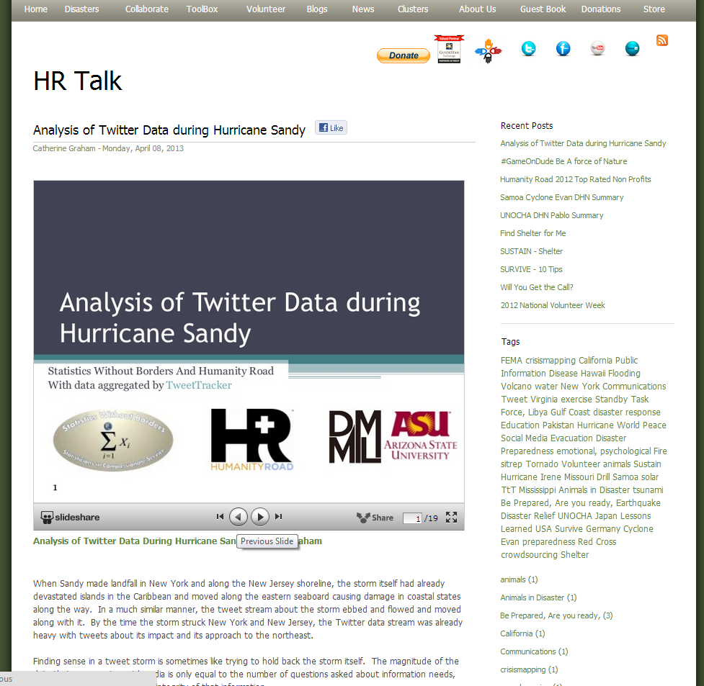

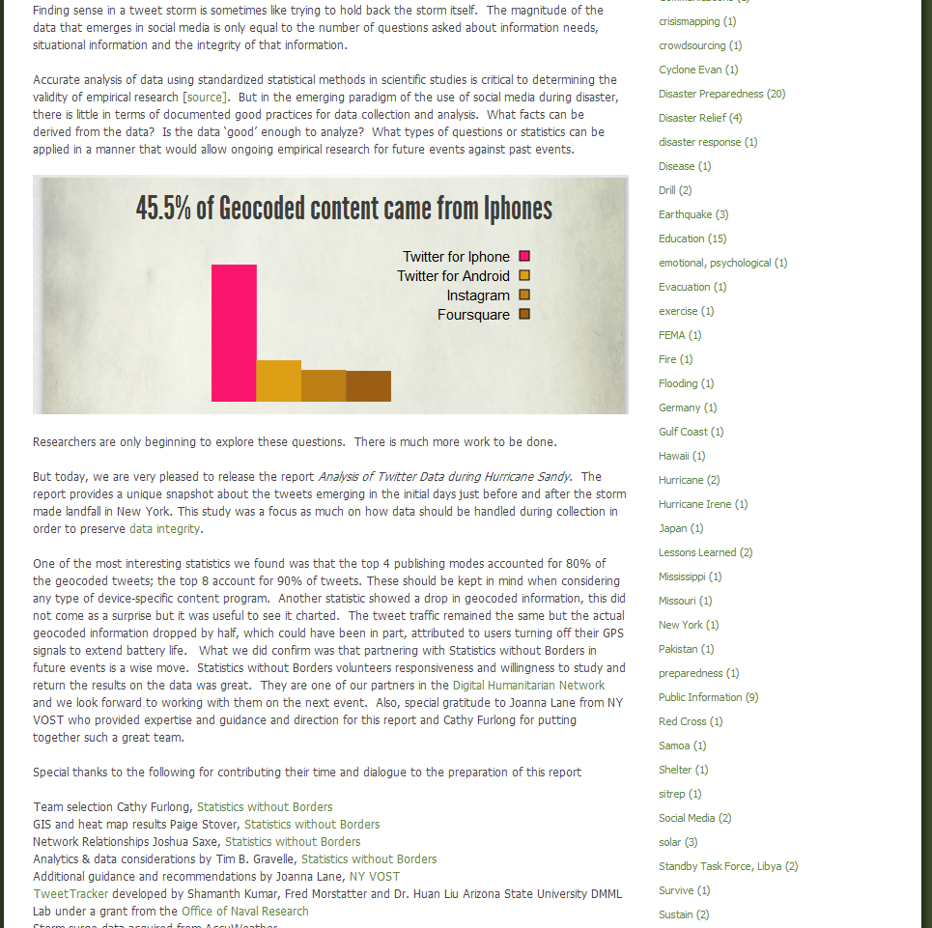

Our HT’2013 paper was mentioned in New Scientist Blog

http://newscientist.com/blogs/onepercent/2013/03/twitter-arab-spring-tweeter.html

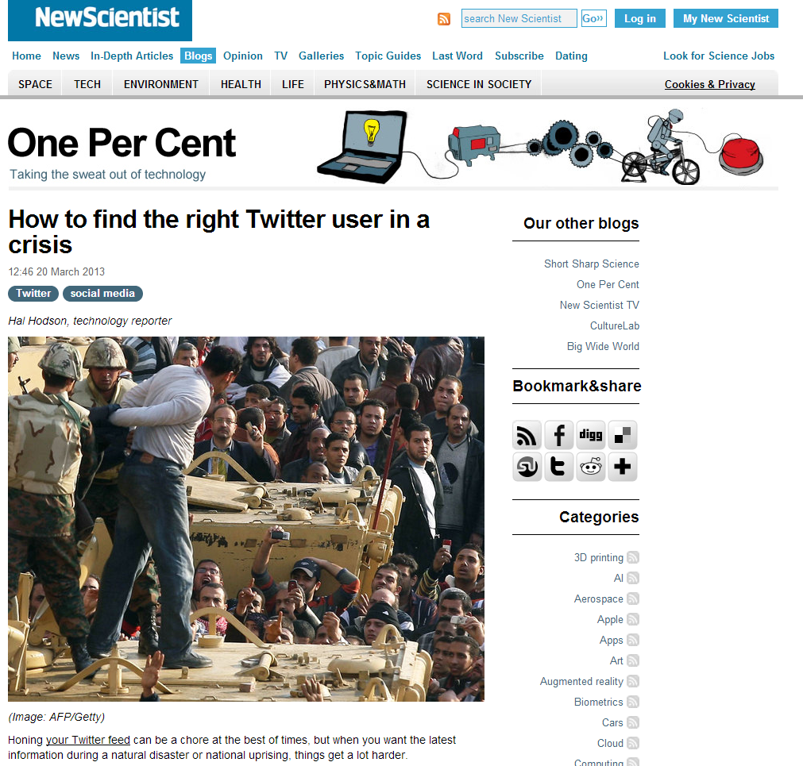

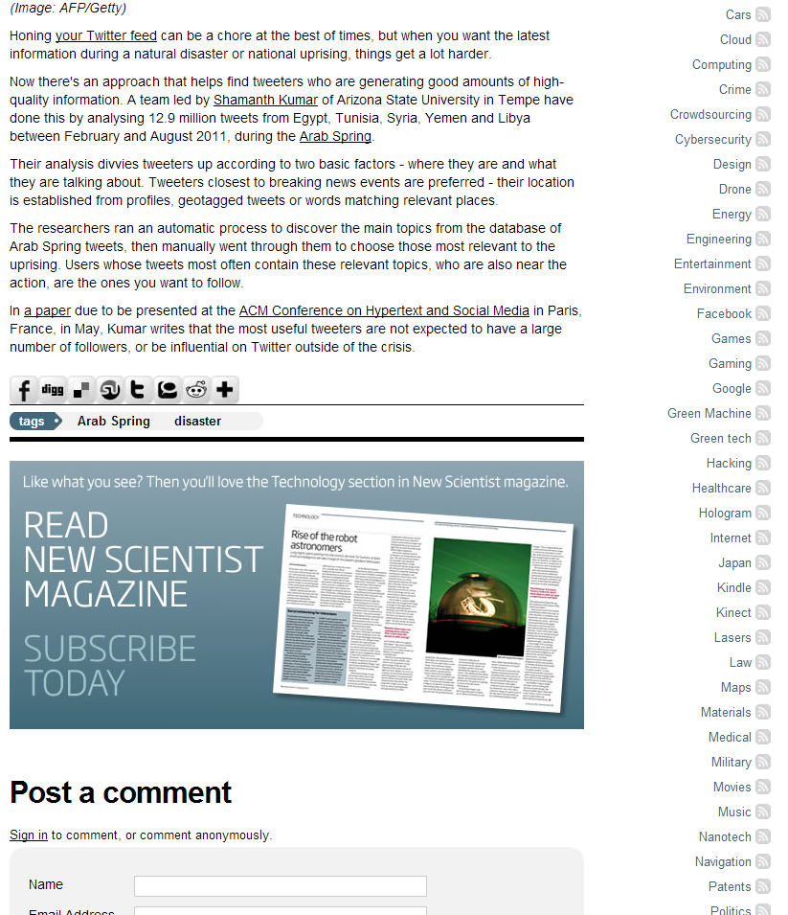

Coverage in ASU news

https://asunews.asu.edu/20130325_dmml_newsscientist

fullcircle.asu.edu/2013/03/expanding-social-medias-potential-to-benefit-society/

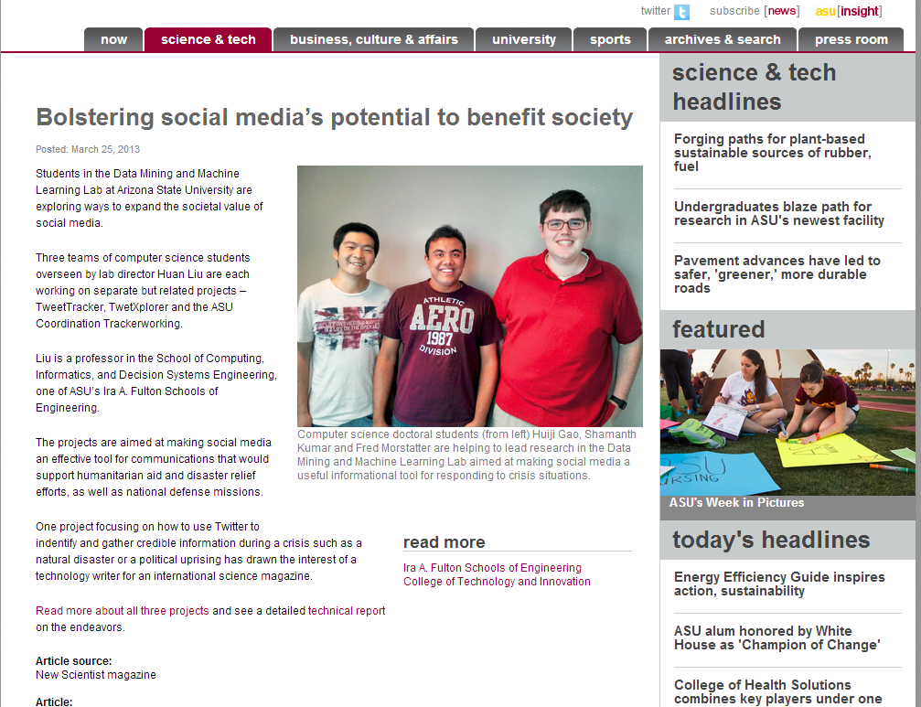

DMML Awarded the DURIP grant to build a HA/DR center

https://asunews.asu.edu/20130311_huanlui_socialmediaproject

http://fullcircle.asu.edu/2013/03/making-social-media-an-effective-tool-for-humanitarian-aid-national-defense/

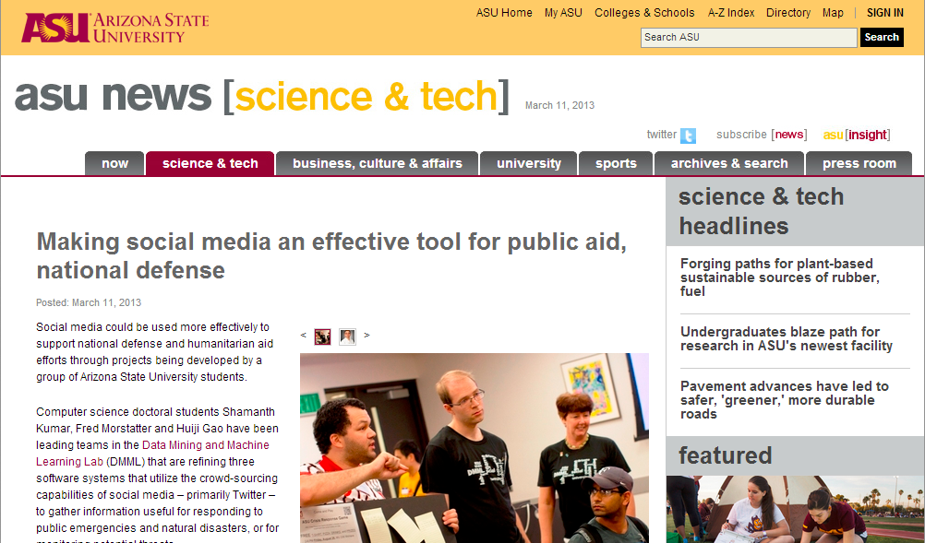

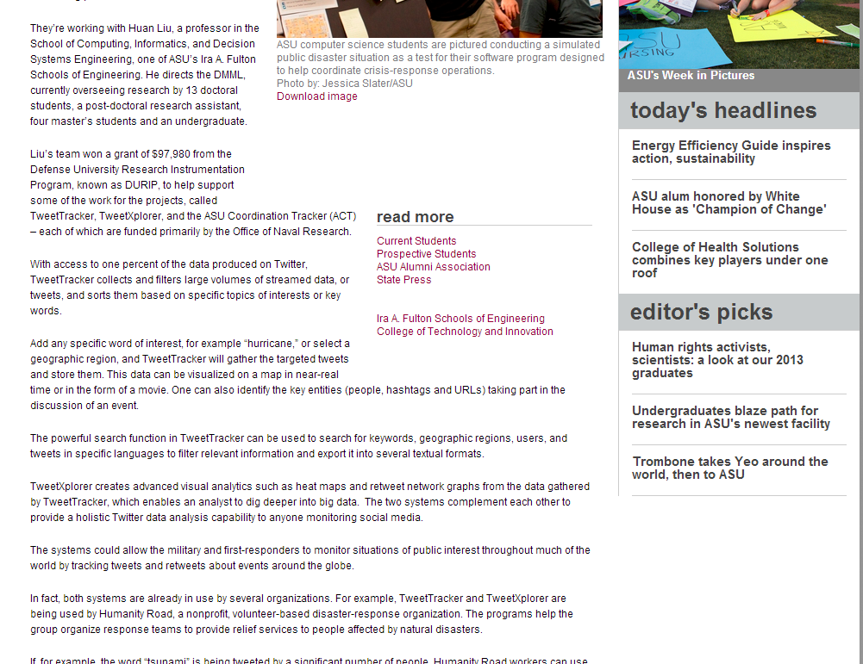

First ASU Crisis Game Organized in 2011
Over 75 students participated in the first Crisis Response Game, a disaster simulation to experiment with the use of social media in crisis situations for data collection, task allocation and response
coordination, and to identify ways that relief organizations can more effectively track and analyze information using social-media based tools like TweetTracker and ACT to collaboratively respond to a real disaster. Read More at: http://intheloop.engineering.asu.edu/2011/08/31/first-crisis-response-game-held-on-asu-campus/

