ENGLISH 425 (#74089)
“William Blake & Critical Theory”
Tuesday & Thursday, 10:30 – 11:45 AM
Professor Mark Lussier

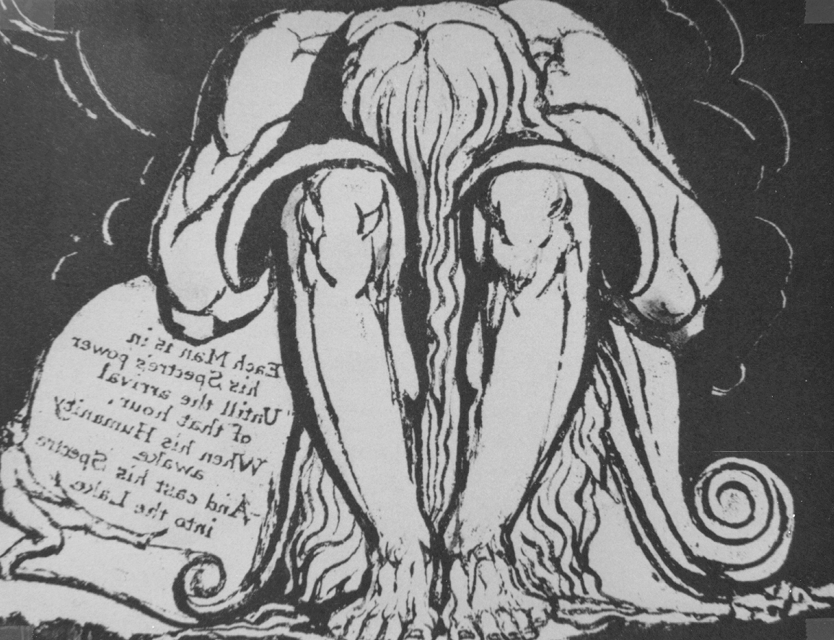

I. Pertinent Information

Office = L547C
Office Hours = Tuesday & Thursday, 1:00 – 3:00 PM
By Appointment Otherwise
Phone = (480) 965-3925
Email = mark.lussier@asu.edu
Webpage = www.public.asu.edu/~idmsl

II. Textbooks

The Complete Poetry & Prose of William Blake (CPP)
William Blake: The Complete Illuminated Books (IB)
The Critical Tradition: Classic Texts & Contemporary Trends (CT)

III. Course Description

One of the distinctive features of William Blake has been the degree to which his poetic work, and especially his illuminated books of prophecy, has exhibited the ability to provide fertile ground for the application of a wide range of new critical approaches (whether deconstruction, feminism, new historicism, psychoanalysis or reception aesthetics). Phrased different, Blake’s work has simply absorbed these approaches without being exhausted in the process, and this course will explore the dynamic ‘textual interspace’ wherein poetry, visual design and critical theory intermingle to provide mutual illumination. This course, therefore, is designed to satisfy two elements of the English major: a distribution requirement (Literature, 1660-1900), and the critical theory requirement. Since Blake’s work confronts a wide range of aesthetic, poetic, critical, cultural, political, and social issues, some works studied in the class might be of a provocative nature.

IV. Course Requirements

Given that the course is senior-level, the requirements are organized along the lines of an advanced undergraduate seminar. First, attendance will be taken and strongly encouraged, since the combination of studying both Blake and Critical Theory makes for a rigorous semester, with each week building on the preceding one. You are allowed two absences without the necessity of justification, but you should, if missing class is a necessity, contact me in advance. If you miss more than two classes, you risk a reduction of your final grade, depending upon specific contexts for those absences. Second, the writing for the course is organized in specific products of ever-greater complexity. And so, the first writing assignment will be a straightforward ‘explication de texte’, which will survey primarily diagnostic purposes. The second writing assignment will be to adopt a specific critical essay/approach and to apply that body of theory to some aspect of a discrete work. The third writing assignment will be a short critical summary of a secondary source (a published piece of applied theory), which will become the preliminary element for the fourth piece of writing, an annotated bibliography of secondary sources related to your specific research topic. Of course, the final writing assignment will be a research paper on a self-selected topic or subject. The grade for the course will be generated in the following way:

Essay 1 10%
Essay 2 20%
Essay 3 10%
Annotated Bibliography 20%
Research Paper 30%
Participation 10%

V. Reading Schedule

The reading pace for the course will be brisk but fair, and I have tried to provide a positive rhythm to the reading, with less reading assigned when graded assignments are due. And so, here’s the structure of our efforts.

Preliminary Matters

08/26 Introduction to the Course
Review of Syllabus
First Roll Call

08/28 Bindman, “Introduction” (IB 7-17)
Richter, “Introduction” (CT 1-22)
Lussier, Lecture: “The Persistence of Blake”

Contrary Matters

09/02 Blake, “All Religions are One” (CPP 1-2; IB 18-27)
Blake, “There is No Natural Religion A&B (CPP 2-3; IB 28-42)
Blake, “The Gates of Paradise” (CPP 32-3; IB 135-41)

09/04 Blake, Songs of Innocence and of Experience (CPP 7-32; IB 43-97)
Nietzsche, “The Birth of Tragedy” (CT 439-51)

09/09 Blake, The Marriage of Heaven and Hell (CPP 33-44; IB 107-134)
Freud, “Creative Writers and Daydreaming” (CT 509-13)

09/11 Blake, The Marriage (continued)
De Saussure, “Binary Oppositions” (CT 845-51)
Essay 1 Due
Historical Matters

09/16 Blake, America, A Prophecy (CPP 51-59; IB 154-73)
White, “The Historical Text as Literary Artifact” (CT 1383-97)

09/18 Blake, Europe, A Prophecy (CPP 60-67)
Blake, “The Song of Los” (CPP 67-69)

09/23 Blake, “On Homer’s Poetry” (CPP 269; IB 402)
Plato, The Republic & “Ion” (CT 30-45)

09/25 Blake, “On Virgil” (CPP 270; IB 402)
Horace, The Art of Poetry (CT 82-94)

Psychological Matters

09/30 Blake, “The Mental Traveller” (CPP 483-6)
Blake, Letters (699-785)

10/02 Blake, Letters (continued)

10/07 Blake, The Book of Urizen (CPP 70-83; IB 203-31)
Jung, The Principle Archetypes (CT 554-64)
Essay 2 Due

10/09 Blake, The Book of Urizen (continued)
Blake, The Book of Ahania (CPP 84-89; IB 232-39)
Lacan, “The Mirror Stage” (CT 1122-28)

Mythic Matters

10/14 Blake, The Four Zoas, Night the First (CPP 30-13)
Freud, “The Dream-Work” (CT 500-08)

10/16 Blake, The Four Zoas, Night the Ninth (CPP 386-407)
Blake, “A Vision of the Last Judgment” (CPP 554-67)

10/21 Blake, Milton (CPP 95-143; IB 246-97)
Bloom, “A Meditation upon Priority” (CT 1156-60)

10/23 Blake, Milton (continued)
Lévi-Strauss, The Structural Study of Myth (CT 859-67)

10/28 Blake, Milton (continued)
Frye, The Archetypes of Literature (CT 691-701)
Essay 3 Due

10/30 Blake, Milton (concluded)

11/04 Blake, Jerusalem (CPP 144-259; IB 298-399)
Jauss, “The Three Horizons of Reading” (CT 981-9)

11/06 Blake, Jerusalem (continued)
Benjamin, “The Work of Art . . .” (CT 1232-48)

11/11 Veterans Day Holiday

11/13 Blake, Jerusalem (continued)
Jameson, The Political Unconscious (CT 1290-1306)

11/18 Blake, Jerusalem (continued)
Horkheimer & Adorno, The Culture Industry (CT 1254-62)
Annotated Bibliography Due

11/20 Blake, Jerusalem (continued)
Geertz, Thick Description (1366-82)

11/25 Blake, Jerusalem (concluded)

11/27 Thanksgiving Holiday

Gender Matters

12/02 Blake, “The Book of Thel” (CPP 3-7; IB 98-106)
Wollstonecraft, A Vindication (CT 275-84)

12/04 Blake, Vision of the Daughters of Albion (CPP 45-51; IB 142-53)
Sedgwick, Between Men (CT 1683-6)

12/09 Research Papers Due

Within the “Reading Schedule” (see below), assignments are made by the abbreviations that follow each text listed here.

